© 2018
Kravchenko S. O., Candidates of Veterinary Science,
Bobrova V. V., post-graduate student,
Poltava State Agrarian Academy
ULTRASONOGRAPHY CHANGES IN ACUTE AND CHRONIC PANCREATIC INFLAMMATION IN CATS
Reviewer – Candidate of Veterinary Sciences N. I. Dmytrenko
Diagnosis of inflammatory pancreatic disease in the absence of specific tests: SPLI (specific pancreatic lipase in cats) and TLI (trypsin-like immunoreactivity), which today are the gold standard for the diagnosis of pancreatitis in cats, but are not available yet in our country for clinicians, is quite complex in the absence of a specific clinical picture, due to the peculiarity of the course of this disease in this species of animals. Ultrasound scanners with high-sensitivity sensors are relatively accessible today in the daily practice of a veterinarian and this visual method of diagnosis makes it possible to assess the presence or absence of structural changes in the pancreas of cats with a non-specific clinical picture of the disease. The article analyzes the possibilities of the ultrasonic diagnostic method in the study of this organ in this species of animals clinically healthy and patients and correlation of the revealed changes with the clinical symptoms of the disease are carried out.
Key words: ultrasonic examination, pancreas, cats, diagnostics.
Formulation of the problem. Inflammation of the pancreas in cats in most cases has a chronic course and in general clinical practice remains unidentified in the absence of specific symptoms. The most common signs of pancreatitis in cats include anorexia, lethargy, body temperature, dehydration, jaundice, mild anemia. The classic symptoms are vomiting and abdominal pain, in cats only half the cases are recorded [1].
An echography of the pancreas is performed to confirm its pathology. This method is also of great interest for everyday veterinary practice, since today it is already more accessible with the advent of ultrasound equipment of the expert class. This is a non-invasive method that allows you to obtain information on the state of the pancreas and other internal organs in each particular situation in an emergency procedure, objectively and without any side effects on the body being examined. In addition, with the help of echography, it was possible to perform effectively not only diagnostic but also minimally invasive interventions – biopsy or drainage of pathological formations.
In humane medicine, the method of ultrasound is widely used to diagnose and monitor patients with pancreatic pathologies. In veterinary medicine, the possibilities of this method, the question of ultrasound semiotics of pathological changes in the pancreas, are illuminated episodically and require further research.
Analysis of basic research and publications, which initiated the solution of the problem. Analyzing data from literary sources, it should be noted that according to the conducted researches, the method of ultrasonography of the pancreas in domestic cats has a rather high variability of information content – 75–84 % (Larson) according to some sources and 11–67 % according to other studies [2]. This discrepancy is related to the technical capabilities of the equipment used, the experience of the doctor of ultrasound diagnosis and the degree of damage to the organ. To pathologies of the pancreas, which are most often registered in small pet animals, include pancreatitis acute and chronic with concomitant complications, nodal hyperplasia and neoplasms [4].
The purpose of the study: to analyze informative method of ultrasonography of the pancreas in its pathological condition in domestic cats.
Materials and methods. The research was conducted on the basis of the clinic of veterinary medicine «VetExpert» in Poltava. The object of the study was domestic cats of different age groups and breeds. Now 130 animals have been screened for ultrasound examination with pathologies not related to the pancreas and suspected of pancreatic pathology. The diseased animals were inspected clinically, collected anamnestic data. Parallel exploration of individual biochemical and physical parameters of blood, urine. Ultrasound studies were performed by an IMTRACEMICICALITE ultrasound scanner (Sigma 5000 series) KONTRONMEDICAL, a linear transducer with a frequency of 7.5–12 MHz in the B-mode. Before conducting ultrasound examination of the abdominal organs in urgent situations and in the absence of vomiting, 12-hour hungry diet and an oral administration of the enterosgel sorbent in an amount of 5 grams per adult animal and preliminary filling of the stomach with water (prepuberation immediately prior to the study in volume 20–40 ml). The wool was bled before the study, a special gel was applied to the skin. In cats, the body and the left fate of the pancreas are better visualized [2, 3], therefore, the focus was on the study of this particular part of the body, in parallel, examined the hepatotoxic system and the organs of the gastrointestinal tract, namely the stomach and duodenum, since in 80 % cats duct of the pancreas and bile ducts merge into a common duct that falls into the duodenum. Such a tight anatomical connection between the liver, the pancreas and the duodenum in this species of animals involves the simultaneous inflammation of all three organs [1, 4]. Animals were examined in the dorso-wind position with ventral access. In the study of the pancreas, the contours (equal or unequal) echogenyne (normal, reduced or elevated), echogenicity prevalence (locally or diffuse), gauge width and pancreatic duct, peritoneal effusion, evaluation of the surrounding tissues, duodenum and ileus (thickness of walls and the possibility of differentiation of layers, peristalsis), evaluation of the passableness of the biliary tract (shape, location of the gall bladder, contour estimation, volume and homogeneity of the bile, diameter of the total bile duct Strait). According to the literature, in clinically healthy animals, the isoehechnogenicity of the parenchyma of the gland with hepatic parenchyma and adipose tissue is marked, the diameter of the duct – from 0.5 to 2.0 mm. The diameter of the left fate is on average from 3.0 to 10.0 mm [3].
Research results. Only 1.6 % of cats needed previous anesthesia due to increased aggression, most often it was for healthy animals. 98.4 % of cats responded well enough to the survey. In 75 % of animals, the left fossa of the pancreas with a central duct was well visualized, which was identified by energy doppler, only 25 % of the body and the right fate. The results of the studies were interpreted in the light of data from anamnesis, clinical and laboratory studies. The best visualization of this organ was recorded in animals with peritoneal effusion and in animals with reduced or normal weight.
Changes in echocardiogram of the pancreas were reported in 22 cases
п/п | Age of an animal | Diagnosis | Clinical  manifestations | echo change in  pancreas
1 | 16 years | chronic kidney disease | Anorexia, chronic vomiting | lower organ echo density
2 | 9 years | Triadite | Chronic vomiting, diarrhea | higher organ echo density
3 | 2 years | extraneous object in the intestine | Acute vomiting | lower organ echo density
4 | 6 years | Chronic pancreatitis in differential diagnosis | Anorexia | higher organ echo density
5 | 2,5 years | Triadite | Anorexia | lower organ echo density, expanded duct up to 2.3 mm
6 | 19 years | Breast tumor | Anorexia, chronic vomiting | Hypoehogenic nodes in the stratum of parenchyma of the pancreas
7 | 6 years | pancreatitis | Anorexia, chronic vomiting | lower organ echo density, an increase in the size of the pancreas to 11.9 mm
8 | 10 years | pancreatitis | Anorexia, apathy | lower organ echo density, an increase in the size of the pancreas to 12,1 mm, inequality of contours
9 | 10 years | Feline immunodeficiency virus | Anorexia, apathy | Mixed echogenic parenchyma
10 | 1 year | Feline Infectious Peritonitis | Peritoneal effusion | lower organ echo density, an increase in the size of the pancreаs increase the size of the gland
11 | 3 years | pancreatitis | Anorexia, vomiting | lower organ echo density, an increase in the size of the pancreas expanded duct up to 2,5 mm, inequality of contours
12 | 16 years | Kidney lymphoma | Anorexia, apathy | higher organ echo density
13 | 9 months | extraneous object in the intestine | Anorexia, vomiting | lower organ echo density, an increase in the size of the pancreas, expanded duct up to 2,4 mm
14 | 3,5 years | pancreatitis | Chronic vomiting | Mixed echogenic parenchyma
15 | 6 months | extraneous object in the intestine | Anorexia, vomiting | lower organ echo density, an increase in the size of the pancreas expanded duct up to 2,4 mm, lower echo density of adipose tissue around the pancreas
16 | 1,1 years | Feline Infectious Peritonitis | Increasing the size of the abdomen | lower organ echo density
17 | 11 years | chronic kidney disease | Anorexia, polydipsia/ polyuria, vomiting | lower organ echo density
18 | 2,5 years | pancreatitis | Chronic vomiting | higher organ echo density, an increase in the size of the pancreas to 2,6 mm
19 | 6 years | Diabetes mellitus | Polydipsia/ polyphagia | lower organ echo density, an increase in the size of the pancreas to 2,1 mm
20 | 7 years | Lymphoma of the intestine | Diarrhea | Increase of size, cystic formations in the stratum of parenchyma
21 | 4 years | No clinical signs of the disease | No clinical signs of the disease | lower organ echo density, an increase in the size of the pancreas to 4,0 mm
22 | 14 years | Hyperthyroidism, DCM, Triadite | Loss of appetite | lower organ echo density, Hypoehogenic and hiperehogenic nodes in the stratum of parenchyma of the pancreas
Thus, for the diagnosis of pancreatitis in cats, account was taken of the decrease (Pic. 1) or the increase of the echogenicity of the organ (Pic. 2), the echogenicity of the surrounding tissues (Pic. 3), the increase in the size of the gland without change or with the change in the diameter of the central duct (Pic. 4), atony of the 12th-small intestine, cavity formation in the pancreas (for example, pseudocysts) (Pic. 5, 6), which is characteristic for the development of inflammatory processes in these organs.
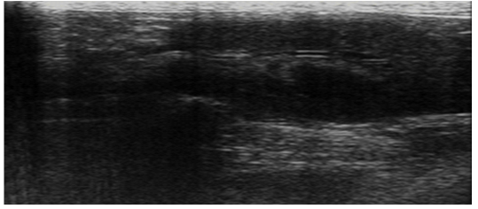
Pic. 1. A diffuse decrease in the echogenicity of the parenchyma of the pancreas, increasing the size
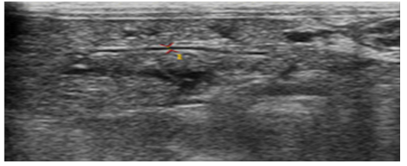
Pic. 2. A diffuse increase in the echogenicity of the parenchyma of the pancreas
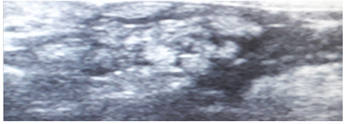
Pic. 3. Increased echogenicity of surrounding tissues, local effusion
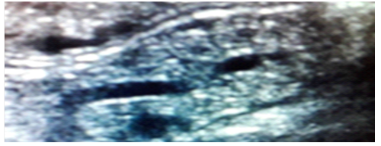
Pic. 4. Expansion of the central pancreatic duct
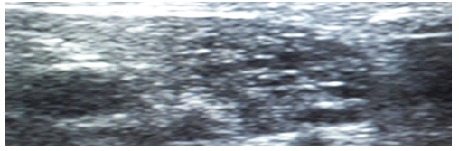
Pic. 5. Anechoic cavity formation in parenchyma of the pancreas
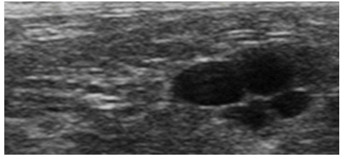
Pic. 6. Anechoic hollow formation in tissues surrounding the pancreas
Conclusion. Thus, ultrasound examination of the pancreas in cats is a promising method for diagnosing the pathological conditions of this organ, since the pancreas in the cats is well visualized with ultrasound, even without a previous hungry diet. The obtained data have a diagnostic value for the detection of pathological states of the pancreas in this species of animals and require further research in this direction.
BIBLIOGRAPHY
- Каттен И. Сочетание панкреатита с холангиогепатитом и воспалительным заболеванием кишечника (триадит) у кошек / И. Каттен // Фокус. – 2013. – Том 23. – №2. – С. 4–10.
- Ксенуліс П., Штайнер Й. Панкреатит у кошек / П. Ксенуліс, Й. Штайнер // Фокус. – 2009. – Том 19. – №2. – С. 11–20.
- Маннион П. Ультразвуковая диагностика заболеваний мелких домашних животных / П. Маннион. – М. : Аквариум, 2008.
- Пенник Д. Атлас по ультразвуковой диагностике. Исследования у собак и кошек / Д. Пенник, М.-А. Д’Анжу. – М. : Аквариум-Принт, 2015.

