© 2018
Telepen’ko Yu.Yu., Junior Researcher
(scientific adviser – Candidate of Agricultural Sciences V. O. Silenko)
Institute of Horticulture of Ukraine
COMPARATIVE ASSESSMENT OF DROUGHT RESISTANCE OF BLACKBERRY VARIETIES (RUBUS L.) IN THE WESTERN FOREST-STEPPE OF UKRAINE
Reviewer – Candidate of Biological Sciences O. I. Kitaiev
The article presents the results of laboratory studies of the influence of high temperatures on the physiological state of the leaves of 25 varieties of blackberries in the Western Forest-Steppe of Ukraine. In the laboratory, water-physical properties, such as water retention capacity, moisture deficit and water content of leaf tissues, were studied. In terms of resistance to loss of moisture, the varieties under study are divided into three groups: high-drought-resistant (Black Diamond, Black Pearl, Chief Joseph, Heaven can Wait, Loch Tay, Natches, Orkan, Nasoloda, Chester, Ouachita), medium-drought-resistant (Karaka Black, Adriene, Аsterina, Brzezina, Cacanska Вestrna, Navaho, Tornfree, Sadove chudo, Jumbo, Kiowa, Reuben) and varieties with low resistance (Apache, Black Butte, Black Magic, Triple Crown). Varieties Natches and Apache, and the highest – Black Butte are characterized by a low indicator of water deficit. The highest waterlogging of blackberry leaf tissues was noted in varieties of Loch Tay (58.9 %), Tornfree (59.7 %) and Brzezina (60.8 %). The least hydrated are the fabrics of varieties Navaho and Black Butte (51.4 and 51.7 % respectively).
Key words: drought tolerance, adaptability, water retaining ability, moisture content, moisture deficit, grade.
Formulation of the problem. In the life and annual cycle of plants there are no important or unimportant periods. The development of the plant is continuous and the external factors of each period affect it. Carrying out physiological studies makes it possible to identify the most adapted varieties for cultivation under certain climatic conditions and in the future to improve the technology of their cultivation, which will not only allow plants to overcome a high stress load, but also improve the quality of the crop [2]. The vegetative period in recent years is characterized by unstable moisture, often periods without precipitation, which cause soil and air drought. Such temperature variations and insufficient rainfall are negatively affecting the growth and development of plants. It was established that after dry periods, a decrease in frost resistance was observed at 4–6 °С [4]. It is known [6] that water is a solvent and, at the same time, an environment in which the movement of matter occurs and its exchange, and its high heat capacity stabilizes the temperature of plants. Due to the lack of moisture in the fruit plants, the growth stops, the leaves and the leaves fade and the leaves fall and the seed of the generative kidneys decreases, and, accordingly, the yield, not only in the year of drought, but also in the next, dramatically decreases the quality of the fruits.
Study of drought tolerance by physiological methods is best carried out during periods of the greatest stresses of stress factors, in arid and especially hot periods, from the end of the growth of the shoots to the aging of the leaves [8]. The most informative of the laboratory-field methods for studying the drought-tolerance is the study of the indicators of water regime of the leaves: vegetation of tissues, water deficit and determination of water retention capacity.
An analysis of the latest research and publications that initiated the solution of the problem. Investigations of O. V. Serdiuk [9] found that the water loss parameters of blackberries in comparison with the similar studies Yu.Yu. Andrusyk with raspberries, 1.5 times smaller. It indicates a higher potential drought tolerance for blackberries. The root system of the blackberries is highly developed and lies at a depth of 1.5 m [10]. However, blackberries, as well as any other plants, can not grow optimally and bear fruit without sufficient moisture, because moisture is necessary for the formation of fruits, and a strong leafy apparatus evaporates a significant amount of water. In the leaves of plants there are mechanisms that regulate the flow of water, depending on the environment. It is known [5] that plants are able to regulate the evaporation of moisture from their tissues due to the work of stomata. The process of transpiration in the context of cultures is significantly different, and its varying intensity between varieties within a single culture is observed. The blackberry variety is rather limited not only in the territory of the Forest-Steppe zone, but also throughout the country due to the lack of a sufficient number of varieties of domestic selection. At present, 5 varieties of blackberries are included in «State Register of Plant Varieties Applicable to Distribution in Ukraine», of which two are breeding by P. Z. Sherenovyi. However, there are more than 300 varieties of blackberries and raspberry hybrids that are more durable and productive in the world [10]. Therefore, on time, the question of a detailed study and selection of varieties with high adaptive ability to stress factors. And in conditions of global warming, the creation of varieties, drought-resistant and high-yielding irrespective of temperature and humidity becomes more relevant.
The purpose of the research is to improve the assortment of blackberries on the basis of the study of the economic and biological characteristics of new varieties and their adaptability in the soil-climatic conditions of the Western Forest-Steppe of Ukraine for further sorting and introduction into breeding programs.
The research task was to determine the influence of high temperatures on the physiological state of leaves of 25 varieties of blackberries in the conditions of the Western Forest-Steppe of Ukraine.
Material and methods of the research. The research was conducted in the conditions of the Western Forest-Steppe of Ukraine on the basis of the Institute of Horticulture of the National Academy of Sciences of Ukraine (Kyiv) during the period of the greatest tension of the water regime of 2016–2017. The objects of research were 25 varieties of blackberries, namely: Adriene, Apache, Asterina, Black Butte, Black Diamond, Black Magic, Black Pearl, Brzezin, Cacanska Vestrna, Chester, Chief Joseph, Heaven Can Wait, Jumbo, Caraka Black, Kiowa, Loch Tay, Natches, Navaho, Orkan, Ouachita, Reuben, Tornfree, Triple Crown, Nasoloda (control) and Garden Miracle. Plants are planted according to the method of collecting varietal studies [8, 1] in autumn 2014. The scheme of planting 3.00×1.25 m. The agrotechnical measures were carried out in accordance with the generally accepted technology of growing berry crops.
Laboratory studies were conducted at the Laboratory of Plant Physiology and Microbiology of the Institute of Nanosciences of Ukraine.
The study of water-physical properties of the leaves of the studied varieties was carried out in accordance with «Programs and methods of sorting fruit, berry and nut tree crops» [8].
Statistical and mathematical processing of the obtained data was carried out by the method of dispersion analysis with the help of applied computer programs [3, 7].
Research results. In order to obtain a generalized assessment of drought tolerance of blackberries, the average values ​​of the results obtained during the research period (2016–2017) are given.
Analyzing the indicated parameters of water retention capacity (see table), different intensity of water loss in the section of investigated varieties was recorded.
The study of the dynamics of changes in water-holding capacity showed that the most intensive leaves lost water in the first 2 hours after weighing. Thus, the highest percentage of water loss was recorded in Garden Miracle (9.5 %) and Black Butte (9.2 %). The lowest moisture loss index was noted for Natches (2.7 %). The control variety of domestic selection of Nasoloda in the first 2 hours lost 4.6 % of water.
During 4 hours of exposure, the leaves were lost from 5.5 % (Natches) to 16.3 % (Black Butte Blackberry), and for 6 hours – from 7.50 (Natches) to 24.8 % of water (Black Butte Blackberry). The percentage of water loss in the variety control was recorded at 8.1 (after 4 hours) and 11.9 % (6 hours).
Since drought in the environment can be quite long, an important indicator in the study of drought tolerance of the variety is the study of water loss after a daily exposure. In general, based on the data obtained, the Natches variety, which showed a consistently high water retention capacity (26.30 %), indicates a high level of adaptability to drought conditions. Also, a significantly lower index of water retention capacity is characterized by varieties Chief Joseph (33.8 %), Chester (34.1) and Orkan (34.5 %). Black Magic, Black Butte Blackberry and Apache have the least drought-tolerant ones, which, on average, recorded the highest water losses during the years of research (53.9, 52 and 49.8 % respectively).
Water-retaining ability of blackberry varieties (average for 2016–2017)
Title of the grade | Loss of water after exposure, %
Title of the grade | 2 hours | 4 hours | 6 hours | 24 hours
Slonki
Black Butte | 9.20 | 16.30 | 24.80 | 52.00
Black Diamond | 4.60 | 8.60 | 11.90 | 37.20
Black Pearl | 4.50 | 8.80 | 13.10 | 35.50
Karaka black | 7.80 | 13.70 | 22.30 | 46.00
Half-stray
Adriene | 8.10 | 14.40 | 21.20 | 44.70
Asterina | 5.70 | 11.60 | 18.4 | 48.00
Brzezina | 3.60 | 8.80 | 12.70 | 41.10
Cacanska bestrna | 4.70 | 9.80 | 15.30 | 46.30
Chief Joseph | 4.80 | 8.20 | 11.30 | 33.80
Heaven can Wait | 4.50 | 12.10 | 15.50 | 38.50
Loch Tay | 3.40 | 7.20 | 9.90 | 36.00
Natches | 2.70 | 5.50 | 7.50 | 26.30
Nаvaho | 5.00 | 10.70 | 17.10 | 42.20
Orkan | 4.50 | 8.10 | 11.70 | 34.50
Tornthree | 7.60 | 11.20 | 17.80 | 47.20
Triple crown | 5.30 | 10.30 | 14.80 | 49.00
Nasoloda (k) | 4.60 | 8.10 | 11.90 | 37.30
Sadove chudo | 9.50 | 14.10 | 17.80 | 48.70
Straightforward
Apache | 6.80 | 13.90 | 19.30 | 49.80
Black Magic | 8.30 | 13.80 | 22.40 | 53.90
Chester | 3.00 | 6.40 | 9.50 | 34.10
Jumbo | 6.20 | 13.50 | 19.20 | 46.70
Kiowa | 7.30 | 14.00 | 18.90 | 47.40
Ouchita | 3.30 | 7.20 | 11.80 | 35.90
Reuben | 4.50 | 8.30 | 12.70 | 41.10
НІР₀₅ | 0.12 | 0.27 | 0.42 | 0.95
After analyzing the above-mentioned material, the studied varieties for the stability of moisture loss can be divided into groups, namely:
• High-dampness (water loss for 24 hours exposure was 32.40±6.10 %): Black Diamond, Black Pearl, Chief Joseph, Heaven Can Wait, Loch Tay, Natches, Orkan, Nasoloda, Chester, Ouachita;
• medium-dampness (water loss – 44.55±3.45 %): Karaka Black, Adriene, Asterina, Brzezina, Cacanska Vestrna, Navaho, Tornfree, Sadove chudo, Jumbo, Kiowa, Reuben;
• Low-dampness (51.45±2.45 %): Apache, Black Butte, Black Magic, Triple Crown.
The assessment of drought-tolerance of plants for water deficit was conducted according to the following classification: 10–1 5% – moderate influence of drought; more than 18 % – significant tension of the water regime, which causes irreversible violations in the structural structure of membranes [7].
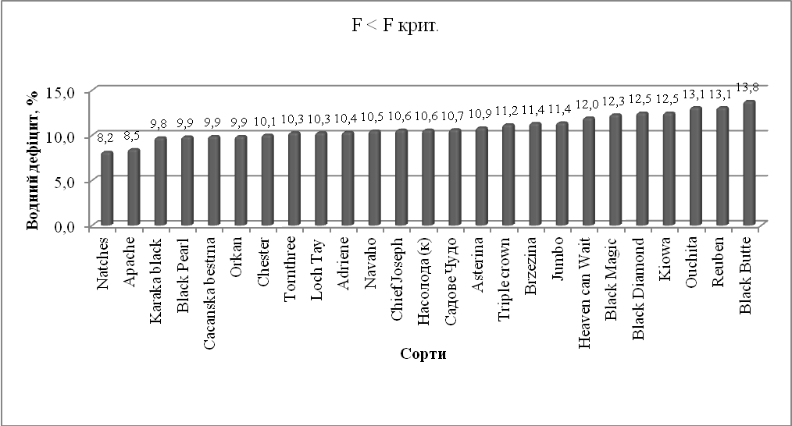
Pic. 1. Water deficit of leaves of blackberries,% (average for 2016–2017)
It should be noted that, in terms of the studied varieties, the water deficit does not exceed 13.8 %, which confirms the fact that the plants are very dry (Pic. 1). In general, in terms of the studied varieties, there was no significant difference between the values ​​of water deficit. However, the smallest deficit of moisture is characterized by the Natches variety, with an index of 8.2 %, and the largest – Black Butte (13.8 %), which indicates a slightly lower its adaptive potential in conditions of drought.
An important element in assessing the physiological state of plants in the period of drought is their ability to maintain an optimal level of vegetation of the tissues of leaves. Reducing the level of vegetation in a plant can lead to irreversible processes, such as reducing the growth of shoots and roots, premature fading of leaves, even until they are washed and dumped, reducing the amount of substitute nutrients and disrupting the assimilation of CO₂. However, such anatomical features as udder and water deficit are used only as an auxiliary criterion for determining drought tolerance [7].
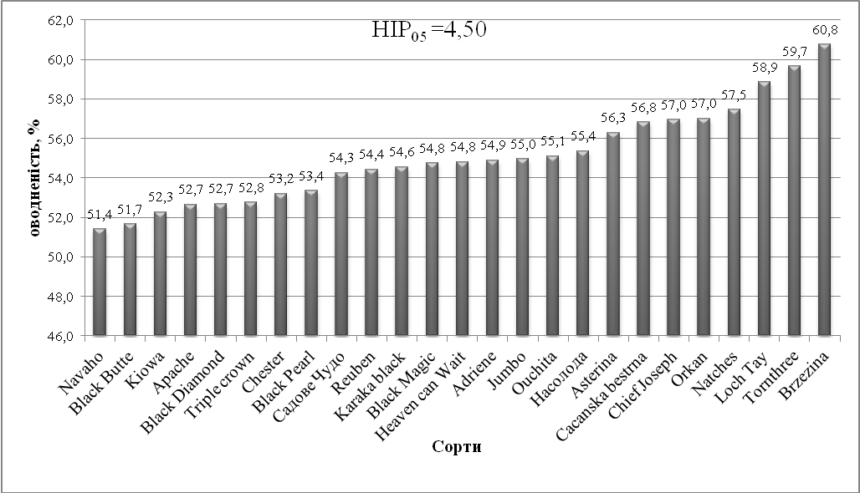
Pic. 2. Vegetation of leaf tissue of blackberries, % (average for 2016–2017)
The level of vegetation of the examined varieties of blackberries was in the range from 51.4 to 60.8 %. When conducting a dispersion analysis of the obtained data, it was found that only Brzezina (60.8 %) has a significantly higher level of vegetation (NIP₀₅=4.50). The indices of the remaining varieties do not differ significantly from the control.
Conclusion. According to the results of laboratory studies of the water-physical properties of the leaves, the varieties of blackberries examined for resistance to moisture loss are divided into three groups. Dedicated to high-dense (Black Diamond, Black Pearl, Chief Joseph, Heaven Can Wait, Loch Tay, Natches, Orkan, Nasoloda, Chester, Ouachita); medium hardiness (Karaka Black, Adriene, Asterina, Brzezina, Cacanska Vestrna, Navaho, Tornfree, Sadove chudo, Jumbo, Kiowa, Reuben) and varieties with low resistance (Apache, Black Butte, Black Magic, Triple Crown). Grains with an average drought tolerance risk to cultivate without irrigation, and low – only if there is irrigation. It was found that the lowest indicator of water deficit is characterized by Natches and Apache varieties, and the highest is Black Butte. The highest moisture content of blackberry leaves was noted in Loch Tay (58.9 %), Tornfree (59.7 %) and Brzezina (60.8 %). The least honey is the fabrics of varieties Navaho and Black Butte (51.4 and 51.7 % respectively). According to the set of indicators, the Black Butte variety has the lowest adaptive ability to drought compared to the rest of the varieties, and Natches – the highest, which allows it to recommend it for implementation in breeding work as a bearer of the drought resistance gene.
BIBLIOGRAPHY
- Андрієнко М. В. Методика вивчення сортів і форм ожини / М. В. Андрієнко. – К., 1992. – 21 с.
- Гудковский В. А. Основные стресс-факторы и механизмы повреждения растений /
В. А. Гудковский, Н. Я. Каширская, Е. М. Цуканова // Садівництво. – Вип. 55. – 2004. – С. 283–290.
- Доспехов Б. А. Методика полевого опыта / Б. А. Доспехов. – М. : Агропромиздат, 1985. – 351 с.
- Кривошапка В. А. Кліматичні зміни та ризики при вирощуванні плодових і ягідних культур в умовах північної частини Лісостепу України / В. А. Кривошапка, М. О. Бублик, О. І. Китаєв, В. В. Груша // Садівництво. – Вип. 71. – 2017. – С. 130–138.
- Кушниренко М. Д. Физиология водообмена и засухоустойчивости плодовых растений / [под ред. проф. П. А. Генкеля]. – Кишинев : ШТИИИНЦА, 1975. – 214 с.
- Лархер В. Экология растений / [перевод Д. П. Викторова ; под. ред. Т. А. Работнова]. – М. : «Мир», 1978. – 282 с.
- Меженський В. М. Основи наукових досліджень у садівництві. Розрахунки в Microsoft Exel : Навч. посібник / В. М. Меженський. – К., 2017. – 212 с.
- Программа и методика сортоизучения плодовых, ягодных и орехоплодных культур / [под ред.
Е. Н. Седова, Т. П. Огольцовой]. – Орел : ВНИИСПК, 1999. – 608 с.
- Сердюк О. В. Адаптивність нових сортів і гібридів ожини до умов правобережної підзони Західного Лісостепу України : автореферат дис. на здобуття наукового ступеня к. с.-г. н. – К., 2010. – 22 с.
- Шеренговий П. З. Сучасні технології вирощування ожини та малино-ожинових гібридів / [за ред. П. З. Шеренгового]. – К., 2013. – 132 с.

