© 2017
Liashenko S. V., Candidate of Technical Sciences, Associate Professor,
Poshyvailo Yu. O., master's degree
Poltava State Agrarian Academy
IMPROVING MACHINES FOR PRODUCTION OF FUEL MATERIAL OF NECESSARY FRACTION FOR HOUSEHOLD USE
Reviewer – Doctor of Technical Sciences, Professor O. M. Kostenko
The use of fuel material in the conditions of a personal peasant economy is considered. An analysis of the effectiveness of different types of biofuels is carried out. The expediency of using wood chips as an alternative to biofuel is substantiated. The analysis of constructions of industrial machines for making of wood chips is presented. It is established that for designing a household chipper its construction should be provided disk-knife working element and calibration sieve.
Key words: biofuel, granules, wood chips, chipper, machine, constructions, production technology.

Formulation of the problem. Each year in the woods of Poltava region grows by 1/3 more trees than we use. Also, every year waste wood is harvested during logging. Wood and its waste are raw materials that can be recycled to fuel chips. Therefore, wood chips is a crust resistant fuel material. For the production of wood chips, first of all, trees used to be damaged during drilling, branches, and also industrial waste wood harvesting are used.
One of the most pressing issues that arise after a forest is cut – what to do with waste? Recently, there has been a rapid transition to the use of biomass as a fuel. Solid biofuels play a significant role in the energy supply of industrialized countries: in the US, its share is about 4 %, in Denmark – 6 %, in Canada – 7 %, in Austria – 14 %, in Sweden – 16 % of the total primary energy consumption [2]
The efficiency of processing biomass into energy products is achieved only by the rational parameters of technological processes and machines that perform it.
An analysis of the latest research and publications that initiated the problem. The cod is the main product of wood shredding. Distinguish technological, green, fuel and decorative cod. Classification of fractions and properties of cod as chopped wood are determined by the action of several GOST-s (GOST 23246-78 and GOST 18110-72). The new official normative and technical documentation in this area is regulated by DSTU EN 15234-4: 2013 [4].
The analysis of technologies for the production of various types of solid biofuels is devoted to the work of Dumich, Bunetsky, Gabel, and others [1, 2, 3]. Summarizing the results of the research of scientists it should be noted that the technologies of biofuel production are described quite fully, but the designs of machines for its manufacture are constantly being improved.
The purpose and objectives of the research: to offer the design features of a machine for the production of fuel material in the conditions of a personal peasant economy. To achieve the goal, it is necessary to analyze the existing industrial materials for the production of fuel materials. Identify rational design elements of machines, and adapt them to the design of a prototype household machine in order to obtain fuel material necessary fraction.
Research results. Modern boilers provide automatic combustion of various types of solid biofuels (granules, pellets, sawdust, wood chips, ribs, etc.) with humidity from 10 % to 70 % [5].
Some weight of the same material, in what form it would not be (crushed, pressed, granulated, etc.), has the same calorific value. Some of the characteristics of solid biofuels (density, particle size, surface shape) through shredding and sealing may be changed, but its main fuel and technology characteristics are unchanged. The energy value of biofuels from a given material depends only on its moisture content [6].
Granules and pellets are made by pressing the wood waste (sawdust, cod), agricultural waste (straw and shells of cereals, corn stalks and sunflower, etc.) and biomass of energy crops. Some manufacturers use astringent substances that often contain phosphorus to extend the storage life of the granules. During combustion, the phosphorus compounds enter the flue gases and contribute to the formation of acid rain and increase the corrosion of chimneys. Therefore it is better to use granules without astringent substances.
Production of granules or pellets has significant disadvantages, which reduce their efficiency as a fuel. First, for the production of pellets, a high quality wood with a corium content of no more than 8 % without rot and impurities of needles and leaves is required. Such material is more efficiently used for the production of furniture and other products than burning. Secondly, the production of granules is a rather complicated and energy consuming process, and equipment has a high cost. Secondly, the most significant drawback of granules is their hygroscopicity.
The aforementioned disadvantages of pellet production have led to the fact that some EU countries are beginning to prefer the use of wood chips and cuts of agricultural crops as fuel.
Wood chips, although having a lower volumetric calorific value than granules, but it is much cheaper.
The production of cod is carried out only by one machine – a crossroads. To store raspberries do not need special rooms.
Wood cod is made from all the remnants of logging and remote wood plants as a result of sanitary felling in forest plantations and the degradation of gardens in private peasant farms. Material for the production of cod is obtained as a result of the usual exploitation of forestry. Crayfish can also be obtained from wood energy plants and wood waste wood processing and furniture enterprises. There are several types of cod (see table).

European classification of wood chips

Faction chips, size | Classification | Humidity  cod, % | Classification
Mild fraction, length – up to 3 cm | G30 | 20 | W20
Average fraction, length – 3–5 cm | G50 | 30 | W30
Large fraction, length – up to 5–10 cm | G100

For the production of cod, the crushers are used. Firms offer cars mobile (trailer and self propelled) and stationary driven by an electric motor with a productivity of 10 to 120, which can shred logging waste (branches, knots etc.), sawmills and wood processing enterprises (trimming etc.), as well as materials that are to be recycled (old furniture, pallets, construction waste and gardening etc.).
For the manufacture of cod, and the provision of its necessary fraction, namely GOST, we analyzed the designs of the following machines.
The Ukrainian company ARPAL offers SHEEPORES MK-120TR, which allows you to easily process tree trunks, crowns, branches, wood industry waste in diameter up to 12 cm on a technological cod size of 5–50 mm, (Pic. 1).
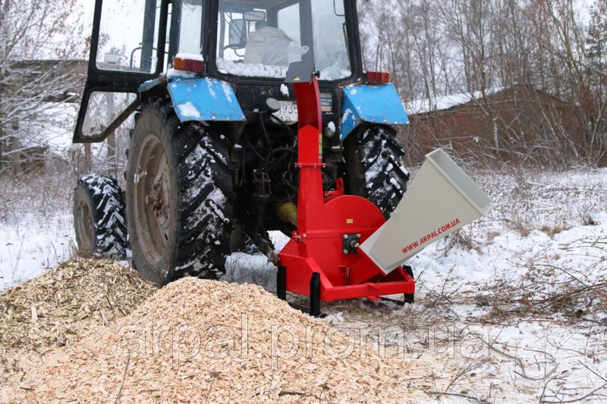
Pic. 1. SCHEEPORES MK-120TR

But a significant drawback is the cost of installation, as it is too large (approximately $ 1.500), as for usage in a private farm. The machine is aggregated with the power tool (tractor), a certain power from the shaft of power take-off, which in turn creates additional costs.
The peculiarity of the shredder's design is the disk-knife cutting unit, which provides shredding of the material to a given fraction.
Wood processing machine of the joint Ukrainian-German enterprise «Olnova» (DP 660-E stationary, electric) should be considered, as it is intended for grinding woodworking waste such as hump, rake, opail, as well as branches and cut trees (Pic. 2). Therefore it is recommended for cleaning forest plantations, sanitary zones of large cities, clearing of lines of electric grids, and further processing of material into technological and fuel cod. It is supposed to be made in stationary and hinged variants. The maximum size of crushing wood waste in a diameter up to 160 mm of any length. Performance up to 8, depending on the type of crushing material. Ability to adjust the size of the fraction of cod at the exit from 5 to 40 mm.
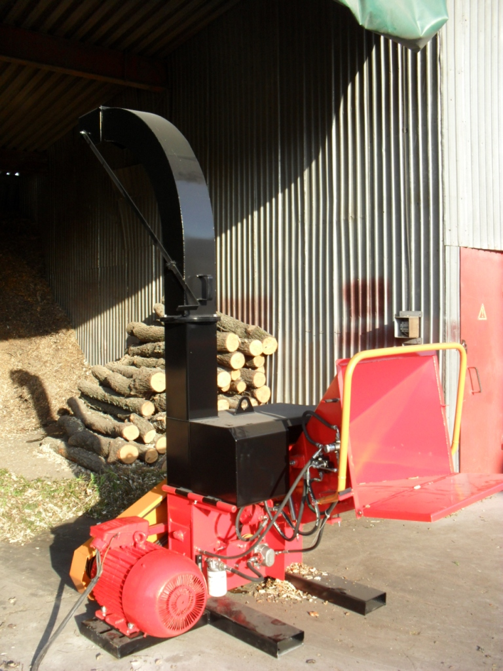
Pic. 2. Woodworking machine DP 660-E
A major disadvantage is the high cost of this installation (approximately $ 4,000). The advantages include the possibility of adjusting the size of the crack fraction at the outlet.
We will analyze the features of the TW 13 / 75G CHIPPER cross-section offered by the English company TimberWolf (Pic. 3).
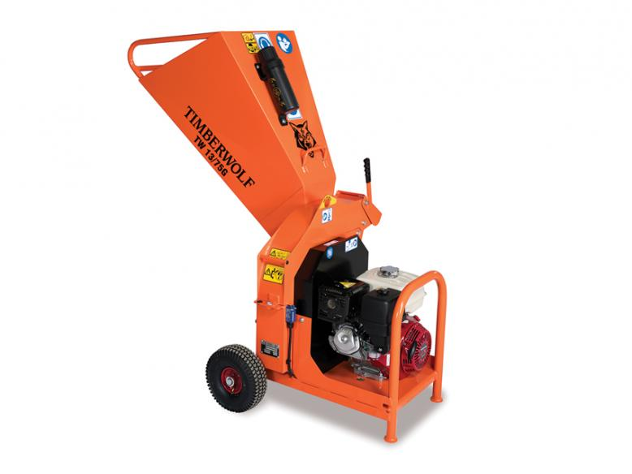
Pic. 3. Crosscut TW 13 / 75G CHIPPER, English company TimberWolf
With the help of the petrol engine Honda 13HP, the Timberwolf TW 13 / 75G Chipper is designed to operate throughout the day with low operating costs. The advantages of the design are mobility, the use of its own engine. The disk-knife cutting mechanism provides grinding of material of a certain fraction, and the design of blades creates an air stream for intensive removal of cod and increases the productivity of the machine. The disadvantages include the high cost of the crossroads (roughly $ 2,000). The diameter of the material loaded into the receiving tray must not exceed 75 mm.
So, after analyzing the design features of the three machines, we can conclude: the design of a household machine for the production of fuel chips of a given fraction in the conditions of a personal peasant farm should combine a disk-knife working body, a calibration sieve, and a drive from an electric motor with a power of 2 to 3 kW.
Conclusions:
1. Wood pellets and pellets from biomass are an ecological type of fuel with a high net of calorific value. However, the production of granules is a complex, labor-intensive and resource-consuming process.
2. At the local level, in the conditions of private farms, it is expedient to use biofuel (cod), which does not require significant production costs.
3. For private farms, it is necessary to design a chipper that would combine the advantages of industrial machines at an affordable cost.
BIBLIOGRAPHY

1. Бунецький В. Аналіз технологічних процесів отримання твердого палива у вигляді пелет або брикетів / В. Бунецький // Вісник ЦНЗ АПВ Харківської області: Механізація та електрифікація. – Х., 2011. – С. 328–340.
2. Габрель М. Виробництво твердого біопалива в Україні: Стан та перспективи розвитку / М. Габрель // Технологія та устаткування деревообробних підприємств: Науковий вісник НЛТУ України. – Львів,
2011. – С. 126–131.
3. Думич В. Аналіз технологій виробництва різних видів твердого біопалива
/ В. Думич // Науково-виробничий журнал «Техніка і технології АПК». – 2013. – №11 (50). – С. 24–27.
4. ДСТУ EN 15234-4:2013 Національний стандарт України. Тверде біопаливо. Забезпечення якості. Частина 4. Тріски деревні для не промислового використання (EN 15234-4:2012, IDT). – К. : Мінекономрозвитку України, 2015. – 10 с.
5. Проспекти фірми Heizomat.
6. Так работают немцы! // Woodworking News – новости деревообработки, №3 (111). – 2010.

