© 2017

Mazurkevych A. I., Doctor of Veterinary Sciences, Professor of Department of Physiology, Pathophysiology and Immunology of Animals,
Maliuk M. O., Doctor of Veterinary Sciences, Professor, Head of Department of Surgery of acad.
I. O. Povazhenko,
Kharkevych Yu. O., Candidate of Veterinary Sciences, senior lecturer of the Department of Physiology, Pathophysiology and Immunology of Animals,
Savchuk T. L., postgraduate student of the Department of Physiology, Pathophysiology and Immunology of Animals
National University of Life and Environmental Sciences of Ukraine
THE HISTOLOGICAL CHANGES IN THE BONE MARROW IN AN EXPERIMENTAL LESION OF THE BONE
Reviewer – Doctor of Veterinary Sciences, Professor of Department of Pathological Anatomy B. V. Borysevych
We investigated the histological changes in the bone marrow in experimental damaged bone tissue. Analysis of histological changes in the bone marrow confirms the pattern and character of development of reparative osteogenesis. We established that mechanical trauma to the bone causes severe reactions at the site of the defect, not only from the bone tissue, and bone marrow. It was also found that with 14 day intensive osteogenesis. The obtained data can be used to develop stimulation methods and means of preventing complications in the restoration of bone tissue after injury.
Key words: bone marrow, reparative osteogenesis, callus, process osteoreparative, histological slice, medeteranian cells, osteocyte.

The trauma of the bone usually causes disruption of the structure not only bone tissue but also blood vessels, nerves, bone marrow and soft tissue inside or surrounding the damaged organ [2].
An important issue is the veterinary surgical methods improvement of bone fracture healing in animals. A successful solution requires a clear understanding not only about the technique of bonding and fixation of individual bone fragments during osteosynthesis, but also fundamental knowledge about the dynamics of histological changes in tissue that occur during the reparative regeneration [5].
According to histological studies of different authors, from 5 to 15 percent of injuries are violations of terms of healing or end up forming an incomplete callus [4]. Other authors histological studies claim different stages of reparative osteogenesis [6]. Histological structures of long bones were studied for fractures [5], but out of sight of researchers were studying the microstructure of the bone marrow, which is important in bone regeneration.
However, to date, has not sufficiently explored all the questions of the course of reparative osteogenesis in conditions of injury of the bone, and histologic study will give us answers to changes not only in bone tissue and in bone marrow at different stages of regeneration.
The aim of this work is to assess the histological changes in the bone marrow in different terms of reparative regeneration of bone tissue.
The task was to study changes in the bone marrow in different terms of reparative regeneration.
Material and research methods. The experiment was conducted on 18 rabbits-females 3 months of age of the chinchilla breed weighing 2,5–3 kg, in accordance with the requirements of the «European Convention for the protection of vertebrate animals used for experimental and other scientific purposes» (Strasbourg, 1986), the Law of Ukraine «On protection of animals from cruel treatment» (15.12.2009. Data BP, 2010, No. 9).
To minimize the level of the general traumatism, damage of the bone tissue was modeled in the middle third of the diaphysis of the tibia with the medial surface by applying a perforated defect. The defect caused by the surgical drill with a diameter of 2.5 mm under general anesthesia («Zoletil» rate of 0.05 mg/kg of animal weight). The incision was performed local anesthesia with 0.5 % solution of novocaine. The operational field of size 2×2 cm was shaved and treated twice, with a 5 % solution of iodine (method of Philonchickov). All procedures of surgical intervention was carried out in accordance with the requirements of asepsis and antisepsis. After the formation of the defect surgical wound was sutured, animals were removed from anesthesia and kept in stationary conditions of the Department of Surgery named after acad. I. A. Povazhenko.
Sampling of tissues for histological studies were performed at 3, 7, 14, 21, 28 and 42 days of experiment. To do this, the animal was euthanized by intravenous injection of lethal dose of thiopental sodium at a dose of 90 mg/kg [3]. They were selected samples of bone tissue in the defect, where they spent the fixation of samples, decalcification of the bone tissue, the fill blocks fabric celogin and made the cuts using the sledge scrotum [1].
Received histological sections with a thickness of 7–9 µm, which were stained hematoxylin-eosin [1]. Thus, the quality of reparative processes in the area of damage was estimated based on the pattern surface of the bone structure of the newly formed tissue, the presence and location of cellular elements in the lesion.
The results of the research. We carried out a histological examination of the bone marrow in healing of tibial defect in dynamics, starting with 3 and ending 42 era after the simulation of the defect. The results of the research showed that on 3rd day the bone marrow near the site of the defect was infiltrated by a large number of Mature erythrocytes (expressive hyperemia), among which we found undifferentiated cells that on the basis of painting hematoxylin and eosin us to identify failed (pic. 1).
Some of these cells presented rounded cells with rounded deeply shaded with hematoxylin nucleus and a small rim of some basilcytoplasm, and some cells of large size, which also had a rounded intensely colored with hematoxylin core, but a much greater volume of cytoplasm, which is also characterized by several basillie properties (pic. 1).

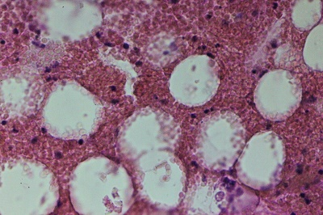
2
2
1
Pic. 1. Bone marrow near the site of the defect on 3rd days after damage of bone fabric: 1 – infiltration of erythrocytes; 2 – undifferentiated cells. Carats with hematoxylin and eosin, x400.
In the central part of the bone marrow-like defect, or remotely from a microscopic changes during this period of observation we were not registered. However, in the center of the bone marrow was extremely expressive extended Vienna filled with red blood cells, which ran parallel to the inner surface of the bone along the bone (pic. 2).

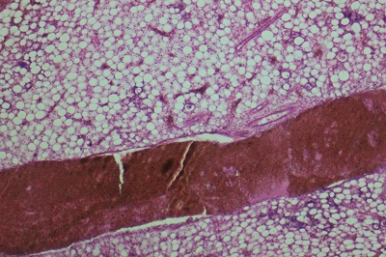
Pic. 2. The Central part of the bone marrow near the site of the defect on 3rd days after injury: dilated, filled with blood the Central vein (arrow). Carats with hematoxylin and eosin, x50.
On 7th day in bone marrow near the site of the defect was recorded a pronounced proliferation of immature cells and few megakaryocytes (pic. 3). From the defect to the opposite part of the bone tube through the bone marrow perpendicular to the location of the defect took place the cord of dense fibrous connective tissue.
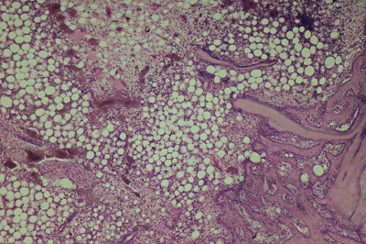
4
3
2
1
Pic. 3. The location of the defect on 7th day after damage: 1 – osteogenesis; 2 – bone marrow; 3 – proliferation of immature cells; 4 – a cord of dense fibrous connective tissue perpendicular to the location of the defect. Carats with hematoxylin and eosin, x50.
In the bone marrow remotely from the location of the defect is recorded the extension and overflow of blood of blood capillaries (pic. 4).

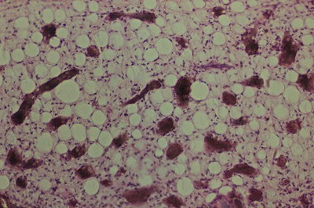
2
1
Pic. 4. The central part of the bone marrow to the site of the defect on 7th day after damage: 1 – immature cells; 2 – extended, blood-engorged blood capillaries. Carats with hematoxylin and eosin, x100.
On 14th day close to the location of the defect, the bone marrow was found growths of fibrous connective tissue and rather intense osteogenesis with the formation in this area of the bone adjacent to the surface on the defect of newly formed bone (pic. 5).

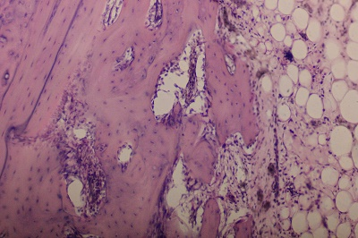
5
4
3
2
1
Pic. 5. The location of the defect on 14th day after injury: 1 – newly formed bone; 2 – the surface of newly formed bone site; 3 – bone marrow; 4 – fibrous connective tissue; 5 – osteogenesis in the bone marrow. Carats with hematoxylin and eosin, x100.
21st day of microscopic changes in the bone marrow in the defect was similar to those observed on 14th day (pic. 6).
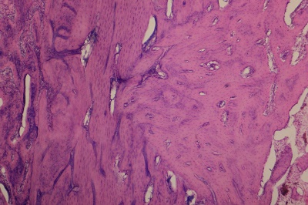
4
3
2
1
Pic. 6. The location of the defect on 21st days after injury: 1 – newly formed bone; 2 – osteon; 3 – the inner part of the callus; 4 – bone marrow. Carats with hematoxylin and eosin, x50.
On 28th day from the bone marrow of newly formed bone surface was still uneven. Here still showed clear bone formation. Single, small, very widely spaced foci of osteogenesis were also in the thickness of bone tissue from the bone marrow (pic. 7). In the bone marrow near the site of the defect we recorded isolated small foci of proliferation of immature cells and hemorrhage.
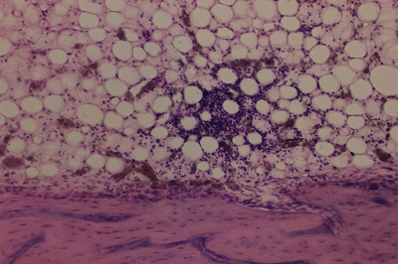
5
4
3
2
1
Pic. 7. The location of the defect on 28th days after injury: 1 – bone marrow; 2 – lesion of proliferative immature cells; 3 – newly formed bone tissue; 4 – hemorrhage 5 – osteoblasts. Carats with hematoxylin and eosin, x100.
On 42nd days in the bone marrow near the site of the defect was recorded and extended blood-engorged blood capillaries (pic. 8).
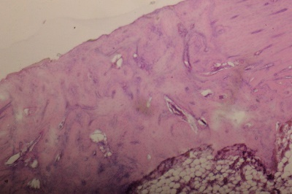
4
3
2
1
1
Pic. 8. The location of the defect on the 42nd day after injury: 1 – intact bone on the side of the place of the defect; 2 – newly formed bone; 3 – bone marrow; 4 – hyperemia of the capillaries. Carats with hematoxylin and eosin, x50.
Any other microscopic changes of bone marrow during experimental studies we have not established.
Conclusions:
1. We established that mechanical damage of bone tissues causes a pronounced reaction from the bone marrow near the site of the defect.
2. It was investigated that near the defect, and remotely from places microscopic changes in the bone marrow were observed only from 3 to 7 days, where he recorded the extension and overflow of blood capillary and vein.
3. It is proved that in the bone marrow at the site of the defect on the 3rd day there medeteranian cells from 7th to 28th days, there is a clear proliferation of immature cells.
4. It is established that in the bone marrow at the site of the defect on 14th day intensive osteogenesis which stayed on 42nd days.
Prospects for further research. It is planned to analyze changes in histological studies, led by stem cells in the injured bone.

BIBLIOGRAPHY

- Горальський Л. П. Основи гістологічної техніки і морфофункціональні методи досліджень у нормі та при патології : навч. посіб. / Л. П. Горальський, В. Т. Хомич, О. І. Кононський. – Житомир : Полісся, 2005. – 228 с.
- Дедух Н. В. Регенерация кости: основные тенденции развития проблемы / Н. В. Дедух,
Е. А. Побел // Боль. Суставы. Позвоночник. – 2013. – №1. – С. 89–90.
- Джонс Л. М. Ветеринарна фармакологія і терапія / Л. М. Джонс ; пер. к. вет. н. А. С. Вишкера. – М., 1972. – Т. 2. – С. 640–641.
- Корж Н. А. Репаративная регенерация кости: современный взгляд на проблему. Стадии регенерации / Н. А. Корж, Н. В. Дедух // Ортопедия, травматология и протезирование. – 2006. – №1. –
С. 76–84.
- Петренко О. Ф. Гістологічні зміни при загоюванні переломів трубчастих кісток у великої рогатої худоби / О. Ф. Петренко, Б. В. Борисевич, В. В. Лісова // Науков. вісник Нац. аграр. ун-ту. – Вип. 42. – К., 2001. – С. 87–90.
- Yoon S. T. Osteoinductive molecules in orthopaedics: basic science and preclinical studies /
S. T. Yoon, S. D. Boden // Clin. Orthop. – 2002. – Vol. 395. – P. 33–43.

