© 2016
Mykolayko V. P., PhD in Agriculture
Uman National University of Horticulture
THE PECULIARITIES OF GROWTH OF CICHORIUM INTYBUS SEED PLANTS DEPENDING ON MINERAL NUTRITION
The results of studies of the influence of mineral nutrition on roots establishment, plant density in a phase of full growth, plant height and number of shoots have been highlighted. It was stressed that the use of complex of agricultural measures provided high root establishment, which ranged from 89,4 to 93,8 %. The high root establishment ensured optimal seed density, which is close to the planned one. It was found that the increase of Cichorium intybus height depended both on mineral fertilizers, schemes of its planting, and on the drip irrigation. It was mentioned that the use of fertilizers, especially nitrogenous and potassium N₄₅K₇₀ has provided the largest increase in plant height and formation of shoots of first and second order as in control – without irrigation, as well as in drip irrigation.
Key words: root, Cichorium intybus, fertilizers, establishment, scheme of planting, plant density, height of plants, irrigation.
Statement of the problem. Cichorium intybus is one of the highly productive crops of diverse use. It is a valuable medicinal, food and fodder plant. Along with the cultivation of other technical crops chicory is economically profitable one, which raw material is used in the food, pharmaceutical and other industries [5, 6].
While developing the system of agricultural crops fertilization we must use the right approach in terms of current decline of natural soil fertility and high environmental burden on them. An efficient use of fertilizers is one of the major problems in plant growing. Evidence-based fertilizer system should ensure a high crop capacity with optimal indices of product quality, improvement or differentiated maintain of soil fertility in terms of environmental safety compliance [3]. Chicory is sensitive to the lack of nutrition elements, and without an adequate provision of plants with necessary mineral nutrients, it is almost impossible to receive high yield in optimal periods.
The analysis of recent research and publications which started solution of the problem. Efficiency of mineral fertilizers depends on the ratio of nutrition elements, and forms of fertilizers. For the same amount of active compound, different forms of fertilizers provide different results due to physiological characteristics of plants. It is found that superphosphate is one of the phosphate fertilizers for chicory on sod-podzolic and gray forest soils. Urea and saltpeter are good form of nitrogen fertilizer on all types of soils. No chlorine compounds are the best for chicory from potash fertilizer. The optimum ratio of NPK is 2:1:4, which positively affects the yield and chemical-technological characteristics of chicory root [2].
However, irrational use of mineral fertilizers with today's very high market prices for them can significantly reduce the production profitability, which may lead to crop unprofitableness. Therefore, when calculating doses of fertilizers for chicory we considered the need of seed in the nutrition elements to form the yield, the content of available for plant nutrients in the soil and fertilizers.
The research of N. Avdonin [1] showed that chicory use phosphate fertilizers in the initial phase of its growth and development, potash ones – in the third month of vegetation, and nitrogen throughout the whole growing season. According to V. Lapa [4], while increasing the doses of nitrogen fertilizers the nitrogen yield increased, to a lesser extent – potassium and phosphorus yield is almost unchanged. During the vegetation chicory uses 31 % of phosphorus and 54 % of potassium from soil, while the use of potassium is increased with its common use with phosphorus. In other words, Cichorium intybus plants consume less phosphorus than nitrogen and potassium.
The aim is to study the effect of mineral nutrition for roots establishment, plant density in the phase of entire growth depending on the scheme of root crops planting in terms of drop irrigation and biometric indicators, including plant height and number of shoots.
Methodology of the reseach. As the starting material for the study we took breeding numbers and chicory varieties, which as a result of selection have been received at Uman’ Experimental Breeding Station of the Institute of bioenergetic crops and sugar beet of NAAS. Experimental studies were performed at the same station during 2012–2015.
Soils of Uman’ experimental breeding station are characterized by a high content of moving phosphorus compounds – 96,3 mg/kg and exchangeable potassium – 62,5 mg/kg (based on Chirikov’s method) and low nitrogen content of easily hidrolysed compounds – 12,7 mg/kg of soil (based on Kornfild’s method). Taking into consideration the study results [1, 2, 4] and the availability of soil by mineral nutrients of the experimental plots, this scheme envisages the entry of nitrogen and potash fertilizers in spring before planting root crops both separately and together.
Statistical data calculation was performed by variance analysis based on Fisher [7].
Results of research. The creation of favorable conditions for high potential productivity of variety is one of the main directions of chicory productivity increase. The whole complex of agrotechnological measures should be aimed at ensuring optimal conditions of physiological processes conducting, which determine high productivity of plants.
Roots establishment is one of the important factors that affects plant density and therefore the productivity of seed plants. The high establishment of roots with soil, climatic and agrotechnical conditions ensures optimal conditions for plant growth, the development of chicory, high yield and seed quality. In all variants root establishment was high and ranged from 89,4 to 93,8 % (Table 1).
1. Root establishment and their density of plants in the stage of entire growth in terms of drop irrigating (average for 2012–2015)
Variant |  |  | Plant establishment, % | Plant density in the phase of entire growth
Irrigation | Planting scheme | Fertilizers | Plant establishment, % | Plant density in the phase of entire growth
Control (without irrigation) | 60×45 | Without fertilizers | 90,7 | 33,6
Control (without irrigation) | 60×45 | N₄₅ | 91,1 | 33,7
Control (without irrigation) | 60×45 | K₇₀ | 91,0 | 33,7
Control (without irrigation) | 60×45 | N₄₅K₇₀ | 90,6 | 33,5
Control (without irrigation) | 45×25 | Without fertilizers | 89,5 | 79,6
Control (without irrigation) | 45×25 | N₄₅ | 89,4 | 79,5
Control (without irrigation) | 45×25 | K₇₀ | 89,5 | 79,6
Control (without irrigation) | 45×25 | N₄₅K₇₀ | 89,7 | 79,7
Irrigation. Humidity of soil is 60 % from the least moisture capacity during vegetation | 60×45 | Without fertilizers | 93,2 | 34,5
 | 60×45 | N₄₅ | 93,1 | 34,6
 | 60×45 | K₇₀ | 93,5 | 34,6
 | 60×45 | N₄₅K₇₀ | 93,8 | 34,7
 | 45×25 | Without fertilizers | 92,3 | 80,4
 | 45×25 | N₄₅ | 92,4 | 80,5
 | 45×25 | K₇₀ | 92,4 | 80,5
 | 45×25 | N₄₅K₇₀ | 92,3 | 80,7
Irrigation. Humidity of soil till the blossom stage is 60 %, till gathering is 80 % from the least moisture capacity | 60×45 | Without fertilizers | 93,6 | 34,6
 | 60×45 | N₄₅ | 93,4 | 34,6
 | 60×45 | K₇₀ | 93,8 | 34,7
 | 60×45 | N₄₅K₇₀ | 93,7 | 34,7
 | 45×25 | Without fertilizers | 92,9 | 80,3
 | 45×25 | N₄₅ | 92,7 | 80,4
 | 45×25 | K₇₀ | 92,7 | 80,4
 | 45×25 | N₄₅K₇₀ | 93,4 | 80,5
НІР _{05 of irrigation} |  |  | 1,5 | 6,7
НІР _{05 of the planting scheme} |  |  | 0,4 | 1,9
НІР _{05 of fertilizers} |  |  | 1,1 | 4,7
A significant difference in roots establishment depending on mineral nutrition was not found both in control – without irrigation, as well as in drip irrigation. Using drip irrigation the establishment was significantly higher than in control of both schemes of seed planting regardless of mineral nutrition level. Thus, if in the control without irrigation and fertilizers according to the scheme of planting root crops of 60×45 cm the establishment was 90,7 %, then in terms of drip irrigation under the same scheme of planting it increased by 2,5 and 2,9 % and amounted 93,2 and 93,6 % (НІР_{05 irrigation}=1,5 %). A similar percentage of increase of the root crops establishment could be followed at the planting schemes of 45×25 cm. By reducing the area of seed plants nutrition (planting scheme of 45×25 cm) one can follow a significant decrease in the percentage of establishment, compared with planting scheme of 60×45 cm. Thus, in the control without irrigation and fertilizers at planting scheme of 60×45 cm the establishment was 90,7 %, and under the planting scheme of 45×25 cm, it decreased by 1,2 %. In monitoring of the fertilizers usage the establishment of root plants scheme of 45×25 cm reduced by 0,9–1,7 %, compared with planting scheme of 60×45 cm (НІР_{05 planting scheme}= 0,4 %). A similar decrease in the percentage of root plants establishment is mentioned in terms of drip irrigation.
When processing the data of dependencies between chicory establishment and agrotechnical measures that were studied, it is important to clarify the impact of each measure, and especially fertilizers. Thus, according to the results of our research it was found that the fertilizer had no significant effect on the establishment of plants. A range of drip irrigation (the share of impact was 67,3 %) and root planting scheme (the share of impact was lower and amounted to 9,6 % (pic. 1)) had the main impact on the plants establishment. It indicated that chicory seeds cultivation under drip irrigation could achieve a high percentage of plants establishment. The share of impact of fertilizers was low – 0,3 %.
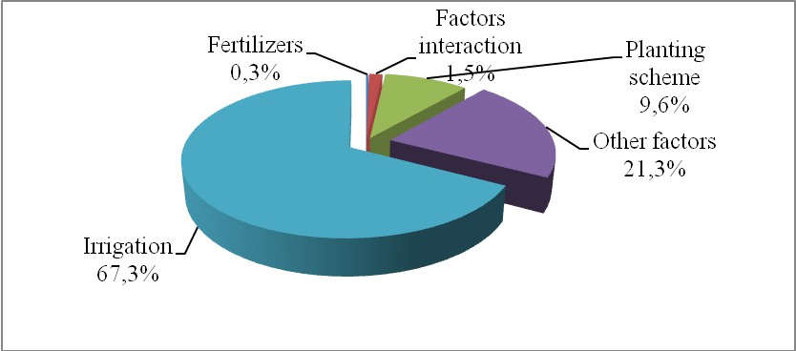
Pic. 1. The share of factors’ impact on the plants establishment depending of agricultural measures
The high establishment of roots ensured the formation of optimal seed density, which was close to the planned. We created a uniform background to study the efficiency of mineral nutrition, planting schemes and drip irrigation on seed plants biometric indicators, photosynthetic capacity, the formation and maturation of seeds. The density of plants in the phase of entire growth in control without fertilizers under the planting scheme of 60×45 cm was 33,6 thousand/ha, and in areas (control) with fertilizers – 33,5–33,7 thousand/ha. In terms of drip irrigation with the same scheme the planting density ranged from 34,5 to 34,7 thousand/ha. We could not see a significant difference by this indicator. Similar results were obtained under the root crops planting scheme of 45×25 cm, but plant density was significantly higher than under the planting scheme of 60×45 cm. It was caused by higher amount of planted roots – dense planting under the scheme of the experiment.
The intensity of the ground mass increase in the ontogenesis of plants depends not only on the weather in the growing season, but also on the methods of its cultivation. The research proved that the increase of chicory plant height depended both on their planting schemes, mineral fertilizers, and on the drip irrigation (Table 2).
2. Biometric indicators of seed plants depending on the agrotechnical measures of its cultivation
(average in 2012–2015)
Variant |  |  | Plant height, cm | The number of shoots
Irrigation | Planting scheme | Fertilizers | Plant height, cm | total | І order | ІІ order | ІІІ order
Control (without irrigation) | 60×45 | Without fertilizers | 147 | 29 | 9 | 20 | 0
Control (without irrigation) | 60×45 | N₄₅ | 158 | 34 | 10 | 22 | 2
Control (without irrigation) | 60×45 | K₇₀ | 147 | 29 | 8 | 21 | 0
Control (without irrigation) | 60×45 | N₄₅K₇₀ | 160 | 38 | 11 | 24 | 3
Control (without irrigation) | 45×25 | Without fertilizers | 154 | 21 | 7 | 14 | 0
Control (without irrigation) | 45×25 | N₄₅ | 160 | 26 | 8 | 15 | 3
Control (without irrigation) | 45×25 | K₇₀ | 157 | 21 | 7 | 14 | 0
Control (without irrigation) | 45×25 | N₄₅K₇₀ | 163 | 29 | 9 | 16 | 4
Average |  |  | 156 | 28 | 9 | 18 | 2
Irrigation. Humidity of soil is 60 % from the least moisture capacity during vegetation | 60×45 | Without fertilizers | 180 | 46 | 14 | 24 | 8
 | 60×45 | N₄₅ | 188 | 51 | 16 | 26 | 9
 | 60×45 | K₇₀ | 179 | 44 | 16 | 24 | 4
 | 60×45 | N₄₅K₇₀ | 192 | 54 | 18 | 27 | 9
 | 45×25 | Without fertilizers | 184 | 33 | 13 | 20 | 0
 | 45×25 | N₄₅ | 191 | 42 | 14 | 22 | 6
 | 45×25 | K₇₀ | 182 | 31 | 12 | 19 | 0
 | 45×25 | N₄₅K₇₀ | 194 | 46 | 15 | 23 | 8
Average |  |  | 186 | 43 | 15 | 23 | 6
Irrigation. Humidity of soil till the blossom stage is 60 %, till gathering is 80 % from the least moisture capacity | 60×45 | Without fertilizers | 182 | 37 | 14 | 22 | 1
 | 60×45 | N₄₅ | 186 | 42 | 15 | 23 | 4
 | 60×45 | K₇₀ | 180 | 34 | 14 | 20 | 0
 | 60×45 | N₄₅K₇₀ | 190 | 47 | 16 | 26 | 5
 | 45×25 | Without fertilizers | 187 | 34 | 16 | 17 | 1
 | 45×25 | N₄₅ | 191 | 36 | 16 | 18 | 2
 | 45×25 | K₇₀ | 186 | 31 | 15 | 16 | 0
 | 45×25 | N₄₅K₇₀ | 198 | 40 | 18 | 20 | 2
Average |  |  | 188 | 38 | 16 | 20 | 2
НІР _{05 irrigation} |  |  | 5,1
НІР _{05 planting scheme} |  |  | 1,5
НІР _{05 fertilizers} |  |  | 3,6
The most significant increase in plant height and formation of shoots of the first and second order with the seed formation was ensured by drip irrigation. On average by the experiments, using the drip irrigation, the seed plants were higher on 30–32 cm, and shoots of the first and second order were more than 5–7 pieces/plant compared to the control without irrigation. However, at various levels of ensuring the seed by humidity, a significant difference in the height of plants and the number of shoots of the first and second orders was not found. Thus, if the soil humidity was 60 % of HB during the growing season, the seed height was 186 cm, the humidity in 60 % to the flowering phase and 80 % in interphase period it was 188 cm. It was due to the biology of plants. An intense gain of ground mass is carried out before flowering, and during the interphase period «flowering–seed ripening» the nutriments are spent mainly on the formation of generative organs and seed formation, but not to gaining of ground mass.
The use of fertilizers and especially together nitrogen and potassium N₄₅K₇₀ ensured the largest increase in plant height and formation of shoots of the first and second orders as in control – without irrigation, as well as in drip irrigation. In terms of drip irrigation, the seed plants were significantly higher and they had more shoots of the first and second orders in all versions with fertilizers, compared with the control – without fertilizers and with fertilizer but without irrigation. When using only potash fertilizers the plant height and number of shoots at them of the first and second orders were on the level of control – without fertilizers and without irrigation, and both without and with its use. Using only nitrogen fertilizer ensured the gain of plants height compared with control – without fertilization and with the variant, where only potash fertilizers had been used and we could follow the tendency to shoots increasing of the first and second orders.
A significant increase in the height of seed had been indicated depending on their placement schemes both in control and in terms of drip irrigation. Under the planting schemes of 45×25 cm, in all versions the seed plants were significantly higher than in the planting scheme of 60×45 cm as in a control – without irrigation, as well as with drip irrigation. And vice versa, by reducing the area of seed plants nutrition (scheme of planting of 45×25 cm) each seed plant had less shoots of the first and second orders, than on the seed plants, which had a large area of nutrition (planting scheme of 60×45 cm).
In determining the factors that influence the height of the seed depending on the agrarian measures it was found that the influence of the «irrigation» was the largest and was 83,5 % (pic. 2).
The proportion of impact of such factor as «fertilizers» was lower and amounted 8,3 %, the lower impact had the factor «planting scheme» - 2,4 %. Interaction of factors had little effect on plant height.
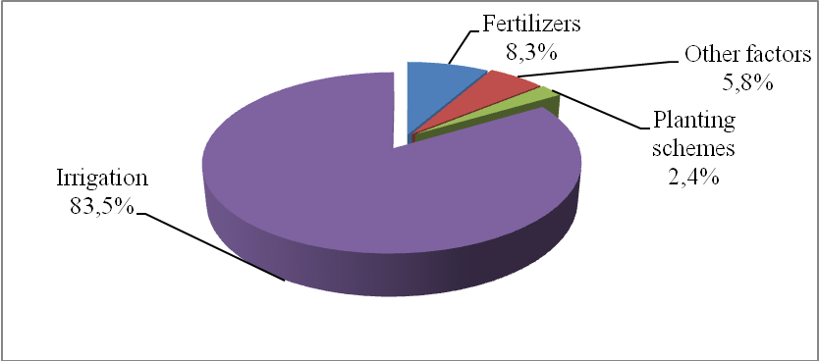
Pic. 2. The share of factors’ impact on the chicory seed plants height (average in 2012–2015).
Conclusion and prospects. The use of complex of agricultural measures ensured high establishment of roots, which ranged from 89,4 to 93,8 %. A significant difference on this indicator depending on mineral nutrition was not found.
The increase of chicory plants height depended both on fertilizer, its planting schemes, and on the drip irrigation.
It is found that the use of fertilizers, especially nitrogen and potassium N₄₅K₇₀ ensured the largest increase in plant height and formation of shoots of the first and second orders as in a control – without irrigation, as well as in drip irrigation.
BIBLIOGRAPHY
- Авдонин Н. С. Цикорий / Н. С. Авдонин. – М., 1935. – С. 34.
- Вильчик В. А. Цикорий / В. А. Вильчик // Ярославль : Верх-Волж. кн. изд-во, 1982. – С. 38.
- Лапа В. В. Влияние удобрений на урожайность и качество озимого тритикале на дерново-подзолистой легкосуглинистой почве / В. В. Лапа, В. Н. Босак, H. A. Близнюк // Агрохимия. – 2005. – №7. – С. 25–28.
- Лапа В. В. Продуктивность зернового севооборота и плодородие дерново-подзолистой супесчаной почвы при различной системе применения удобрений / В. В. Лапа // Агрохимия. – 2003. – №1. – С. 20–29.
- Шичева Л. А. Ботаническое описание цикория / Л. А. Шичева // Цикорий. – М. : изд-во ВНИИ сырья спиртовой промышленности, 1935. – с. 17–25.
- Яценко А. О. Цикорій: біологія, селекція, виробництво і переробка коренеплодів / А. О. Яценко. – Умань, 2003. – 157 с.
- Fisher R. A. Statistical methods for research workers / R. A. Fisher. – New Delhi : Cosmo Publications, 2006. – 354 р.

