© 2016

Marenych M. M., PhD of Agricultural Sciences,
Yurchenko S. O., PhD of Agricultural Sciences
Poltava State Agrarian Academy
SOWING PROPERTIES OF SEED OF AGRICULTURAL CULTURES DEPENDING ON APPLICATION OF GROWTH STIMULANT
Reviewer – Doctor of Agricultural Sciences, Professor M. Ya. Shevnikov
The results of researches of sowing properties of seed which was treated by new humic preparations (which are made by a company «Soil Biotics», USA) are presented in the article. In laboratory terms we probed stimulant effect on germination energy, laboratory germination, intensity of growth of organic mass and flowing of growth processes. We found that treatment of seed by preparation «Seed treatment» favors to more rapid growth of organic mass, activating of water absorption ability of seed and intensifies growing processes. We noted the positive influence of preparation on the growth processes on condition of treatment exposure 45 days. Application of preparation «Foliar concentrate» also strengthened growth processes and stimulates the growth of sprouts root mass.
Keywords: seed, stimulants, energy of germination, likeness, germination processes.

Statement of the problem. Scientific researches prove that treatment of seed before sowing by a growth stimulant preparations provides a rapid and good germination, increases resistance of plants to such unfavorable factors as a lack of moisture and defeat illnesses, considerably improves competition properties of cultural plants concerning weeds. In a modern plant-grower this problem is decided with the help of means of chemical protection which negatively influences on an environment, quality of products and harms the health of user.
Analysis of the last researches and publications concerning this problem. A lot of researches are devoted application of humin substance, including Ukrainian scientific periodicals. Humus substances favourably influence on permeability of cellular membranes, activate activity of enzymes, processes of albumens synthesis, carbohydrates, promote of breathing intensity, the intensity of water exchange which in same queue results in improvement of plants growth. Especially it is perceptibly when the processes of plants treatment are begun with preparations on the early stages of development. It is necessary to take into account that the positive action of humates increases in the extreme terms of growing – lack of moisture, salinity, high or low temperatures, surplus concentration of fertilizers and pesticides [4, 6, 1].
Researches from determination of humates influencing, which were conducted by the scientists of Institute of Agriculture of Steppe Area of NAAS, were illustrated that in the case of their use the field germination rose in relation to control on 3,1–4,2 %. Application of humates stimulated increase of plants survival on 4,5–4,8 %. It is also important that the positive influencing of humates proceeds after the germination of seed, – length of counterfoils of the best plants exceeded control indexes on 18,8–29,2 %, and relatively to option-standard with biological preparation «Rizogumin» – on 10,7–20,4 % [2].
Applications of seed disinfectants which have humic substances in their composition helps in the accumulation of sugar by the winter wheat, assists development of the second root system, promotes the coefficient of bushing out at plants, that increases winter hardiness of crops [3, 7].
Application of «Humicol» and «Lignohumate» enables considerably to increase the area of sheet surface in the next stages of plants’ development.
The purpose of researches was to find out the influencing of perspective preparations which created on the basis of «Leonardite» on sowing properties of seed and intensity of growth processes on the initial stages of plants’ growth. The followings tasks were formulated for this purpose:
- To define influence of preparations «Seed treatment» and «Foliar concentrate» on germination energy and seed germination in laboratory terms;
- To define influence of treatment display on sowing properties and processes of growth of plants on the initial stages;
- To do the chemical analysis of organic mass.
Materials and methods of researches. We conducted researches in the Laboratory of quality of grain of Poltava State Agrarian Academy. Material for an experiment was the samples of seed of winter wheat, corn, sunflower and soy. Seed was processed the made to order doses of perspective humic preparations of company «SoilBiotics» (USA): «Seed treatment» is 3 kg/t seed and «Foliar concentrate» is 6 kg/ha. The repeated conducting of researches was fourfold. For processing the results we used methods of dispersion analysis and assessment of the materiality of the difference between means by
t-test [5]. Germination was determined in accordance with conventional procedure.
Results of researches. The positive action of growth stimulant of plants which created on the basis of organic raw material registers in all scientific researches. Debatable is only question of norms of bringing and doses of preparation for treatment of seed. In our view they very often are unmotivational understated. In particular the analysis of scientific and practical recommendations for application of preparations shows that norms applications which recommend a producer and salesman of products can differ in dozens times!
Application of humic preparations for treatment of seed or bringing of them in laboratory substrates has a positive effect. The results of laboratory analyses testify to the noticeable tendency of growth of such indexes of initial development of plants as mass of sprouts, length of counterfoil and length of stems which were determined in the moment of determination of index of seed germination (table 1).
Table 1. Results of influencing of seed treatment of the field cultures by preparation
«Seed treatment» on the indexes of development of plants
Culture | Variant | Middle mass of sprouts, g | Middle length of counterfoil, cm | Length of stem, cm
Sunflower | Control | 0,19
 | «Seed treatment» | 0,29*
Soy | Control | 0,57 | 3,82
 | «Seed treatment» | 0,56 | 4,16*
Winter wheat | Control | 0,14 | 7,91 | 7,55
 | «Seed treatment» | 0,16 | 9,31* | 7,97
Corn | Control | 0,49 | 8,04 | 3,6
 | «Seed treatment» | 0,54 | 7,76 | 4,33*
*a difference is substantial at the level of meaningfulness 0,05
From information of table the mass of sprouts of sunflower grew on 52,6 %. This index on a winter wheat was 14,3, and on a corn it was 10,2 %. Soy was the unique culture where the seed treatment did not affect the mass of sprouts. However, much length of counterfoil was greater on 0,34 cm more long comparatively with a control variant which makes almost nine percents.
Thus, also it should be noted that on a wheat the winter crop of increase of length of counterfoil comparatively with control made 1,4 cm or 17,7 %, and length of stem of sprout grew in this case on 0,42 cm that was about 6 %.
The insignificant diminishing of length of counterfoil in experiments with a corn comparatively with a control variant was statistically unreliable and did not exceed the error of experience, but length of stem grew substantially – it was almost 0,7–0,8 cm or on the average 20,3 %.
The visual review of sprouts testifies about the positive action of «Seed treatment» (see picture).
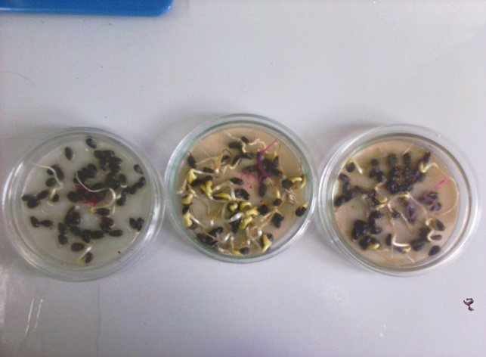
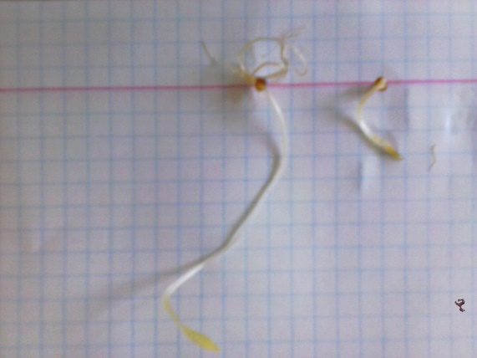
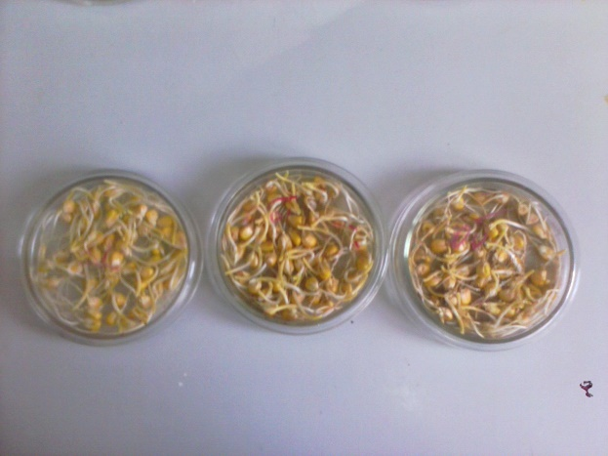

Picture. Results of treatment of seed by preparation «Seed treatment» (SoilBiotics)
The results of the use of treatment of seed of soy with the display of self-control of the treated seed during 45 days appeared interesting enough. Most recommendations from application of humic preparations for treatment of seed are talked about the necessity of their application immediately before sowing. However the producer of preparations (SoilBiotics) recommends also to process seminal material preliminary too.
In our experiments with the seeds of soy of different quality there was a tendency to growth of economic-valuable signs (table 2). Data of table testify that treatment by preparation positively influenced on growth, especially in the seed of soy which are characterized by the low value of this index. An increase of length of sprouts of soy was 50,9–83,7 %. Length of sprouts of wheat grew on almost 46 %.
Table 2. Treatment of seed of sorts of soy and wheat by the made to order doses of preparation
«Seed treatment» (duration of display is 45 days)
Variant | Germination, % | Middle length of sprouts, cm | Middle mass of sprouts, g
Variety of soy «Almaz»
Control* | 40 | 6,78 | 0,17
«Seed treatment» | 62 | 10,2** | 0,17
Variety of soy «Anthracite»
Control | 12 | 4,6 | 0,14
«Seed treatment» | 58 | 8,45** | 0,15
Variety of wheat «Vdala»
Control | 68 | 4,68 | 0,07
«Seed treatment» | 77 | 6,82** | 0,09
** a difference is substantial at the level of meaningfulness 0,01
The positive action of display is explained that preparation gradually gets into the seed and has a time for greater absorption. Components of preparation contribute in absorption of water by seed and sprouts.
The next preparation which is recommended for application by company «SoilBiotics» is «Foliar concentrate». Main advantage of this preparation is its considerable universality during practically all period of vegetation of cultures and unique amount of humic acids comparatively with other known preparations.
In our experiments from the study of seed germination on a control variant for watering ordinary water was used, and on an experimental variant – water mixture of the made to order norm of «Foliar concentrate» (table 3).
Growth of mass of plant of winter wheat did not exceed 6 %, but length of stem here grew on 20,2 %. On a corn mass of plant grew on 18,2 %, length of root grew on 18,4 %, and length of stem grew on almost 87,1 %.
Table 3. Results of laboratory tests of preparation «Foliar concentrate»
Culture |  | Variant |  | Mass of plant, g |  | Length of root, cm |  | Length of stem, cm
Winter wheat | Control |  | 0,17 |  | 7,98 |  | 3,82
Winter wheat | «Foliar concentrate» |  | 0,18 |  | 8,13* |  | 4,59
Corn | Control |  | 0,66 |  | 8,84 |  | 3,57
Corn | «Foliar concentrate» |  | 0,78 |  | 10,47** |  | 6,68**
* a difference is substantial at the level of meaningfulness 0,05;
** a difference is substantial at the level of meaningfulness 0,01
Conclusion. Treatment of seed of agricultural cultures by preparations which are created on the basis of humic and fulvic acids stimulate increase of sowing properties of seed of agricultural cultures. Above all things it touches an assistance development of the root system and sprout in the whole on the stages of germination. Treatment of seed during 45 days prior to sowing contributed in growth of germination on 9–22 %.

BIBLIOGRAPHY

      - Гончаренко М. П. Рекомендации по применению гумата натрия под сельскохозяйственные культуры / М. П. Гончаренко. – Днепропетровский Государственный Аграрный Университет. – 1991. – 22 с.
      - Ефективність передпосівної обробки насіння гороху гуматмікроелементними препаратами в умовах північної підзони Степу [Електронний ресурс] / [Мусатов А. Г., Сидоренко Ю. Я., Бочевар О. В., Ільєнко О. В.] // Бюлетень Інституту зернового господарства. – 2010. – №38. –
С. 74–77. – Режим доступу : http://nbuv.gov.ua/UJRN/bisg_2010_38_17.
      - Каленський В. П. Морозостійкість сортів пшениці озимої в осінньо-зимовий період органогенезу залежно від удобрення та передпосівної обробки насіння [Електронний ресурс] / В. П. Каленський, Л. М. Гончар // Науковий вісник Національного університету біоресурсів і природокористування України. Серія : Агрономія. – 2012. – Вип.176. – С. 33–40. – Режим доступу : http://nbuv.gov.ua/UJRN/nvnau_agr_2012_176_6.
      - Козаренко Д. О. Застосування гуматів – перспективний метод зменшення хімічного навантаження на агроценози / Д. О. Козаренко // Карантин і захист рослин. – 2013. – №8. –
С. 14–16.
      - Насіння сільськогосподарських культур. Метод визначання якості : ДСТУ 4136–2002. – [Чинний від 2004.01.01]. – К. : Держспоживстандарт України, 2003. – 173 с. – (Держспоживстандарт України).
      - Сергієнко В. Рістрегулюючий та захисний ефект гумінових речовин / В. Сергієнко // Агробізнес сьогодні. – 2001. – №7. – С. 26–29.
      - Улянич О. І. Вплив передпосівної обробки насіння регуляторами росту на урожайність салату посівного [Електронний ресурс] / О. І. Улянич, В. В. Кецкало // Збірник наукових праць [Інституту біоенергетичних культур і цукрових буряків]. – 2012. – Вип.14. – С. 356–359. – Режим доступу : http://nbuv.gov.ua/UJRN/znpicb_2012_14_102.

