© 2016
Prykhod’ko R. P., PhD of Technical Sciences
Institute of Problems of Strength named after G. S. Pysarenko
Time-temperature approach to assess of the longevity of critical structural elements
Reviewer – Doctor of Technical Science, Professor A. V. Goryk
An analysis of results of the extrapolation of stress rupture curves is performed using the modified base diagram method. The efficiency of the offered algorithms for predicting the creep rupture longevity with the prediction order equal to two or more on the logarithmic time scale is shown. The application areas of the known parametric methods for predicting the stress-rupture strength of materials are specified based on the experimental investigations. It is shown that these methods allow extrapolating the time destruction to the values that exceed the available experimental data by no more than a factor of 10 times with accuracy sufficient for engineering purposes. To extend the prediction capabilities to 300 thousand hours or more on the basis of the test results of limited duration, a modified base diagram method is offered. A linear dependence is offered to approximate the residual function in terms of the base diagram method. In the case where it is impossible to reduce the stress-rupture curves to a common curve, the residual function parameters are determined from the experimental data for one isotherm. In this case, its parameters are the functions of temperature. The advantages of this parameters’ approach according to Larson-Miller, Orr-Sherby-Dorn, Manson-Succop, Trunin and other are shown during the extrapolation of stress-rupture strength to big longevity.
Keywords: modified base diagram method, extrapolation, creep rupture curves, parametric methods.

Statement of the problem. From year to year, the problem of assessment and extension of the life of critical structural elements of long-term use becomes more and more urgent. A reliable life prediction calls for the availability of sufficiently full information on the material behavior under different conditions of thermo-mechanical loading. A basis for performing the required analysis and making further appropriate decisions is the experimental data on the lifetime and working stress. The obtainment of the proper experimental results under actual conditions is quite time-consuming, since the investigation it can take from several days to tens of years, which, first of all, requires high costs. Thus, the investigation on the refinement of the known approaches and development of new models for extrapolation of creep rupture curves is a pressing problem.
Analysis of recent research and publications, which discuss this problem. The Larson-Miller, Orr-Sherby-Dorn, Manson-Haferd and Trunin’s time-temperature parameters or relations are the most common methods of extrapolation of creep-rupture curves [5–8]. These relations allow to obtain a common relation between the stress, time to rupture and testing temperature, which makes it possible to solve problems of both interpolation and extrapolation based on the known experimental data on the longevity in a wide range of temperatures.
The basis for the parametric methods is the single curve hypothesis, according to which all creep-rupture curves are reduced to a single averaged curve. The function that approximates the experimental results can be presented in the form:
or | (1)
where is the actual stress, is the lifetime of the material at const, is some parameter dependent on two variables, usually on , is the absolute temperature. In the case of the strained stress state, denotes the equivalent stress [3, 4].
Parametric methods can be used to describe the mechanical behavior of the medium with certain restrictions on the type of creep-rupture strength curves for materials. These restrictions are caused by that these methods were created for the evaluation of experimental data by interpolation. Therefore, their use in the extrapolation of creep-rupture strength data is reasonable for short lifetimes corresponding to the prediction order of no more than order 1 on the logarithmic scale. It can be quite easily explained by constructing of the corresponding approximation function for each of the methods.
V. V. Krivenyuk’s base diagram method [1] analyzed by us has a somewhat different approach to the creep-rupture strength evaluation. In this method, the basis for the prediction is the defined basic functions, which are considered to be of the same type and constant for all known materials. The determination of design factors according to this method is performed based on the statistical treatment of experimental and base diagrams. The use of this method, as compared to the parametric methods, allows the longer lifetime prediction covering approximately two orders of magnitude in the logarithmic coordinate system. The interpolation analysis by the base diagram method is more informative: from the change in the calculated parameter it is possible to conclude about the character of the change in the material behavior during the whole experimental investigation. Despite the numerous advantages of this method for long-term creep-rupture strength prediction, it has not gained widespread acceptance in the engineering practice through its main limitation – the incompleteness of the investigations on the determination of temperature and actual stress ranges within which its initial parameters can be used to predict the lifetime of heat-resistant materials.
The purpose of research is the development and improvement of creep-rupture strength extrapolation methods in a wide range of temperatures and stresses.
Task of research is statements of accurate algorithm of an assessment of durability of responsible elements of designs, proceeding from limited experimental selection.
Methods of research meet the requirements of normative documents about long durability and creep.
A new method of creep-rupture strength prediction is presented in [2]. Two versions of this approach are offered. In the first case, the residual functions are temperature invariant; in the second one, they are the functions of temperature. This approach allows to perform the creep-rupture strength extrapolation and, accordingly, to determine the remaining of life of the structure more accurately.
Results of the research. As it is noted above, with the availability of experimental results in a wide range of stresses and temperatures, the parametric methods allow to analyze and extrapolate the creep-rupture strength with sufficient accuracy. However, the prediction which is based on limited number of experimental data, leads to significant errors or it is hardly possible.
To support the above-mentioned, we present the results of the creep-rupture strength extrapolation for steel 12Cr-1Mo-1W-0,3V [9]. As it was shown in [2], in the creep-rupture strength prediction using parametric approaches, their linear models are employed. The accuracy of the creep-rupture strength description is largely dependent on the accuracy with which the constants were found. Table 1 summarizes the results of stress-rupture life prediction with the order equal to 0,8–1,5 on the logarithmic time scale.
1. Extrapolation of creep-rupture strength of steel 12Cr-1Mo-1W-0,3V
T, °С | Order of prediction, q | Experimental values, МPа | Larson–Miller’s method, МPа | Orr-Sherby-Dorn’s method, МPа | Manson-Saccop’s method, МPа | Conrad’s method,  МPа | Korchinsky-Klaus’s method, МPа | Trunin’s method,  МPа
500 | 1,5 | 216 | 319,3 | 316,6 | 311,5 | 327,4 | 380 | 325
550 | 0,8 | 137 | 225,9 | 224,3 | 226,7 | 224,3 | 247,2 | 222,9
600 | 1,4 | 47 | - | - | - | -25,4 | 49,2 | -

The given results are calculated using the linear models of:
а) Larson-Miller [6]
, (1)
б) Trunin [5]
, (2)
where the lifetime, temperature, calculated constants ()

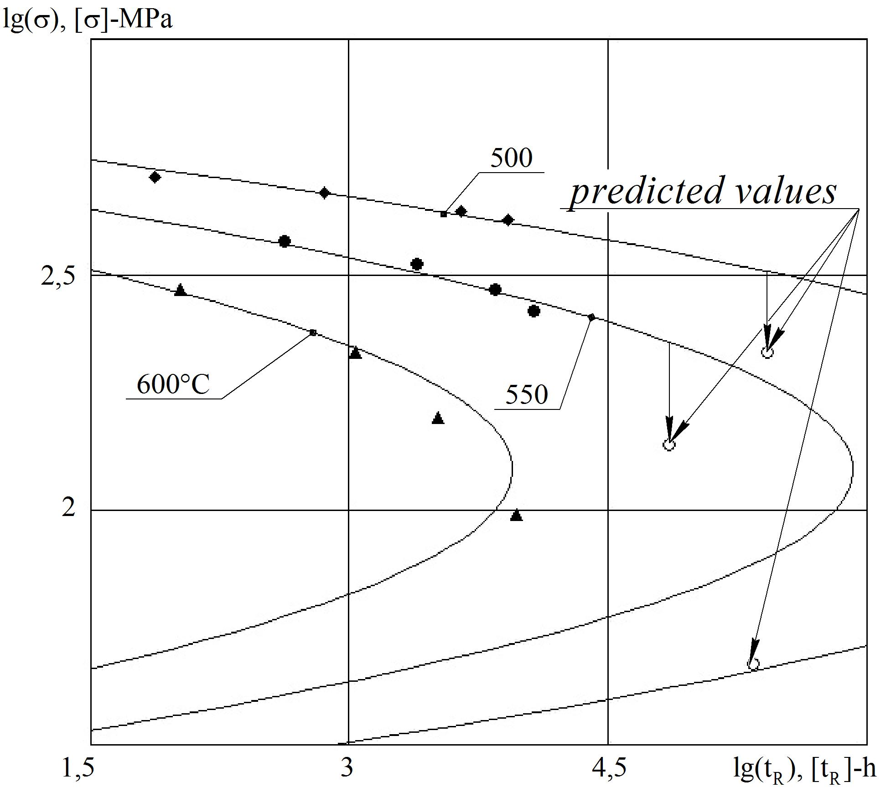
Picture 1. Interpolation analysis of creep-rupture curves of steel 12Cr-1Mo-1W-0,3V by Larson-Miller’s method
It is noteworthy that the absence of the extrapolated value for the corresponding method is indicative that it cannot be calculated for the above-mentioned order of prediction based on the given experimental data. Here the order of prediction was only 1,4 in the logarithmic coordinate system.
Picture 1 shows the shaded markers of experimental values, using which the calculation of the corresponding approximation characteristics by the Larson-Miller’s method was performed. The unshaded markers define the points on the creep-rupture curve for which the extrapolation analysis was made.
As we can see from the picture, the pattern of behavior of the function obtained according to the chosen method for predicting creep rupture curves makes it impossible to obtain a correct result for long lifetimes.
The lack of the calculated extrapolation values of stresses for other methods given in table 1 is explained in a similar way. In its turn, the modified base diagram method allows to carry the reliable lifetime prediction with the order equal to 2,5–3 on the logarithmic life scale. The first version of the model is based on the hypothesis which is the basis for all the parametric relations [5–8], namely, the hypothesis of the combination of all the creep-rupture curves into one averaged curve.
If we know the creep-rupture strength results for the heat-resistant material at some fixed temperatures, then by using the base diagrams, we can in first approximation calculate the stress values for the given lifetime. The base diagrams are described by the relation

. | (3)
Here is the stress according to the base diagram, is the lifetime, is the parameter dependent on the coordinate of the point from which the prediction is carried out.
The refinement of first approximation is done using the formula for the residual function dependent on the parameter that defines the cotangent of slope angle to the ordinate axis for the portion of the creep-rupture strength curve that passes through two points and . In the prediction from the point to the point , the value of the residual function is defined by formula
(). (4)
The calculation of the characteristic governing parameter is performed using the relation
, (). (5)
In the description of creep-rupture strength curves we will assume that the form of the residual function is unchanged. The parameters of the residual function are assumed to be temperature invariant. The graphical representation of the residual function and its description using the chosen approximation function is shown in picture 2.
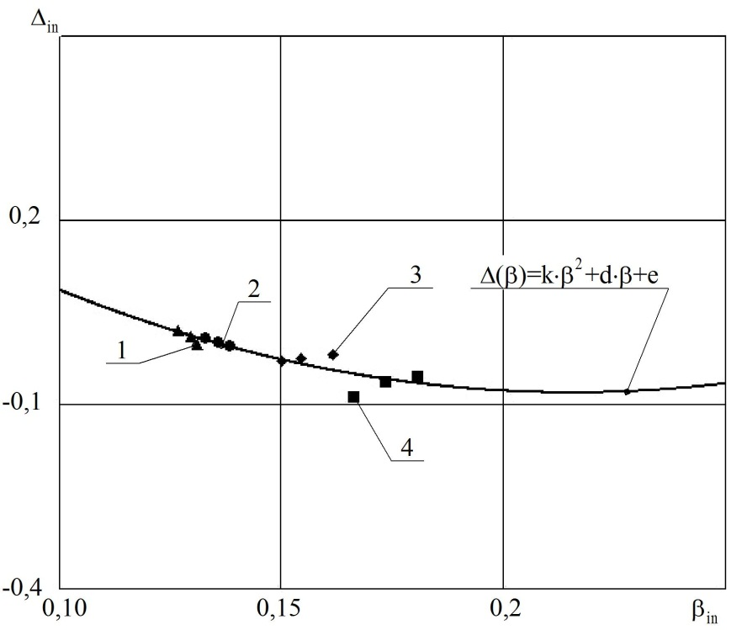
Picture 2. Graphical representation of the residual function of steel 18Cr-12Ni-Mo
1 – 600 °С, 2 – 650 °С, 3 – 700 °С, 4 – 750 °С
As we can see in this case at the approximation of the residual function we used the second order polynomial. By making use of the abovementioned relation, we obtain the values of the predicted stresses for the given lifetime. Table 2 summarizes the results of creep-rupture strength extrapolation for the heat-resistant material 18Cr-12Ni-Mo [10].
2. Results of creep-rupture strength extrapolation of steel 18Cr-12Ni-Mo
, ° | Order of prediction, q | , МPа | ,  МPа | ,  МPа | ,  МPа
600 | 1,2 | 127 | 130,5 | 134,8 | 132,4
650 | 1,6 | 53 | 80,1 | 89,4 | 85,5
700 | 2,1 | 22 | 30,3 | 33,9 | 34,1
750 | 1,4 | 18 | 22,9 | 23,1 | 27,5

The advantages of the offered method of extrapolation of creep-rupture strength curves are seen quite clearly from the given comparative analysis.
The GOST standards regulating investigations on creep and creep-rupture strength do not indicate the required number of specimens, since it is considered that all of them are of the same type, possible structural transformations that may occur are similar, the material is completely isotropic. Therefore, the creep-rupture testing is often limited by several test specimens within one or two temperature ranges.
In these cases, parametric methods cannot be used, since reliable solutions according to initial parameters cannot be found in the approximation analysis.
Our second version of the approach to the base diagram method, when the characteristic parameters of the residual function are considered as temperature dependent, allows to perform a satisfactory extrapolation sufficiently easily and accurately at .
Picture 3 shows a possible representation of the residual functions for each temperature of steel 1,25Cr-0,5Mo-Si [11]. In this case, we confined ourselves to simple linear relation.

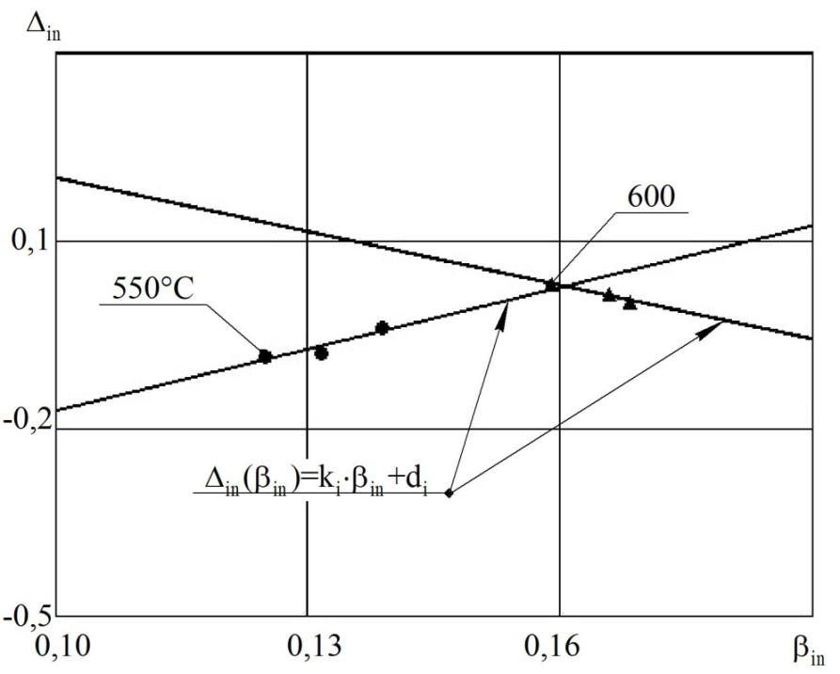
Picture 3. Graphical representation of the residual functions for each isotherm of steel 1,25Cr-0,5Mo-Si
As we can see from the plot in picture 3, the determined parameters of the residual function change in a rather narrow range for each isotherm, which is indicative of the possibility of satisfactory prediction.
3. Results оf creep-rupture strength extrapolation of steel 1,25Cr-0,5Mo-Si
$Т$,  °$C$ | Order of prediction, q | $σ_{\text{експ}},$МPа | $σ_{Л−М},$  МPа (1) | $σ_{\text{Труніна}},$  МPа (2) | $σ_{\text{ММБД}},$  МPа (3) | $$δ_{i}=\frac{σ_{\text{експ}}−σ_{\text{розр}}}{σ_{\text{експ}}},\text{ \%}$$
 |  |  |  |  |  | (1) | (2) | (3)
550 | 2,3 | 61 | 67 | 64 | 62 | 9,8 | 4,9 | 1,6
600 | 1 | 29 | 55 | 54 | 43 | 89,7 | 89,7 | 48,3

Table 3 summarizes the extrapolation results for the abovementioned material. It should be noted that in the prediction by parametric methods, the experimental data from two isotherms were taken into account, whereas in the prediction by the modified base diagram method, each creep-rupture curve was characterized individually.
Thus, analyzing the abovementioned, it is possible to say that the use of the second version of the modified base diagram method makes it possible to perform a reliable creep-rupture prediction for a limited experimental sample (1 or 2 isotherms).
Conclusion. The disadvantages of the parametric prediction methods were analyzed and the limitations of their use in the prediction of creep-rupture strength of heat-resistant steels were determined. The efficiency of the offered version of the modified base diagram method for extrapolation of creep-rupture strength was shown in comparison with the known approaches for long-term life prediction. The comparative analysis of life prediction based on a limited (1 or 2 isotherms) experimental database was presented using different calculation procedures.

BIBLIOGRAPHY

- Кривенюк В. В. Интерполяционный анализ особенностей длительного разрушения хромоникелевых и хромомолибденовых сталей / В. В. Кривенюк, Д. С. Авраменко, Р. П. Приходько // Пробл. прочности. – 2013. – №2. – С. 91–96.
- Кучер Н. К. Прогнозирование высокотемпературной длительной прочности материалов / Н. К. Кучер, Р. П. Приходько // Пробл. прочности. – 2013. – №5. – С. 5–12.
- Локощенко А. М. Моделирование процесса ползучести и длительной прочности металлов / А. М. Локощенко. – М. : МГИУ. – 2007. – 264 с.
- Работнов Ю. Н. Ползучесть элементов конструкций / Ю. Н. Работнов. – М. : Наука, 1966. – 752 с.
- Трунин И. И. Механическое уравнение состояния металлических материалов и прогнозирование характеристик жаропрочности / И. И. Трунин // Пробл. прочности. – 1976. – №9. – С. 9–13.
- Larson F. R. Time temperature relationship for rupture and creep stresses / F. R. Larson,
J. Miller // Trans. ASME. – 1952. – V.74, №5. – P. 765–775.
- Manson S. S. A linear time-temperature relation for extrapolation of creep and stress rupture data / S. S. Manson, A. M. Haferd // NASA TN 2890. – 1953.
- Orr R. L. Correlation of rupture data for metals at elevated temperatures / R. L. Orr,
O. D. Sherby, J. E. Dorn // Trans. ASM. – 1954. – V.46. – P. 113–128.
- Data sheets on the elevated-temperature properties of 12Cr-1Mo-1W-0.3V heat-resisting steel bars for turbine blades (SUH 616-B) // NRIM Creep Data Sheet. – 1998. – №10B. – P. 1–44.
- Data sheets on the elevated-temperature properties of 18Cr-12Ni-Mo stainless steel tubes for boilers and heat exchangers (SUS 316H TB) // NRIM Creep Data Sheet. – 2000. – №6B. – P. 1–36.
- Data sheets on the elevated-temperature properties of 1.25Cr-0.5Mo-Si steel tubes for boilers and heat exchangers (STBA 23) // NRIM Creep Data Sheet. – 2001. – №2B. – P. 1–32.

