© 2016
Storozhenko D. A., PhD in Chemical Sciences,
Bunyakina N. V., PhD in Chemical Sciences,
Dryuchko A. G., PhD in Chemical Sciences,
Ivanyts’ka I. A., PhD in Chemical Sciences
Poltava National Technical University named after Yuriy Kondratyuk
Hrynchyshyn N. M., PhD in Chemical Sciences
Lviv National Medical University named after Danylo Galyts’kyi
INFLUENCE OF ALKALI METAL CATION ON THE FORMATION OF DOUBLE SALTS IN A SYSTEM $\text{MCl}−\text{Nd}(\text{Gd}){\text{Cl}}_{3}−H_{2}O$ ($M−\text{Li},\text{Na},K,\text{Rb},\text{Cs})$ AT 25–100 °С
Reviewer – Laureate of State Prize of Ukraine in Science and Technology, Candidate of Physics and Mathematics Science A. T. Loburets
We investigated phase equilibrium in aqueous systems chloride salt and alkali metal and rare earth elements (neodymium, gadolinium) at 25–100 °C by isothermal solubility in the article. Temperature and concentration limits of crystallization of initial salts and double compounds $\text{MCl}⋅{\text{NdCl}}_{3}⋅5H_{2}O$ ($M−K,\text{Rb},\text{Cs}$), $3\text{RbCl}⋅{\text{NdCl}}_{3}⋅2H_{2}O$, $2\text{CsCl}⋅{\text{NdCl}}_{3}⋅\text{10}H_{2}O$, $3\text{CsCl}⋅{\text{NdCl}}_{3}⋅H_{2}O$, $\text{RbCl}⋅{\text{GdCl}}_{3}⋅2H_{2}O$, $2\text{CsCl}⋅{\text{GdCl}}_{3}⋅7H_{2}O$, $3\text{CsCl}⋅{\text{GdCl}}_{3}⋅5H_{2}O$, $3\text{CsCl}⋅{\text{GdCl}}_{3}⋅2H_{2}O$. We identified double chlorides which were synthesized and identified by physical and chemical methods of analysis.
Keywords: water-salt systems, chloride of alkali metal, chloride of neodymium, chloride of gadolinium, dual chloride.

Statement of the problem. In recent years interest of the study of physical and chemical properties of rare earth elements (REE), alkali metals and their compounds that gets widespread use in modern technology, metallurgy, chemical industry, energy, medicine is growing. Optical quantum generators, storage computing devices are created based on chloride REE compounds [1–5]. Salt and rubidium cesium is used in medicine, organic and inorganic synthesis as catalysts [6]. Lithium chloride is used in creating sources of nutrition pacemakers [7–8].
In connection with the foregoing, it is important the study of phase of balance weights in chloride water systems of alkali metals and rare earth elements (neodymium, gadolinium) in a wide temperature range in order to obtain the data required to make the technology division of REE and alkaline metals; working regulations synthesis of binary compounds found in ternary systems, study of their structure and properties of the purpose of further usage.
Analysis of recent research and publications which begin to solve the problem. Data of solubility in triple aqueous systems of chloride salt and alkali metal neodymium (gadolinium) and properties of double salts crystallize in these systems, in literature is very limited. At 25 °C only system $\text{NaCl}−{\text{NdCl}}_{3}−H_{2}O$[9] and $\text{KCl}−{\text{NdCl}}_{3}−H_{2}O$ [10] was investigated.
The purpose of research – to determine the influence of cations of alkali metal salts on the formation of binary systems $\text{MCl}−\text{Nd}(\text{Gd}){\text{Cl}}_{3}−H_{2}O$ ($M−\text{Li},\text{Na},K,\text{Rb},\text{Cs})$ at 25–100 °С.
Tasks of studies:
- to explore heterogeneous equilibrium in water-salt systems $\text{MCl}−\text{Nd}(\text{Gd}){\text{Cl}}_{3}−H_{2}O$, where $M−\text{Li},\text{Na},K,\text{Rb},\text{Cs}$, at 25–100 °С;
- to build politerms of solubility on which to determine the concentration and crystallization temperature limits of precursors and double-salts in the studied systems;
- to conduct a synthesis of double chlorides detected in the diagrams of the systems and confirm their identity by methods of physical and chemical analysis;
- to set the number of dependent and double salts of neodymium and gadolinium that crystallize in chloride systems from range of alkaline metal and temperature;
- to identify the use of obtained experimental results with solubility in the studied water-salt systems and practical application of double synthesized compounds.
Materials and methods of the research. We used chlorides of alkali metals and neodymium (gadolinium) qualifications of «ch.d.a.» and «h.ch.» additionally purified by overcrystallization. Phase balance in the ternary systems $\text{MCl}−\text{Nd}(\text{Gd}){\text{Cl}}_{3}−H_{2}O$, where $M−\text{Li},\text{Na},K,\text{Rb}, \text{Cs}$, was studied by isothermal solubility method at 25, 50, 75 and 100 °C in air and liquid thermostat, designed by the authors and protected by patents [11–14]. The thermodynamic equilibrium with constant stirring and temperature control within ± 0,1 °C was installed 20–28 hours.
Chemical analysis of liquid and solid phases were carried out on ion content ${\text{Nd}}^{3+}$, ${\text{Gd}}^{3+}$, ${\text{Cl}}^{−}$. Number of gadolinium and neodymium was determine trylonometricly by the presence of xylenol orange in buffer acetate solution [15], chloride ion – by Moore’s method [16]. The content of alkali metal salts was calculated by difference, based on the total content of chlorides. We received results for individual transferred components of analysis of salts and then we applied them to the diagram solubility.
Identification of double salts found in the studied systems was carried out by Skreynemaker’s method, chemical and crystal optical methods of analysis. The synthesized compounds was investigated as dual pycnometrycal, micro photographic, IR spectroscopic, X-ray phasal and, if it is possible, X-ray methods.
Results of the research. The method of isothermal solubility of the first study phase balance in ternary systems $\text{MCl}−{\text{NdCl}}_{3}−H_{2}O$ ($M−\text{Li}, \text{Rb}, \text{Cs}$) at 25, 50, 75 and 100 °С; $\text{MCl}−{\text{NdCl}}_{3}−H_{2}O$ ($M−\text{Na}, K$) at 50, 75 and 100 °С; $\text{MCl}−{\text{GdCl}}_{3}−H_{2}O$ ($M−\text{Li}, \text{Na},K,\text{Rb}, \text{Cs}$) at 25, 50, 75 and 100 °С.
Based on diagrams we study the influence of nature alkali metal cation, temperature of the nature and the number and composition of binary compounds, which crystallize in them.
The following table shows the composition of double salts and their crystallization temperature range, and picture 1 and 2 shows two politerms solubility of 10 investigated.

Composition* and temperature range of the formation of double chlorides systems at 25–100 °C
System$\text{MCl}−{\text{NdCl}}_{3}−H_{2}O$ |  | System$\text{MCl}−{\text{GdCl}}_{3}−H_{2}O$
$M$ – alkali metal | The composition of the double chloride and formation of temperature range | $M$ – alkali metal | The composition of the double chloride and formation of temperature range
$$\text{Li}$$ | avtonika, 25–100 °С | $$\text{Li}$$ | avtonika, 25–100 °С
$\text{Na}$** | avtonika, 25–100 °С | $$\text{Na}$$ | avtonika, 25–100 °С
$K$** | avtonika, 25–50 °С  1–1–5, 75–100 °С | $$K$$ | avtonika, 25–100 °С
$$\text{Rb}$$ | 1–1–5, 25–100 °С  3–1–2, 100 °С | $$\text{Rb}$$ | avtonika, 25–75 °С  3–1–2, 100 °С
$$\text{Cs}$$ | 2–1–10, 25 °С  1–1–5, 50–100 °С  3–1–1, 75–100 °С | $$\text{Cs}$$ | 2–1–7, 25–50 °С  3–1–5, 75 °С  3–1–2, 100 °С

* The first number indicates the number of molecules $\text{MCl}$, the second – number of molecules of neodymium (gadolinium) chloride, the third – number of water molecules.
** For systems $\text{Na}(K)\text{Cl}−{\text{NdCl}}_{3}−H_{2}O$ at 25 °C literary data are published.
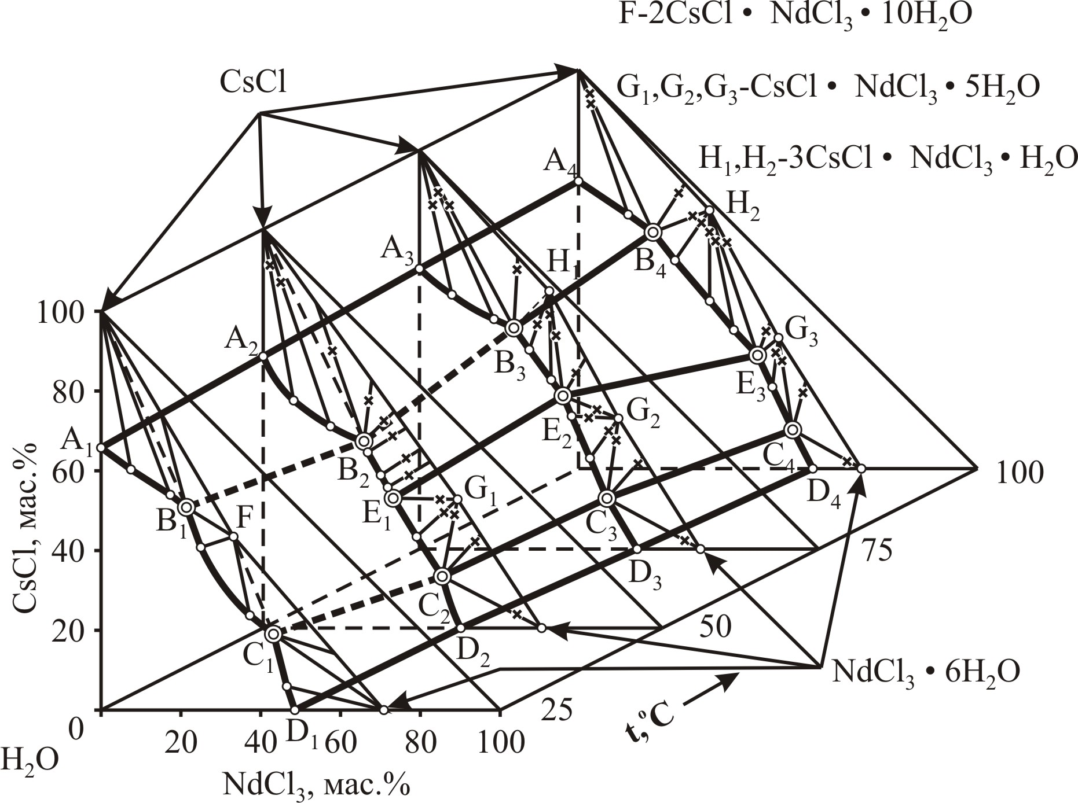
Pic. 1. Politerma of system’s solubility $\text{CsCl}−{\text{NdCl}}_{3}−H_{2}O$
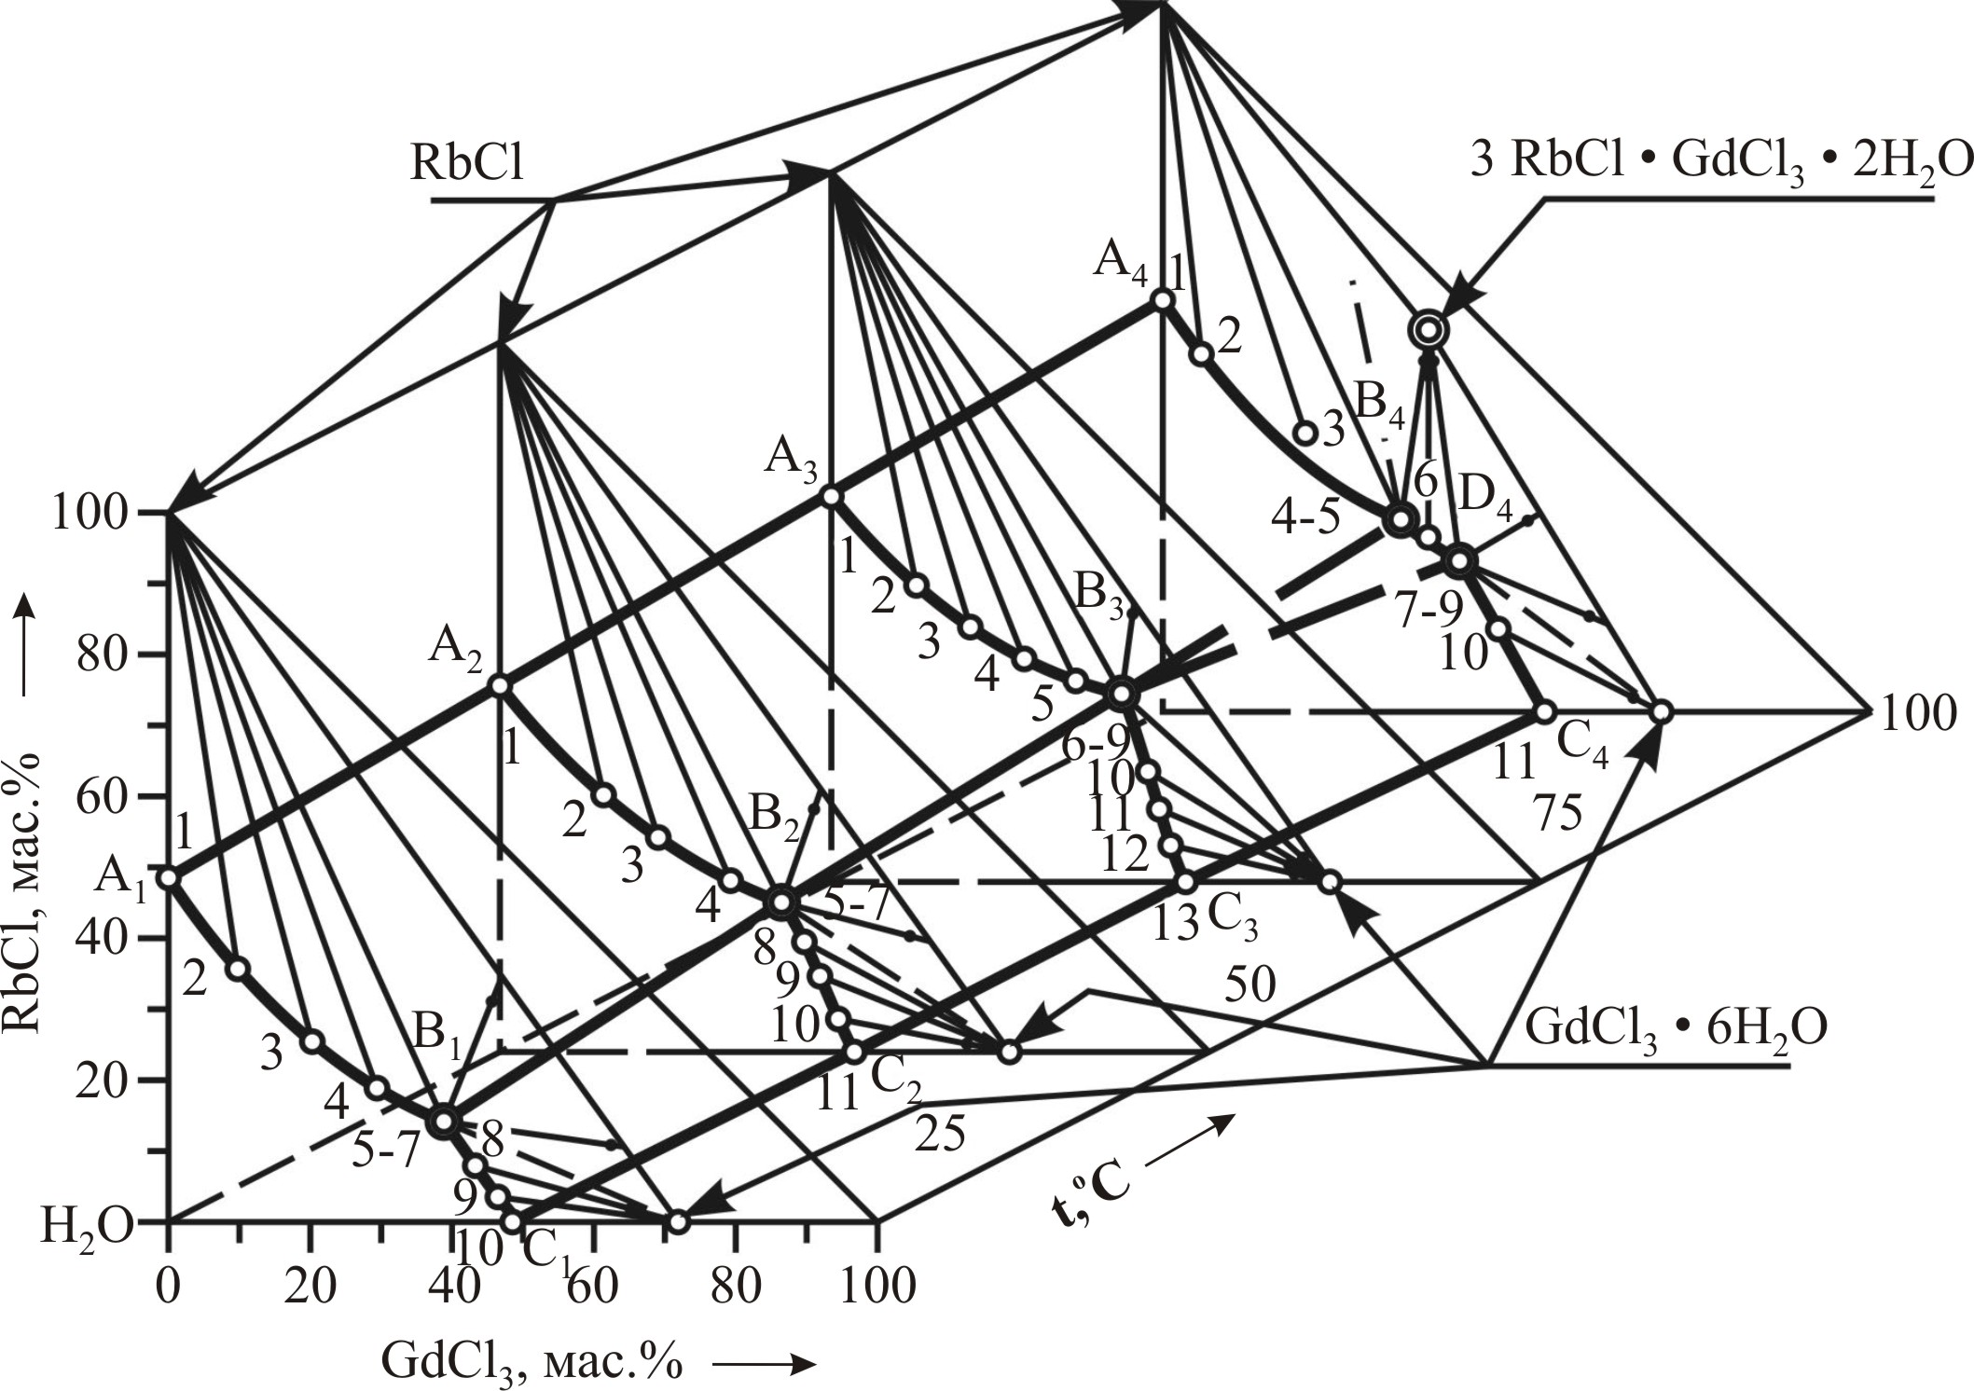
Pic. 2. Politerma of system’s solubility $\text{RbCl}−{\text{GdCl}}_{3}−H_{2}O$
So, systems $\text{Li}(\text{Na})\text{Cl}−{\text{NdCl}}_{3}−H_{2}O$ and $\text{Li}(\text{Na},K)\text{Cl}−{\text{GdCl}}_{3}−H_{2}O$ at 25–100 °С; $\text{KCl}−{\text{NdCl}}_{3}−H_{2}O$ at 25–50 °С, $\text{RbCl}−{\text{GdCl}}_{3}−H_{2}O$ at 25–75 °С – eutonic type.
At 75 and 100 °С in a system $\text{KCl}−{\text{NdCl}}_{3}−H_{2}O$ we found double salt of $\text{KCl}⋅{\text{NdCl}}_{3}⋅5H_{2}O$. The system «rubidium chloride – neodymium chloride – water» double chlorides $\text{RbCl}⋅{\text{NdCl}}_{3}⋅5H_{2}O$ (25–100 °С) and $3\text{RbCl}⋅{\text{NdCl}}_{3}⋅2H_{2}O$ (100 °С) crystallized. System $\text{CsCl}−{\text{NdCl}}_{3}−H_{2}O$ is characterized by a complex interaction of components, which resulted in a solid phase outbox salt, double chlorides $2\text{CsCl}⋅{\text{NdCl}}_{3}⋅\text{10}H_{2}O$ (25 °С), $\text{CsCl}⋅{\text{NdCl}}_{3}⋅5H_{2}O$ (50–100 °С) and $3\text{CsCl}⋅{\text{NdCl}}_{3}⋅H_{2}O$ (75–100 °С) crystallized, and also at 50 °C solid solutions of $\text{nCsCl}⋅{\text{mNdCl}}_{3}⋅{\text{xH}}_{2}O$ (pic. 1).
At 100 °C the system «rubidium chloride – gadolinium chloride – water» double salt of $3\text{RbCl}⋅{\text{GdCl}}_{3}⋅2H_{2}O$ (pic. 2) was found. In a system $\text{CsCl}−{\text{GdCl}}_{3}−H_{2}O$ double chloride crystallize: at 25–50 °C – $2\text{CsCl}⋅{\text{GdCl}}_{3}⋅7H_{2}O$, at 75 °С – $3\text{CsCl}⋅{\text{GdCl}}_{3}⋅5H_{2}O$, at 100 °С – $3\text{CsCl}⋅{\text{GdCl}}_{3}⋅2H_{2}O$. Thus, when the temperature increases from 75 to 100 °C the partial loss of water occurs by crystalline double $3\text{CsCl}⋅{\text{GdCl}}_{3}⋅5H_{2}O$ to the composition $3\text{CsCl}⋅{\text{GdCl}}_{3}⋅2H_{2}O$.
Analyzing the effect of alkali metal cations on the number and composition of double salts in the studied systems can conclude that ability of formation of complex compounds with increasing radius cations of an alkali metal from ${\text{Li}}^{+}$ to ${\text{Cs}}^{+}$. This pattern associated with reduced energy of hydration of alkali metal chlorides in a row $\text{Li}−\text{Cs}$ [17].
In systems $K(\text{Rb},\text{Cs})\text{Cl}−{\text{NdCl}}_{3}−H_{2}O$ and $\text{Rb}(\text{Cs})\text{Cl}−{\text{GdCl}}_{3}−H_{2}O$ number of double chloride increases with increasing temperature of research. Also we found that neodymium cation ${\text{Nd}}^{3+}$ has a greater ability to form double compounds than gadolinium cation ${\text{Gd}}^{3+}$.
All double chlorides we emphasis for the first time. All found double salts were synthesized and identified by chemical, crystal optical, thermal complex, IR spectroscopic, phasal X-ray, and if it is possible, methods of X-ray analysis.
Conclusion from research and prospects. The results are interest for REE chemistry, alkali metal and can be used in processing of technology of hydrochloric materials.
We developed regulations synthesis of ten single crystals of double neodymium chloride (gadolinium) and alkali metals, which are isolated and identified for the first time.
The dependence of the number of double connections and their composition from the radius of alkali metal, temperature of research and cation of REE is installed.

BIBLIOGRAPHY

1. Акустические кристаллы : справочник / [Блистанов А. А., Бондаренко В. С., Переломова Н. В. и др.]. – М. : Наука, 1982. – С. 425–439.
2. А. с. №1797983 СССР. Способ перемешивания гомогенных и гетерогенных сред / А. Г. Дрючко, Д. А. Стороженко, Г. М. Лысенко. Авторское свидетельство. – 1990.
3. Бакуменко Т. Т. Каталитические свойства редких и РЗЕ / Т. Т. Бакуменко. – К. : Академиздат УССР, 1963. – С. 8.
4. Бусев А. И. Руководство по аналитической химии элементов / А. И. Бусев, В. Г. Типцова,
И. К. Иванов. – М. : Химия, 1978. – С. 103–105.
5. Кохан Б. И. Литий, области освоенного и возможного применения / Б. И. Кохан. – М. : ВИНТИ, 1960. – С. 3–63.
6. Краткий справочник физико-химических величин. – СПб. : Специальная литература, 1998. – 232 с.
7. Крешков А. П. Основы аналитической химии. Кн. 2 / А. П. Крешков – М. : Химия, 1976. – 480 с.
8. Лайис М. Сегнетоэлектрики и родственные им материалы / М. Лайис, А. Гласс. – М. : Мир, 1981. – 693 с.
9. Литий, его соединения и технология / [Остроушко Ю. И., Бушкин П. И., Алексеева В. В. и др.]. – М. : Академиздат, 1960. – 199 с.
10. Милованов Г. Н. Редкоземельные элементы. Перечень освоенных и возможных областей применения / Г. Н. Милованов. – М. : ВИНТИ, 1960. – 31 с.
11. Патент України на винахід №107432 від 25.12.2014 р. «Пристрій електромагнітного багатопозиційного перемішування з індивідуальним регулюванням і контролем режиму роботи».
Дрючко О. Г., Стороженко Д. О., Бунякіна Н. В., Іваницька І. О. Номер заявки а 2013 14788 від 17.12.2013. Видача патенту : бюлетень № 24 від 25.12.2014.
12. Плющев В. Е. Химия и технология соединений рубидия и цезия. / В. Е. Плющев, Б. Д. Степин. – М. : Химия, 1970. – 408 с.
13. Приспособление к суховоздушному термостату для непрерывного перемешивания солей в реакционных сосудах с помощью магнитных мешалок / В. Н. Коцарь, В. Г. Шевчук, Д. А. Стороженко,
А. Г. Дрючко, Н. М. Лазоренко // Заводская лаборатория. – 1980. – Т.46, №6. – С. 568.
14. Серебренников В. В. Редкоземельные элементы и их соединения в электронной технике /
[В. В. Серебренников, Г. М. Якунина, В. В. Козик, А. Н. Сергеев]. – Томск : изд-во Томского университета, 1979. – 144 с.
15. Спосіб перемішування гомогенних і гетерогенних систем / Д. О. Стороженко, О. Г. Дрючко,
І. О. Іваницька, Н. В. Бунякіна // Вісник національного технічного університету ХПІ. – Х. : видавництво ХПІ, 2009. – Вип. 25. – С. 111–114.
16. Шевцова З. Н. Изотермы растворимости систем: ${\text{LaCl}}_{3}−\text{KCl}−H_{2}O$, ${\text{NdCl}}_{3}−\text{KCl}−H_{2}O$, ${\text{LaCl}}_{3}−{\text{NH}}_{4}\text{Cl}−H_{2}O$ и ${\text{NdCl}}_{3}−{\text{NH}}_{4}\text{Cl}−H_{2}O$ при 25 °С / З. Н. Шевцова, Л. И. Жижина,
Л. Е. Эльцберг // Изв. высш. учебн. завед. Химия и хим. технология. – 1961. – Т. 4, №2. – С. 176–178.
17. Шевцова З. Н. О растворимости в системах ${\text{LaCl}}_{3}−\text{NaCl}−H_{2}O$, ${\text{NdCl}}_{3}−\text{NaCl}−H_{2}O$, ${\text{LaCl}}_{3}−{\text{CaCl}}_{2}−H_{2}O$ и ${\text{NdCl}}_{3}−{\text{CaCl}}_{2}−H_{2}O$ при 25 °С / З. Н. Шевцова, В. С. Зелова, Л. И. Ушакова // Науч. докл. высш. школы. Сер. Химия и хим. технология. – 1958. – №3. – С. 417–421.

