© 2016
Dmytrykov V. P., Doctor of Technical Sciences, Professor,
Nazarenko A. A., PhD of Technical Sciences, Associate Professor,
Zaporozhets’ M. I., PhD of Technical Sciences, Associate Professor
Poltava State Agrarian Academy
MODIFIED PRODUCTION LINE OF EXPANDED PRODUCTION OF ANIMAL FEED
Reviewer – Doctor of Technical Sciences O. M. Kostenko
The problems that have developed in the production of grain feed were found. The structure and layout of the flexible production lines for the processing of agricultural raw materials was considered. The factors of influence on the processes of extrusion processing of crop production were analyzed.
A modified technology of animal feed production line expanded for various purposes was recommended.
Keywords: agricultural raw materials, expander, feed, modification processing line, processing.

Statement of the problem. In the current socio-economic conditions, special importance is increasing feed efficiency, since the preparation of feed consumed 20–60 % of labor costs in production. Mechanization of feeding significantly expands the range of different species of animals. Production and manufacturing of pellets, granules, different types of canned feed, forage mixture creation, selection components, improving the availability of nutrients requires a high-tech equipment that can replace complex machine and get a high economic effect.
The most highly efficient methods of processing of agricultural raw materials include thermoplastic extrusion processing, which combines thermal, hydraulic and mechanical effects on components that can receive feed of new properties with a primary textures for an animal nutrient balance and higher digestibility. Press expanders provide mechanical effect of raw materials, effectively destroying the structure of the material, thereby increasing the nutritional value and quality of feed. This cultivation is associated with high temperatures up to 130 °C and a pressure of 3,0 MPa.
Analysis of basic researches and publications where the decision of problem is founded. The analysis of the literature, to identify priority areas of technology expanding of feed, points to promising new approaches of processing of plant materials for use in feed production.
One of the most common methods of processing of agricultural raw materials is its extrusion. Raw sharply increased in volume as a result of mechanical stress and heat, there are essential physical and chemical changes in the components of the finished product. To increase the efficiency of extrusion, lower specific consumption of electricity can use pre-steaming product at a pressure of 0,1–0,3 MPa to humidity 17–18 % [1].
Previous expanding improves the efficiency of feed pelleting process, as feed enters the granulation humid 16–18 % and heated to a temperature of 90–115 °C and sealed. As a result productivity of pelleting presses increased, specific power consumption for one ton of pellets reduced. By varying the annular gap expander in the matrix, you can adjust the strength of pellet feed [4].
Usage of expander makes it possible to receive the finished product in the form of animal feed grains product without granulation of loose feed. In this case, significantly productivity of the process of obtaining feed grains increases and unit costs reduced.
Analysis of trends in the production of feed products shows that in the near future, this product appearance will occupy an important place in the creation of combined products [3]. The main advantages of advanced production technology product of expansion is the possibility of flexible circuit technology, high performance and small size expander, continuous process and low production costs.
The purpose of the research is to improve the technology of production of animal feed, which are obtained by thermoplastic extrusion method of plant material.
Task of the studies: analysis of factors which influence on the technological processing of vegetable raw materials with further modification of the technological line of production of expanded structured animal feed (SAF).
Materials and methods of the research. General methodological basis of studies used a systematic approach that provides expanded review process of preparation of expanding feed considering relations of technological and structural parameters of means of production line. To solve these problems we used mathematical modeling and abstract-logical method.
Results of the research. Expanding technology is one of the best ways of conditioning of feed and individual components [2]. Expanding is based on the hydrothermal processing plant material under pressure. Processing feed in expander is carried out at a higher moisture content than the extruder. The leading western firms recommended to process materials with a moisture content up to 26 %. The product is heated by introducing steam and friction. In expander there are no «warming» washers.
At the same temperatures (115–145 °C) processing in the expander at high humidity occurs in less stringent conditions. In the extruder through reduced moisture in some areas «local» support of the products can grow to considerable size, causing a «local» temperature increase, although the overall temperature regime does not change. As in the extruder and expander we can obtain the finished product of different densities due to changes in processing modes [2].
Expanding has several advantages: the introduction of a large number of liquid components – oils, fats, molasses, etc; eliminate harmful food substances; improve the quality and digestibility of animal feed; more performance pressure of granulation; best quality of granules; use of cheaper raw materials for granulation; not granulated production capability. This problem is solved with the application process and expanders produced by firms AMANDUS KAHL, ALMEX, ANDRITZ and others.
Normal operating temperature during the processing of feed for poultry and pigs is in the range of 105–110 °C. You can reach pressures up to 4 MPa and temperature to 130 °C, but only for a very short period, so that the total time of the product through the expander is a few seconds.
The output of the expander product instantly loses load and added fluid largely evaporates. Due to the evaporation of the liquid temperature drops to 90 °C. Depending on the recipe, product temperature and pressure of the finished product may be the structure of the dough, thick flakes or pieces [6].
Granular expandat combines the advantages of both granulated and loose feed. Each slice contains all components; a distribution of particles is very even. You can adjust the particle size of the gap in the roller shredders and get loose feed without such deficiencies as poor fluidity and stratification of the mixture. Expanding achieves the same or a higher degree of starch modification compared to the previous brew that will positively affect the process of digestion of feed.
Picture modifies technological scheme expanding of loose animal feed of company AMANDUS KAHL [2]. A feature of this scheme is the introduction to the structure of the block of power saving control by software, which improves energy and economic parameters of the processing line.
In the scheme of feed production technology there are three main areas: composition, grain storage compartment, and additional training materials; general production; storage of products.
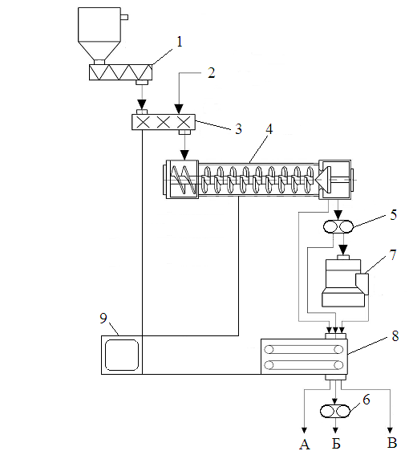
1 – dosing screw, 2 – feed additives, 3 – continuous mixer, 4 – expander with circular gap,
5, 6 – grinders, 7 – press granulator, 8 – cooler, 9 – power energy saving software;
A – rough product of expanding; Б – crushed expanding; B – granular product of expanding
Picture. Modified flowsheet of expanding of feed of company AMANDUS KAHL

Expanding feed without pelleting makes it possible to get SAF. Expanded structured feed – a feed that passes over hydrothermal processing using expander and it is intended for direct feeding in the form of pieces without granulation. SAF can be monoelement feed concentrate with a high content of metabolizable energy, protein concentrate or ready-to-eat feed [5].
SAFs can be fed to piglets and pigs in a dry and semisolid form; dairy animals, preferably at admix to the total feed along with roughage; chicken-laying hens at growing and getting commercial eggs; poultry, especially in the first weeks of life.
SAF is optimal for pigs because pieces unlike granulated one is not so hard, so they do not injure the esophagus and stomach; coarse lumps do not form dust and thereby cause adhesion of chewing and breathing; unlike flour and pieces of expandat granules dissolve easily in water, maintain stability and sustainability when moving, which is important when it is fed to pigs in semisolid form; pieces have more particle surface and porous structure that provides easier penetration of the gastric juices and enzymes.
SAF due to water solubility is especially suitable for feeding in liquid, other than water it is well dispersed in other fluids such as whey or «soup» of food waste. For dilution of expanding products in water we need less time than for breeding granulate or flour.
Conclusion. The process of expanding of agricultural raw materials of different composition and physico-mechanical properties for the production of animal feed is analyzed. Grounded modified production line of SAF production, which is made from agricultural raw materials using a mixture of cereals, pulses and other food components, was considered. The offered by authors modification of expandat production involves the production of a new type of animal feed products based on vegetable and animal raw materials.

BIBLIOGRAPHY

1. Бойко Л. Н. Прогресивные технологии для производства комбикормов [текст] / Л. Н. Бойко // Комбикорма. – 2005. – №4. – С. 23–24.
2. Экспандер с кольцевым зазором фирмы «KAHL» [Электронный ресурс]. – Режим доступа : http://www.akahl.de/akahl/ru/ru_produkte/ru_ tiernahrung/ru_ringspalt-expander/.
3. Розроблення екструдатів підвищеної біологічної цінності [текст] / [Ковбаса В. М., Махинько Л. В., Герасименко О. В., Шаран А. В., Піддубний В. А.] // Зернові продукти і комбікорми. – 2005. – №1. – С. 29–31.
4. Крони Л. И., Генхтун Г. С. Производство комбикормов и кормових смесей [текст] / Л. И. Крони, Г. С. Генхтун. – К. : Урожай, 1993. – 187 с.
5. Шестернина С. А. Применение экструзионной технологии в комбикормовой промышленности [текст] / С. А. Шестернина // Обзорн. информ. – М. : ЦНИИТЭИ хлебопродуктов, 1994. – 29 с.
6. Повышение эффективности производства комбикормов [текст] / [Шевцов А. А., Остриков А. Н., Лыткина Л. И., Сухарев А. И.]. – М. : ДеЛи Принт, 2005. – 243 с.

