© 2015
Tkachenko R. N., graduate student

Luhansk National University named after Taras Shevchenko
(scientific advisor – Candidate of Engineering Science, A. A. Beseda)
STUDY OF TECHNOLOGICAL PROPERTIES OF A SEPARATION OBJECT AND FUNCTIONALITY OF THE WORKING BODIES OF SEPARATING EQUIPMENT
Reviewer – Doctor of Engineering Science, A. V. Chesnokov
The work is devoted to the study of the movement of inoculum under the action of gravity in sowing system, namely metering system – sow automated – dialects device – undertenon space dovetail ploughshare – switchgear. The impact resistance when the flow of inoculum on the example of winter wheat was theoretically described. Which is considered with regard to the form of the profile of its convenient shape flow in sow automate, provided mechanical feeder that is able to asume and theoretically describe the general scheme of the movement of seed in sowing system.
Keywords: soil,operating procedure, separation, friction properties, bulk material, impurities.

Statement of the problem. Soil condition directly affects the flow of the operating procedure of separation, and in particular the efficiency performance of the separation equipment of potato harvesters. The mechanical structure and soil moisture affect the process most of all [8].
Therefore, the determination of the degree of the soil condition influence on the quality indicators during the separation process steps and the study of the possibilities of different equipment is a challenge and requires more detailed study.
Analysis of recent research. In the process of creating efficient separating systems potato harvesters individual scientists conducted research. So in the works of N. N. Kolchin it investigated the working conditions, the properties of the cultures and processes of harvesting, post harvest handling and storage of potatoes [3]. The study of G. D. Petrov’s method of potatoes harvesting and the study of complex machinery for its implementation [6]. I. Y. Zinoviev, V. E. Zubkov did issues of theory and practice of separating of soil lumps and stones from tubers. The study covers of the blocked pseudo-liquefied layer and is aimed at the creation of promising new technologies, machines and their working element [2].
Analysis of the literature demonstrates the need for clarification of the influence of soil conditions on the flow process.
The purpose of the research – to determine the degree of soil condition influence on quality indicators of separation and capabilities of different types of separation equipment; to define the direction of the further study of the problem.
Results of the study. While examining the root crops (turnips, rutabaga, carrots, beets, potatoes, etc.) special attention should be paid to potato as it is a valuable and socially significant product. Ukraine ranks are fourth in the world in the production of this crop. This is primarily achieved by planting a large number of areas, with low yields [5].
Due to the diversity of soil and climatic conditions in Ukraine and, accordingly, different composition of the soil, it is necessary to provide and use the appropriate agro-technical operations in the tuberous cultivation. The possibility of using varieties for different purposes, planting schemes, types of row spacing, complex machine and harvester complexes are taken into consideration.
The main specificity of potato harvest mechanization is the extraction of potato tubers from the soil surface. Operating parts affect the ground, and accordingly their operation depends directly on the physical and mechanical properties of the soil [5]. The work of undermining parts is impacted by tuber socket parameters, the work of separating devices – by the structure and condition of the soil and impurities.
Based on the recommendations the soil under potatoes should be sabulous, easy or medium loamy with humus content of 2–2,5 % [7]. It is not recommended to use soils with heavy texture and wetland soils. This is primarily due to lower yields, increasing diseases impact and it makes the separation of the tubers from the soil and external contaminants more difficult. Therefore, in order to avoid the mentioned problems, it is necessary to direct the processing steps in soil preparation to lumps destruction and loose condition creation which should be provided up to the harvest.
We examine the separation object (a mixture of components, which enters the separation device) as a granular material.
Granular materials are directly involved in many processes of agricultural production. This includes the plant growing and root vegetables. In this case, the granular material is a mixture of potato tubers and impurities which need to be separated (soil, plant debris, stones).
For a detailed study of the separation process it is necessary to analyze the main characteristics and patterns that occur in granular materials. As during the separation process movement of granular material occurs, so physical, mechanical and technological properties and working bodies of the machines should be known for the design of technological processes.
Examining of the solid phase of granular material it is necessary to identify the main groups: measurable, structural, frictional, thermal, aerodynamic, electrical-physical. After analyzing separating devices of these groups measurable, friction and aerodynamic equipment should be singled out.
We characterized each of the groups of parameters of the solid phase of granular material. The group called determiners measures the dimension and the relationship of the particles and their shape, which is necessary for the design of the separation equipment according to the principle of separating dimensions.
While considering the group of friction properties it is possible to single out the friction force for tranquility micron particles $d≥\text{100}$ micrometer, and static and impact forces of the particles for $d≤\text{100}$ micrometer. These parameters are necessary for the construction of the separation equipment for separating the material according to friction and aerodynamic properties.
The main parameter of the granular material as the dispersed phase system is a packing density, which is characterized by a relevant factor.
$K=\frac{V_{T}}{V}=\frac{ρ}{γ_{O}}$ (1)
where, $ρ$ - solid phase density in kg / m³;
$γ_{O}$ - bulk density of the particulate material, kg / m³.
In the soil mechanization, this factor is called porosity factor [4]. This factor is changeable quantity and it varies depending on the conditions of formation of particulate material.
The separation process is also affected by the bulk density.
$γ_{O}=\frac{ρ}{К}$ (2)
So we see that the bulk density depends on the stacking factor and accordingly also varies depending on the bulk material.
Therefore, we note that the type, condition and structural components of the soil directly affect the parameters and consequently the quality performance of the separation equipment.
Considering the work of separating equipment of different types, depending on the soil conditions it is needed to consider their possibilities. Basically the work of separation bodies is based on the principle of separation by the difference of distinctive properties of the mixture components, namely: specific gravity, aerodynamic properties, elasticity, hardness, sliding and rolling friction, electrical properties, rays absorption ability, optical reflectivity, and a set of several properties [1].
Separation by specific gravity with a fluid use, «boiling» layer of sand or fine soil, requires additional costs and depends on the soil moisture.
Separation with the use of frictional properties and separating the components by the difference of the factors of friction and rolling cannot be of high quality and effective in the case of the harvesting on heavy or waterlogged soils.
The separation is operated more effectively by the equipment which simultaneously uses several distinctive properties of the blend components [1].
Studying the work of separating devices (see picture) we will analyze and indicate their potential.
When using the rubber screen (a) and separation conveyor with rubber fingers inclined towards loading side and moving across (b), the separation occurs depending on the shape and the absolute weight of the components of potato heap.
The difference of forms and surface roughness of the component parts of the mixture are used by the device (c and d) – oscillating trough and (h) – cone separators.
The conveyor with a rotating brush (d), as well as modifications of this device uses the difference in specific gravity, the ability of the rolling, weight and size of the bodies.
Under the influence of the force generated by the air flow in inclined conveyor with a fan (e), potato have the best rolling capacity, is blown in prefabricated channels running parallel to the table, and the stones are removed by the table.
The vibrating surface (f) requires sorting by size, as separation occurs depending on the specific gravity and the absolute size.
The work of the drums with rubber bands (h), and their modifications is based on the use of the difference in weight and the surface properties of components being separated.
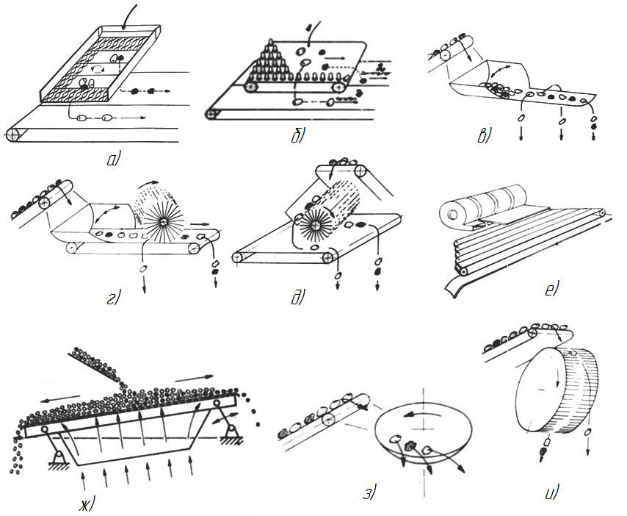
Working bodies for separating tubers from lumps and stones are based on the combined use of a number of properties: a) rubberized roar; b) conveyor with rubber fingers; c and d) swinging gutters;
e) a conveyor with a rotating brush; f) inclined conveyor with a fan; g) vibrating surface; h) cone separator;
i) drum device.
The work of the considered separating devices is based on the use of several properties of the separating material and under certain conditions can perform separation of sufficient quality. In the real conditions of work (the case of the work on heavy soils, soils of increased stoniness, humidity, etc.), these figures are reduced down to unacceptable.
Conclusion. According to the performed analysis of the separation object and the capacities of the separation equipment of different types, it is possible to determine the further direction in the study of this issue. It is noted that the efficiency of the separation equipment is highly dependent on soil conditions. The greatest influence on the separation process is made by the texture of soil and its moisture [8]. Therefore, in general, while designing and modernizing the working bodies of the separation equipment it is necessary to consider the separation factor:
, % (3)
where, - separation factor of bulk material, - the mass of the heap which falls to the separator, kg; - the mass of heap that comes down from the separator, kg.
BIBLIOGRAPHY
- Долгов И. А. Уборочные сельскохозяйственные машины (конструкция, теория, расчет) : учебник / И. А. Долгов. – Ростов-на-Дону : издательский центр ДГТУ, 2003. – 707 с.
- Зиновьев Ю. И., Зубков В. Е. Научные основы механизированных процессов вторичной сепарации картофеля / Ю. И. Зиновьев, В. Е. Зубков. – Луганск : Лугань, 1997. – 176 с.
- Колчин Н. Н. Техника для послеуборочной обработки и хранения картофеля: состояние и перспективы развития / Н. Н. Колчин // Картофель и овощи. – 2002. – №8. – С. 6–8.
- Механіко-технологічні властивості сільськогосподарських матеріалів : підручник / [Царенко О. М., Войтюк Д. Г., Швайко В. М. та ін. ; за ред. Яцуна С. С.]. – К., 2003. – 448 с.
- Наукові основи агропромислового виробництва в зоні Степу України / [редколегія : Зубець М. В. (голова) та ін.]. – К. : Аграрна наука, 2010. – 986 с.
- Петров Г. Д. Картофелеуборочные машины. – М. : Машиностроение, 1984. – 320 с.
- Современное промышленное производство овощей и картофеля с использованием систем капельного орошения / [Гиль Л. С. , Дьяченко В. И., Пашковский А. И., Сулима Л. Т.]. – Ж. : ЧП «Рута», 2010. – 390 с.
- Трубилин Е. И. Машины для уборки сельскохозяйственных культур (конструкция, теория и расчет) : учебн. пос. – [2-е изд. перераб. и дополн.] / Трубилин Е. И. – КГАУ, Краснодар, 2010 – 325 с.

