© 2015
Lyashenko S. V., Candidate of Engineering Sciences
Poltava State Agrarian Academy
TECHNOLOGY OF DEEP SOIL LOOSENING ON SMALL HOMESTEAD LANDS
Reviewer is Doctor of Engineering Sciences, Professor L. І. Levi
The known scientific researches confirmed the necessity of destruction close-settled soils. Existent agrotechnical technologies of treatment soil are inapplicable for the terms of subsidiary areas. Technical solution problems is offered by the use fuel-efficient power machines. The recommended chart is resulted for implementation of technological process of the deep loosening of soil on subsidiary areas. Technical solution is offered – deep loosening of soil for diminishing of influencing of subsurface layer of soil which appears on the small holdings as a result of permanent reiteration of methods of his till on physico-mechanical properties of soil and productivity of agricultural cultures
Keywords: homestead land, sub arable layer, soil, motoblock, soil cultivating machine.

Statement of the problem. On the modern stage of development of agriculture all more attention is spared to the ecological methods of till of soil. Plough till of homestead lands results in strengthening of erosive processes which result in washing off and weathering of the most valuable humus layer of soil from its surface. Frequent drives on these lands surfaces using a tractor with a plough results in over compression of soil and, as a result, formation of over compressed humps on homestead lands leads to accumulating melted and rain water in them, that expedites the active soaking of plantations and rotting of potatoes and root crops. These negative phenomena violate the ecosystem of homestead lands that was created in natural way during many years; reduce biological activity of soil and, in total, result in the substantial shortage of harvest or transferring of this area in the rank of not suitable for use. Homestead lands provide prevailing part of city-dwellers with their food. Having small areas of arable soil, that can’t be cultivated using modern agricultural technique because of it’s size, summer residents bump into the problem of its over compressed sub arable layer. We witness the process of crumbing of its upper layer and compression of its lower fertile soil layer because of its long-term same type superficial till. That problem results in gradual reduction to the productivity of agricultural cultures and diminishes its fertility.
Deep till of soil for agricultural lands is not a new problem. There is a series of technologies and agricultural machines that allows periodically conducting mellowing of sub arable layer. Such operations allow reducing compression in fertile layer of soil and its salinity as a result of the better moisture penetration during fall-winter period and during irrigation, increasing its gas-penetrability, improving its agro physics properties.
Prevailing majority of homestead lands is cultivated by primitive agricultural instruments. As a result of its power consumption and insignificant depth of till (up to 15 cm) in combination with the permanent repeat of till methods, we see formation of compression on a depth from 15 сm (solidity of sub arable layer reach 1,8 МPа and more). With distribution and wide usage of mobile small power means (motoblocks, motocultivators) appeared the possibility of the introduction on their basis the soil cultivating instruments, that needs developing its construction and corresponding technology for implementation of deep till of soil.
Analysis of basic researches and publications where the decision of problem is founded. In production conditions on agricultural enterprises deep soil loosening sets, chisel ploughs, mellowing cultivators are widely used. The productivity of such machines reaches a few hectares on an hour, the width of till of soil and sizes of the aggregate are unacceptable for the terms of homestead lands.
The design of most productive agricultural aggregates is scientifically is proved. The question of implementation of the soil cultivating organs of deep loosening for the different types of soil is observed in scientific researches of the known scientists: academicians Artobolevskyi І. І. [1], Gjelegovskyi V. О. [2], Vasylenko P. М. [3], doctors of engineering sciences Vernjaev О. V., Babitskyi L. F. [4], Panov І. М., Karpusha P. P., Rjabtsev G. О., Krasnoschokov М. V. and others.
In the basis of working organ design for no pull of till of soil is a wedge. The specifics of cooperation of the wedge with the soil environment consists in separating of the soil on different elements during wedge’s work, which condense because of clench tensions which means their density becomes higher than before the till. However due to air layers that exist between the particles of soil, and increase in the process of till, the approximate density of the soil environment diminishes to the optimal figures and lower. According to V. P. Gorjachkin, the destruction of chunk of soil is divided into two stages:
1) gradual crushing of soil by a wedge, that develops with increasing effort, followed by a growing compression and the amount of compressed particles;
2) flat shifting, tearing off after achieving maximum tensions.
The patch loosening is a rotation of loosened and unloosened patches, it answers the question of destruction compressed «sole», it helps the penetration of moisture and roots of plants in the lower ground horizons. This method of till is executed by the units of chisel type (ПЧ - 2,5, ЩРП- 3-70, КШП- 5,6 and others) on a depth up to 40 cm.
Scientific and production companies worked out the wide spectrum of soil cultivating working organs and agricultural aggregates for motoblocks and motocultivators. The question of the usage of such technique for the deep soil loosening on homestead lands is actual for today.
Judging by a calculation, that the necessary till depth for soil is 0,35 m while rates of movement gets up to 0,3 m/c, we get a hauling force on the soil cultivating working organ of 2870Н. In a recalculation to power – 861Wt. Thus, theoretical calculations confirmed, that a working organ with the thickness of 0,01 m is able to cut chaps on the depth of 0,35 m with the speed of 0,3 m/c.
The construction of working organ is shown in picture 1.

1

2

3

h
Pic. 1. Structural chart of deep soil loosening sets for homestead areas: 1 – working organ; 2 – suspended mechanism; 3 – motoblock; h – depth of the till.
Taking into account suspended rod of motoblock, for implementation of such technological process we should to apply the power of no less than 1 kWt.
Aim: increasing the efficiency of the motocultivators usage by developing the technology of the deep soil loosening, directed to uncompressing of the plough «sole» on the homestead lands, and improving of thee soil loosening environment in a natural way.
The basic tasks of this research are: to analyse the technologies of the deep soil loosening; to work out recommendations for implementation of the deep soil loosening using deep soil loosening set and a motoblock.
Materials and methods of the research. Technology of the deep soil loosening is developed with the use of basic clauses and principles of the pedology, theory of mechanisms and machines that allows save and effective uncompressing of the soil according to ecological requirements and rules by the means of mechanical instruments but taking into consideration the natural factors. Proving the technology of deep soil loosening was accomplished using already existent and new methods of the experimental research. The results of experimental research were reckoned using clauses of mathematical statistics. Agrotechnical and power estimations were conducted using the industry standards.
Results of the research. According to theoretical calculations we made an experimental working organ for loosening of sub arable soil layer (pic. 2).
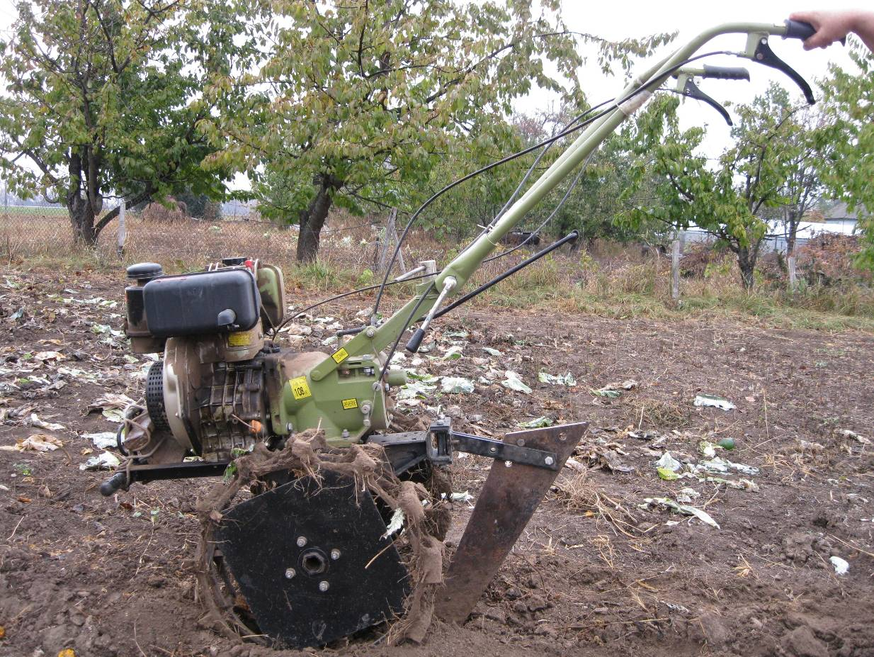
Pic. 2. Soil cultivating aggregate composed of the offered working organ and motoblock of ZIRKA IZ 105
That research was conducted on an area of 0,05 hec. after harvesting the vegetable cultures. At humidity of soil of 18 %, thickness of soil of 1,4 МPa and on the depth of 0,35 m. Chaps cutting were executed with the interval of 0,8 m by a net method. A working organ was put into one with the motoblock of ZIRKA IZ 105 with the single-cylinder engine of KM178F, 4-stroke diesel with the air cooler and the power of 4,41 kWt.
The spring cultivating of experimental area showed that:
- moisture of the melted snow accumulates mainly in soil directly in created channels (pic. 3);
- specific resistance of till area by milling cultivators lowered to 6 %;
- we prevent formation on the dense salt crust surface (pic. 4);
- the spring «mature» of soil is even and gradual (pic. 5) .
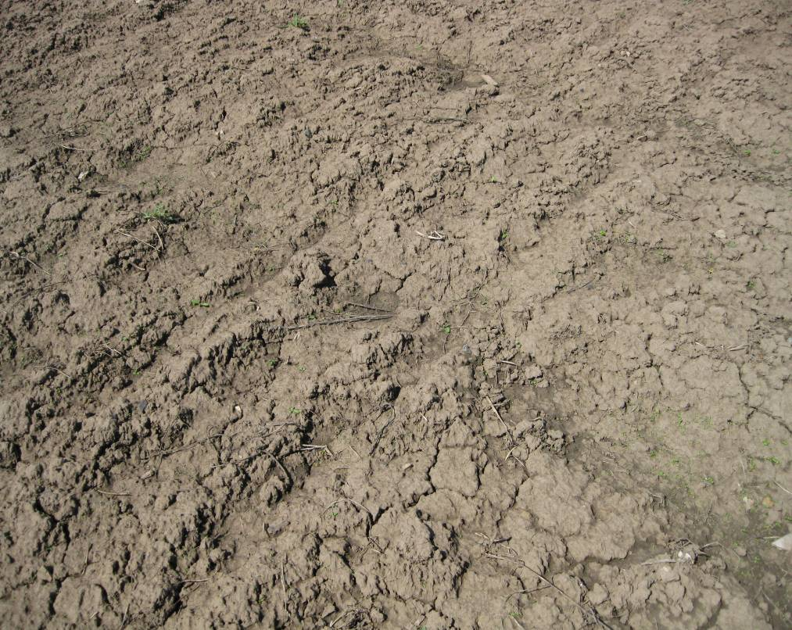
Tracks of autumn deep till
Pic. 3. A spring accumulation of the melted moisture on the experimental area

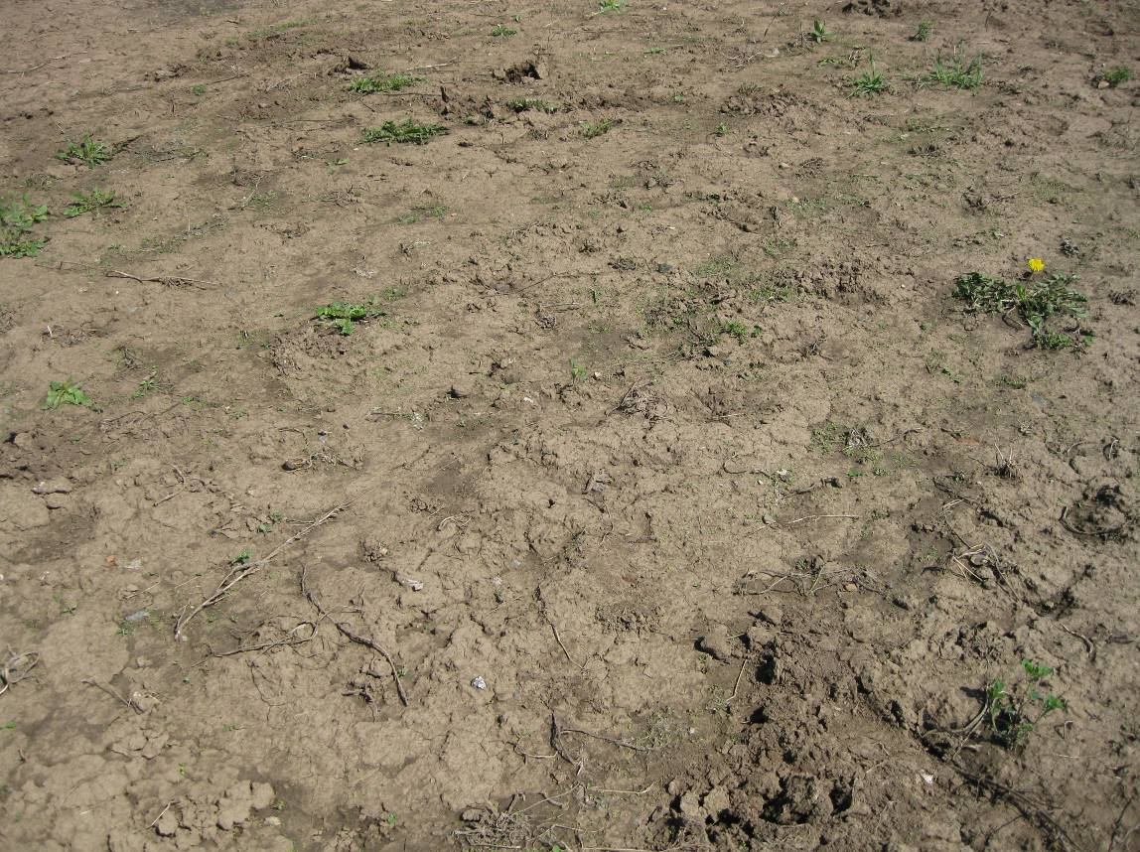

Pic. 4. Beginning of formation of salt crust on an untilled «comparative» area
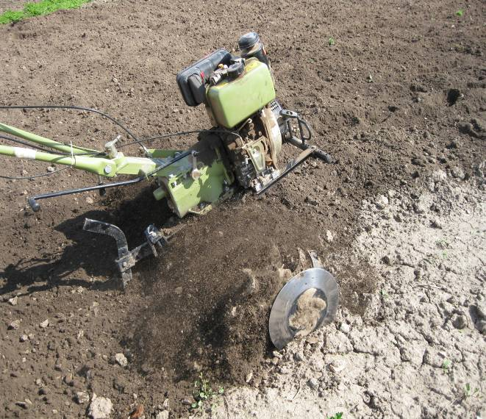
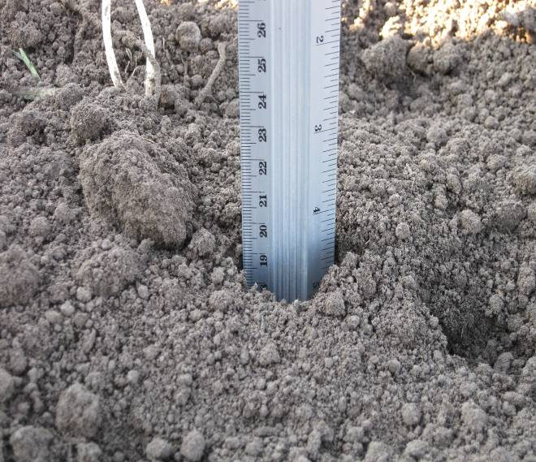
Pic. 5. Soil structure after the till by a rotor cultivator on the depth of 15сm.
Conclusions:
1. We offer the technical solution shaped as a knife of deep soil loosening unit for reduction of sub arable soil layer influence that can appear on a homestead lands as a result of permanent repeat of its till methods, on physic and mechanic soil properties and productivity of agricultural cultures.
2. We showed the advantages of introduction autumn chaps cutting and the results of the field tests.
3. We determined that the effective use of the offered technology of the deep soil loosening on homestead lands reduces the thickness of soil in 2–3 times.

BIBLIOGRAPHY

1. Артоболевский И. И. Теория механизмов и машин / И. И. Артоболевский. – М. : Наука, 1988. – 639 с.
2. Бабицький Л. Ф. Деформація ґрунту залежно від форми робочого органу / Л. Ф. Бабицький // Вісн. с.-г. науки. – 1978. – №6. – С. 84–87.
3. Василенко П. М. Теория движения частиц по шероховатым поверхностям сельскохозяйственных машин / П. М. Василенко. – К. : УАСХН, 1960. – 284 с.
4. Желиговский В. А. Элементы теории сельскохозяйственных машин и механической технологии сельскохозяйственных материалов / В. А. Желиговский. – Тбилиси : СХИ, 1960.

