© 2015
Kharak R. M., Candidate of Engineerings Sciences,
Levchuk V. I., Candidate of Engineerings Sciences,
Lykhvenko S. P., Senior Teacher
Poltava State Agrarian Academy
EXPERIMENTAL RESEARCH OF DIRIGIBILITY AND HAULING INDEXES OF THE 14 КН CLASS TRACTOR ON THE PLOUGHING
Reviewer is Candidate of Engineerings Sciences V. V. Loyenko
The results of experimental research of dirigibility, hauling and economic indexes of arable aggregate in composition the tractor of MTZ-50 with the plough of PN 3-35B on stubble with the differential and blocked interwheeled drive of back bridge are presented. As a result of analysis of research results worsening of dirigibility of tractor is set at the blocked drive comparatively with a differential. At the same time, the considerable diminishing of skidding and increase of aggregate hauling efficiency (about 10 %) at the blocked drive were noticed. Researches of tractor are conducted also by hauling recommendation at motion in a furrow depth 30 cm (right wheels) and on stubble (left wheels) on III, IV and the V transmissions. The results allow to draw a conclusion about the substantial improvement of hauling indexes of tractor with the blocked interwheeled drive.
Keywords: revolving moment, ploughing, plough, tractor, tractive force, expense of fuel, hauling description, dirigibility, stubble, lateral forces, angle of slope of tractor, guided wheels, hauling efficiency.

Statement of the problem. On the tractors of production of Minsk tractor factory of class of 14-20 кН the system of blocking of anchorwomen of wheels of back bridge with a hydraulic occasion is set. It allows to execute different hauling operations with the blocked or differential gear with the purpose of improvement of hauling-couplings indexes of agricultural aggregates.
In the process of ploughing right wheels of tractor are in a furrow, and left are on the stubble, consequently in the different terms of coupling. In addition, a redistribution of tractor weight between right and left wheels as a result of his transversal inclination which also influences on hauling-couplings qualities of arable aggregate. Work of aggregate in such terms influences also on dirigibility of tractor.
In this connection research of influencing of the blocked occasion on hauling-couplings and economic indexes and dirigibility of arable aggregate causes certain interest.
Analysis of recent publications which began a solution of the problem. Blocking interwheeled a differential is used in the constructions of many known tractors build companies of the world: CAT, CASE, NewHolland, JohnDeer, Kubota, KHTZ, LTZ et cetera. Beginning from 1968 the system of blocking interwheeled a differential with a hydraulic occasion is inculcated on the tractors of MTZ. At one time researches of efficiency of its action were conducted on a department «Tractors and Cars» of the Poltava State Agricultural Institute on the requirement specification of Minsk Tractor Factory [1].
Not all results of researches of this self-supporting subject (which was executed the collective of department under the direction of D. I. Mel'nikov) to this time was analysed. They can have objective interest both today and in the future at appearance of new materials and technologies for the tractor wheeled modules.
Dirigibility and firmness of motion of tractor in the conditions of the different coupling of wheels at their blocked and differential occasion were probed on the base of engine MTZ-80 [2]. Results of researches of distributing of revolving moments between anchorwomen by wheels in the process of ploughing [3] allowed to come to the conclusion that dirigibility of tractor at blocked between the wheeled gear worsened, and hauling-couplings indexes are improved. Blocked gear also results in the increase of expense of fuel.
A research purpose was establishment of influencing of blocking of interwheeled differential of the tractor MTZ-50 with the plough of PN 3-35 B in the process of ploughing of stubble of winter wheat on his dirigibility and hauling-couplings and economic indexes.
For determination of criteria of dirigibility of tractor ploughing was carried out on a depth 15, 20, 25 cm and work of aggregate on the third transmission.
For the evaluation of hauling-couplings indexes of tractor ploughing was executed on a depth 30 cm.
Researches of tractor hauling description on III, IV and V transmissions at motive in a furrow in depth 30 cm (transversal inclination of tractor was within the limits of 120°±30`) at the blocked and differential gear of anchorwomen wheels were also conducted.
Researches were conducted in obedience to agreements with the Minsk Tractor Factory [1].
Revolving was measured moments on anchorwomen wheels of tractor, lateral forces and forces of resistance of the guided wheels and their corner of turn, turns of crankshaft, skidding, expense of fuel, rate of movement, tractive force on a hook. Other indexes were determined after formulas which presented in [2].
Materials and research methods. For the receipt of necessary information on the tractor of MTZ-50 strain devices, which provided possibility directly to measure the value of revolving moments on anchorwomen wheels of tractor and their frequency of rotation, frequency of rotation of crankshaft of engine, rate of movement of tractor, expense of fuel, corner of turn of the guided wheels, lateral forces and forces of resistance to rolling of the guided wheels were set. Research parameters were written down on oscillogram with the use of strain laboratory on the base of car GAS-53А.
Oscillogram was processed after a standard method with the use of computer technique.
Hauling description of tractor on ploughing turned out after a standard method [6 ]. In quality loading on a hook the tractor of MTZ-50 was used, and loading changed by including of different transmissions on this tractor. The indexes of hauling description were determined after formulas, presented in [3].
Results of researches. Registration of power action of hanging plough PN 3-35Б on the tractor MTZ-50 was conducted at three values of depth of ploughing: 15, 20 and 25 cm on the third transmission. At loadings on the hook of tractor, near to nominal, when total circulating moment on anchorwomen wheels ΣМ_{к} = 10,9-11,94 кН•м, the total values of lateral forces which operate on the guided wheels have a small size comparatively ΣР_{bp} = 0,539-0,955 кН. Stabilizing moment which created lateral forces of the guided wheels did not exceed the size of M_{st} = M_{pov} = 1,3-2,0 кН•м, that testifies to the comparatively small size of declining moment which operating from the side of plough on a tractor.
Lateral forces which operating on the guided wheels were distributed so that on a right wheel which moves in a furrow, on all loadings modes 1,3–1,5 had lateral force times more than on the field wheel which moves for stubbles.
That touches forces of resistance of R_{fp} that operate in the area of the returned guided wheels diminishing of size of these forces at growth of depth of ploughing in a considerable measure explained unloading of these wheels at the increase of the hauling loading on a tractor.
From data of researches corners of turn of the guided wheels which provide the origin of lateral forces for balancing of declining moment of M_{ot} which created a plough were in limits α = 2,3–4,80⁰ that considerably below corner of turn of the guided wheels at which automatically turned off blocking interwheeled a differential.
From data of researches middle efforts of tractor driver on a steering wheel at ploughing did not exceed 13,5 Н that testifies to sufficient lightness of management a tractor. But it follows to mean that loading on a tractor driver at arable aggregate grows because he must constantly hold the guided wheels returned on a corner 2,3–4,80⁰. Also the body of tractor driver is constantly inclined to the right on a corner about 120⁰ at ploughing on a depth 30 cm. As a result of research of hauling indexes of tractor at implementation of ploughing on a depth 30 cm is got next information. A tractor with the deblocked differential develops maximal power on the hook of N_{г} = 18,4 kilowatt at tractive of P_{g} about 14 кН force, here skidding δ = 0,34. Hauling efficiency of tractor in this mode does make η_{т} = 0,54.
During work of aggregate in the same terms at a blocked differential on a hook increased power to 26,2 kilowatt (on 42,4 %), skidding diminished to 0,1 and hauling efficiency grew to 0,60 (on 11 %). Growth of power on a hook and hauling efficiency at a blocked differential carried out, mainly, due to diminishing of skidding (almost in 3,4 times) and increase here upon of speed aggregate that from 1,36 to 1,75 m/с (on 28,7 %). Consequently, the analysis of hauling indexes of arable aggregate at ploughing shows efficiency of application of the blocked interwheeled occasion of tractor. Analysing the constituents of hauling efficiency (pic. 1, 2) it is possible to see that efficiency of transmissions η_{тр} little depends on blocking of differential, but increased from 0,80 to 0,86 at growth of tractive of Р_{г} force.
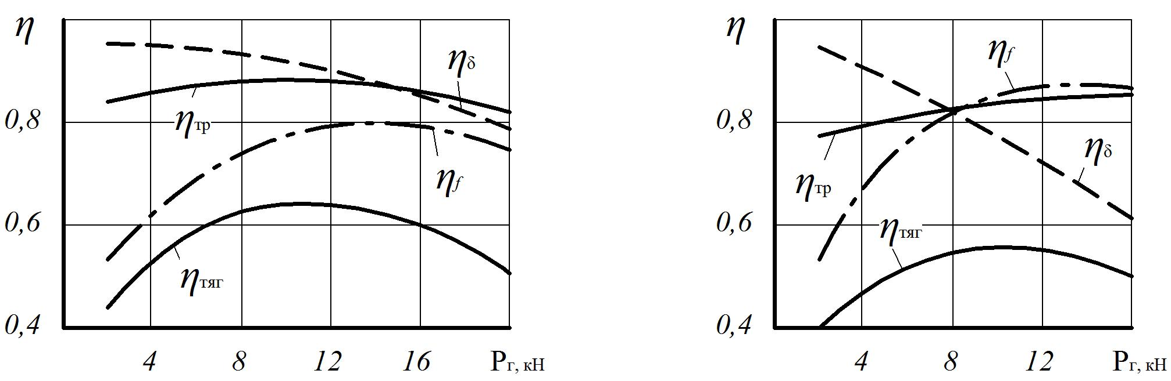
Pic. 1. Constituents of hauling efficiency at the blocked interwheeled gear
in the process of ploughing
Efficiency that takes into account losses on skidding diminishes at the increase of effort on a hook: at the deblocked gear – from 0,97 to 0,60; at blocked gear – from 0,97 to 0,80.
Pic. 2. Constituents of hauling efficiency at the differential interwheeled gear in the process of ploughing
Efficiency what does characterize losses related to work of working part η_{f} rises from 0,53 at Р_{г} = 2 kHz to 0,88 at Р_{г} = 13 kHz at a blocked differential.
Blocking a differential results in the promoted deformation of tires and supporting surface at roll of anchorwomen of wheels as a result a power consumption is increased to work of blocked anchorwomen of wheels, but it is compensated the considerable increase of hauling properties and diminishing of skidding of tractor.
An analysis of hauling description of tractor on III, IV and V transfer speed in the conditions when the right wheels of tractor move in a furrow in depth 30 cm, and left for stubbles, allows to do next conclusions.
At the differential interwheeled gear (pic. 3) on III transfer speed maximal tractive force is provided on the hook of Р_{г} = 20 kHz, at skidding δ = 0,44 when at the same tractive force and blocked interwheeled gear (pic. 4) skidding is 0,164, that in 2,68 times less, and maximal tractive 22 kHz force at skidding 0,260.
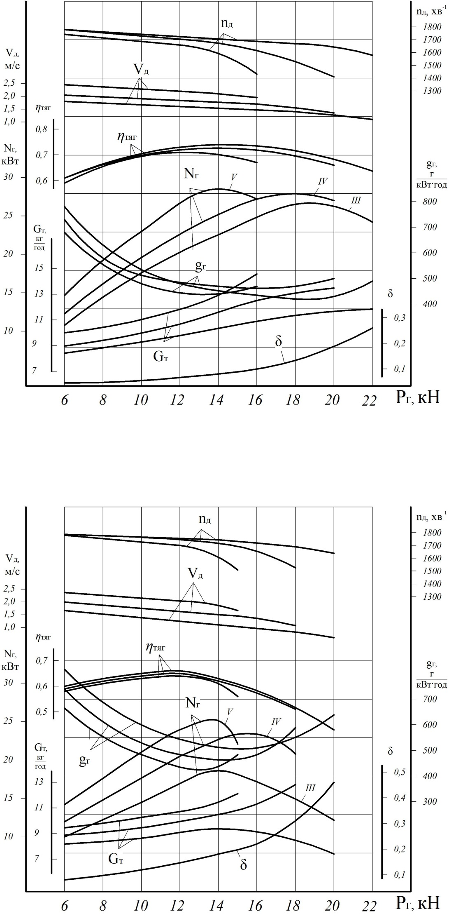
Pic. 3. Hauling description of tractor MTZ-50 at the differential interwheeled gear

At the basic value of tractive force on the hook of tractor (14 kHz) on the III transmission and differential gear of skidding is 0,16, and at the blocked gear is 0,096, rate of movement of tractor according to 1,33 and 1,55 m/с, hauling efficiency are 0,63 and 0,69.
Consequently, the productivity of aggregate at the blocked gear on the III transmission and nominal loading on the hook of 14 kHz grows on 16,54 %, mainly due to diminishing of skidding, here expense of fuel in an hour Gт grows on 8,86 %. A specific hook expense of fuel g_{г} is at the blocked gear on 21 % more than at a differential.
On the IV transmission at the blocked gear a tractor develops maximal tractive force on the hook of 20 kHz, and at a differential is 18 kHz. The productivity grows at the blocked gear and nominal loading of 14 kHz on 11,11 %, and the expense of fuel in an hour increased on 11,59 %, a specific expense does not change. Hauling efficiency at a differential gear is 0,62, and at blocked is 0,68.
Pic. 4. Hauling description of tractor MTZ-50 at the blocked interwheeled gear
On the V transmission at a differential gear maximal tractive of tractor force makes 15 kHz, and at blocked is 16 kHz. The productivity at the blocked gear and nominal loading grows on 9,09 %, and the expense of fuel in an hour increased on 12,91 %, a specific expense does not change substantially.
Consequently, as a result of analysis of hauling and economic indexes of tractor of MTZ-50 after experimental hauling description on ploughing find out that the blocked gear allows to increase maximal tractive force on a hook, to decrease skidding and promote the productivity at nominal tractive force on a hook on 9,12 %. At the same time, application of the blocked gear results in growth of sentinel expense of fuel within the limits of increase of the productivity, in comparing to the differential occasion.
Conclusions: 1. At ploughing of stubble by the tractor of MTZ-50 with the plough of PN 3-35Б for providing of proof motion of tractor in a furrow it is necessary to hold the front wheels of tractor returned on a corner 2,3–4,80º depending on the depth of ploughing. Middle efforts on a steering wheel do not exceed 13,5 Hz.
2. In the process of ploughing on a depth 30 cm at the blocked interwheeled gear the skidding of tractor is compared to the differential gear diminished on 11 % and hauling efficiency grew on 11 % that testifies to the positive influencing of blocking on the hauling indexes of arable aggregate.
3. Blocking of the interwheeled differential results in the promoted deformation of tires of anchorwomen of wheels of tractor and supporting surface, as a result power consumption is increased to work of working part but it is compensated diminishing of skidding and improvement of hauling indexes of arable aggregate. At the same time there is growth of expense of fuel in an hour at a blocked gear.
4. Analysis of hauling and economic indexes of tractor of MTZ-50 after hauling description at motive right wheels in a furrow in depth 30 cm and left is for stubbles allows to look after the increase of maximal tractive force on all transmissions at the blocked gear of back wheels, diminishing of skidding, growth of hauling efficiency and productivity (mainly due to diminishing of skidding). At a blocked gear the expense per hour of fuel grows practically adequately with the increase of the productivity, and a specific expense does not almost change.
BIBLIOGRAPHY
- Исследование управляемости и нагруженности силовой передачи трактора кл. 1,4 тс с автоблокирующимся дифференциалом : отчеты о НИР / Полтавский сельхозинститут. – МТЗ. – №517. – Полтава, 1973.
- Лихвенко С. П., Харак Р. М. Експериментальне дослідження стійкості прямолінійного руху трактора в умовах різного зчеплення ведучих коліс / С. П. Лихвенко, Р. М. Харак // Вісник Полтавської державної аграрної академії. – 2012. – №1. – С. 178–180.
- Лихвенко С. П., Харак Р. М. Аналіз роботи орного агрегату з трактором МТЗ-80 із диференціальним і блокованим міжколісним приводом / С. П. Лихвенко, Р. М. Харак // Вісник Полтавської державної аграрної академії. – 2013. – №3. – С. 171–174.
- Мельников Д. И. Экспериментальное исследование тягових свойств колесного трактора кл. 1,4 тс с блокирующимся дифференциалом / Д. И. Мельников, Г. Ф. Скоробагатый, В. Ф. Синель-ник // Тр. Харьк. с-хин-таим. В. В. Докучаева. – Т. 193. – Харьков, 1974. – С. 50–55.
- Скоробагатый Г. Ф. Исследование нагруженности ведущих полуосей трактора МТЗ-80 с автоблокирующимся дифференциалом на пахоте. Совершенствование конструкций, улучшение ремонта и эксплуатации сельськохозяйственних машин / Г. Ф. Скоробагатый, С. П. Лыхвенко,
А. И. Пилипенко // Тр. Харьк. с-хин-таим. В. В. Докучаева. – Т. 215. – Харьков, 1976. – С. 57–62.
- Тяговые характеристики сельськохозяйственных тракторов : [альбом-справочник]. – М. : Россельхозиздат, 1979. – 240 с.

