© 2015
Dryuchko A. G., Candidate of Chemical Sciences,
Storozhenko D. A., Candidate of Chemical Sciences,
Bunyakina N. V., Candidate of Chemical Sciences,
Ivanitskaya I. A., Candidate of Chemical Sciences,
GolubâtnikovD. V., student,
Kitaygora K. O., student
Poltava National Technical University named in honor of Yuriy Kondratyuk
TRANSFORMATIONS IN NITRATE PRECURSORS SYSTEMS AT PREPARATORY FORMATION STAGES OF RARE-EARTH ELEMENTS CONTAINING OXIDE FUNCTIONAL MATERIALS
Reviewer is Candidate of Physico-Mathematical Sciences A. T. Loburets
Using the complex of physical chemistry methods the authors studied nature and special features of chemical interaction, thermal transformation (25–1000 ºC) of structural components in the system of nitrates of neodymium and potassium as model of the systems of nitrates of rare-earth elements and elements IA of the group of periodic system, ammonium, which are now widely used in the syntheses, the technological regulations of the creation of the functional materials of different designation with the assigned complex of structurally sensitive characteristics. A number of special features and regularities in their joint behavior was discovered.
The keywords: neodymium, potassium, nitrates, complexion, coordination compounds, thermal transformations, property.

Statement of the problem. Considerable attention that now is being paid to the study of nanoscale materials, primarily, is due to significant differences of their properties from the properties of bulk materials of the same composition and is the result of detection by them of quantronix effects.
For obtaining the nanosized inorganic materials on oxides of transition and rare earth elements, the most promising is the use of methods of «soft chemistry» based on synthesis from aqueous or non-aqueous solutions at relatively low temperatures. Their key advantages are: the possibility of obtaining products with controlled composition and micromorphology, efficiency, environmental acceptance and so on. Unfortunately, the vast majority of the currently known studies does not make it possible to formulate general principles for creation of nanomaterials possessing the assigned composition, micro- and mesostructure, functional characteristics. The main reason for this is that the mechanism of nanoparticles formation in these conditions is rather complex from physico-chemical point of view and may include parallel processes of hydration (solvation), association, complexation, formation and transformation of heterophases, laws of which are poorly understood. In this regard, one of the main challenges in the development of reproducible methods for the directed synthesis of nanodispersed materials using approaches of «soft chemistry» is a detailed study of mechanisms and dynamics of processes taking place during formation of nanoparticles. Such fundamental study envisages a systematic study of the composition and micromorphology of intermediate compounds, that in most cases determine the microstructure and structure-sensitive characteristics of the final functional nanomaterials.
Modern REE oxides-containing functional materials are extremely diverse. A common uniting point for all of them is the structure. Transition metals in structure of complex oxides coordinate oxygen poledra of different configurations. The structure of substances is formed by various combinations between polyhedra, which in different combinations can be united by vertices, edges, faces. In cavities formed by fragments of polyhedra rows the larger cations of alkali, alkaline earth, rare-earth elements are placed. Many properties of complex oxides depend not only on their composition and structure but also on defect structure that purposefully allows to influence their target parameters.
Analysis of major studies and publications which initiate the problem’s solution. At present, the search of new methods and complex technologies for the synthesis of special, functional REE oxide-containing materials with a liquid multi-component nitrate systems [2–25] is being carried out. Such technological schemes are based on the production of fine powder materials by chemical homogenization of initial components in joint selection of products from the liquid phase by sequential or joint deposition followed by heat treatment in the form of their hydroxides or other insoluble compounds; the use of a thermolysis method of a solvent, ionic and molecular coordination precursors; replacement of a solvent; a spray drying; cryochemical crystallization, sol-gel processes, etc. The synthesis of nanocrystalline materials is a complex scientific and technological problem.
The information about the condition and possible ways of improvement of creation technologies of REE oxide-containing functional materials is available. The existing requirements to their stability and reproducibility properties initiated our study.
The aim of this work is a basic research of cooperative processes proceeding upon obtaining the oxide rare earth-containing functional materials using nitrates of elements of various electronic structure and finding the possible methods of influence on liquid-phase and solid-phase systems based on thermal activation of reagents for reproducing their structure-sensitive characteristics. In the work to assess the management of these processes and to obtain materials with the desired properties as model it was studied the system , components of which specify the technical characteristics of the synthesis product or modify its physical properties. The choice for studies of neodymium nitrate (as representative of the rare earth elements of cerium subgroup) is determined by existing statistical data about the most probable changes in composition or structure of the compounds created by neodymium while passing from lanthanum to lutetium in a natural number. The choice of values for the temperature section 50 ^{о}C for studying the solubility isotherms of the system is determined by instability of hexahydrate of neodymium nitrate and start point of its melting in crystalization water at 68 ^{о}С, above which it is in a liquid highly viscous metastable condition.
To solve this problem, our research were focused on:
- solid analytical literature review of the available scientific information on the subject of the work;
- the choice of methods and means of physico-chemical studies of a model system;
- mastering the methods and techniques of preparation and conduct of the experiment;
- experimental study of chemical interaction of components, heterogeneous equilibria in water-salt system (50 °C) with the application of complex physico-chemical methods;
- building the isothermal solubility chart system. Determination of concentration limits of original compounds crystallization and identified of complex salts in the system;
- identification of optimal growth conditions and performing the synthesis of coordinating neodymium nitrates and potassium examination of their properties and confirmation of identity;
- thermographic study of solid phases produced in the system of neodymium nitrate and potassium from solutions – solution-melts, melts;
– clarification the nature and peculiarities of sequential thermal transitions in the rare earth-containing nitrate multicomponent systems in different aggregate states during the heat treatment;
– using the acquired knowledge to justify the preparatory processes in the production of REE-containing functional materials for various purposes, development of possible ways to control them.
To clarify the nature of chemical interactions and phases equilibria in water-salt system of the studied nitrates (precursors of multicomponent oxide functional materials) in full concentration ratios in a temperature range of solutions existence the method of solubility, described in [1, 6], was used.
The method allows to find the limits of self-development, to which in specific conditions in equilibrium state the isolated system of this composition aims.

The transformations nature of solid phases, crystallizing in the investigated ternary system was studied using the method of thermal analysis on derivatograph Q–1500 D, the developed thermo-analytical complex, as well as methods of elemental and X-ray analysis.

The experimental part. In this work as source salts there were used hydrated and anhydrous nitrates of these elements of the brand «p.f.a.», additionally purified by recrystallization.
Heterogeneous equilibria in aqueous system of nitrate salts was studied isothermally at 50 °C in dry air thermostat, with continuous mixing using the mixing electromagnetic multi-device. The equilibrium of phases was established within 1–2 days. Sampling of liquid and solid phases of the investigated mixtures for preventing crystallization and maximum separation of mother mix were carried out by a special samplers in the same isothermal conditions using the forvacuum pump.
The chemical analysis of liquid and solid phases, the «leftovers», were tested on the content of Nd³⁺ ions, they were determined trigonometrically; ions К⁺ were calculated according to the difference concerning the total content of nitrates in dry residue. The obtained experimental data from the studied system for individual ions were calculated according to their salt content, generalized, summarized in table 1 and according to the correspondent principles were applied to the solubility chart (Pic. 1).
- Data of phase equilibria study in the system KNO₃ – Nd(NO₃)₃ – H₂0 at 50 ⁰С

Points of composi-tion | Saturated solution |  |  |  | Composition of «leftovers»,  wt. % |  | Solid phases*
Points of composi-tion | Composition, wt. % |  | Properties |  |  |  | Solid phases*
Points of composi-tion | KNO₃ | Nd(NO₃)₃ | d·10³ кг / м³ | n | KNO₃ | Nd(NO₃)₃ | Solid phases*
1 | 2 | 3 | 4 | 5 | 6 | 7 | 8
1 А | 44,88 | 0,00 | 1,223 | 1,3748 | 100,00 | 0,00 | А
2 | 40,12 | 8,67 | 1,391 | 1,3862 | 97,93 | 1,25 | Also
3 | 35,21 | 20,31 | 1,514 | 1,4014 | 95,68 | 1,72 | « - »
4 | 28,46 | 38,81 | 1,602 | 1,4406 | 94,51 | 3,22 | « - »
5 | 26,80 | 48,65 | 1,858 | 1,4659 | 94,03 | 4,36 | « - »
6 |  |  |  |  | 91,54 | 5,56 | « - »
7 |  |  |  |  | 74,51 | 23,07 | А + В
8 D | 27,26 | 51,82 | 2,092 | 1,4781 | 37,95 | 52,73 | Also
9 |  |  |  |  | 33,84 | 56,49 | В
10 | 24,08 | 53,28 | 2,064 | 1,4764 | 34,07 | 57,16 | Also
11 |  |  |  |  | 34,58 | 57,29 | « - »
12 E | 21,34 | 54,91 | 2,068 | 1,4791 | 31,95 | 60,97 | В + Г
13 |  |  |  |  | 29,82 | 65,46 | Г
14 | 17,03 | 57,09 | 1,960 | 1,4772 | 30,12 | 66,91 | Also
15 | 13,94 | 61,08 | 1,969 | 1,4778 | 29,23 | 66,65 | « - »
16 |  |  |  |  | 29,61 | 67,07 | « - »
17 F | 11,49 | 63,31 | 2,124 | 1,4822 | 15,17 | 70,18 | Г + Б
18 |  |  |  |  | 8,01 | 70,76 | Also
19 | 4,44 | 66,02 | 1,964 | 1,4726 | 1,76 | 72,49 | Б
20 С | 0,00 | 66,16 | 1,974 | 1,4667 | 0,00 | 75,28 | « - »

*А – KNO₃; Б – Nd(NO₃)₃·6H₂0; В – K₂[Nd(NO₃)₅(H₂O)₂]; Г – K₃[Nd₂(NO₃)₉]·H₂O

Graphical display of composition of solid phases formed in the system was carried out according to Schreinemakers [1, 6]. Their identity was confirmed by chemical, X-ray phase, thermal and other methods of analysis.
Pic. 1. Solubility system isotherm KNO₃ – Nd(NO₃)₃ – H₂0 at 50 °C
The study of mutual behavior of structural components in a liquid phase and phase of equilibria in the system of potassium nitrate – neodymium nitrate – water, the building of its solubility isotherms allow to determine the concentration boundaries of separation into the solid phase of potassium coordinating neodymium nitrates. The obtained data allowed to make the choice of optimal conditions of separation of complex nitrates and carry out their synthesis by isothermal evaporation of the solvent. In slightly supersaturated mother mixture isometric crystals of binary potassium nitrates were obtained. The habitus of crystals K₂[Nd(NO₃)₅(H₂O)₂] (Fig. 2a), K₃[Nd₂(NO₃)₉]·H₂O (Pic. 2b) is determined by the composition of compounds, the nature and content of their constituent cations, conditions of crystallization and is their diagnostic sign.
The chemical analysis of the synthesized compounds confirms the mass ratio of elements in the above formulas. The conducted X-ray phase analysis of samples indicates that the compounds are characterized by individual set, position and intensity of lines in the diffraction charts (Pic. 3) and it confirms their individuality. Thermographic examination of initial nitrates KNO₃, Nd(NO₃)₃·6H₂O; solid phases formed in the system of neodymium nitrates and potassium; synthesized potassium coordinating nitrates of REE were conducted on the developed thermo-analytical complex for differential thermal analysis and on derivatograph of F. Paulik, I. Paulik, L. Erdei Q–1500 D system.
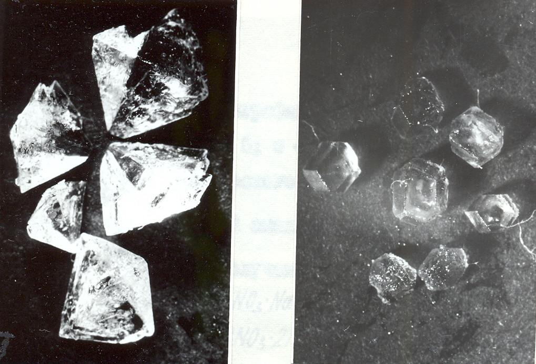
а) b)
Pic. 2. Microphotoes of crystals
а) K₂[Nd(NO₃)₅(H₂O)₂]; b) K₃[Nd₂(NO₃)₉]·H₂O
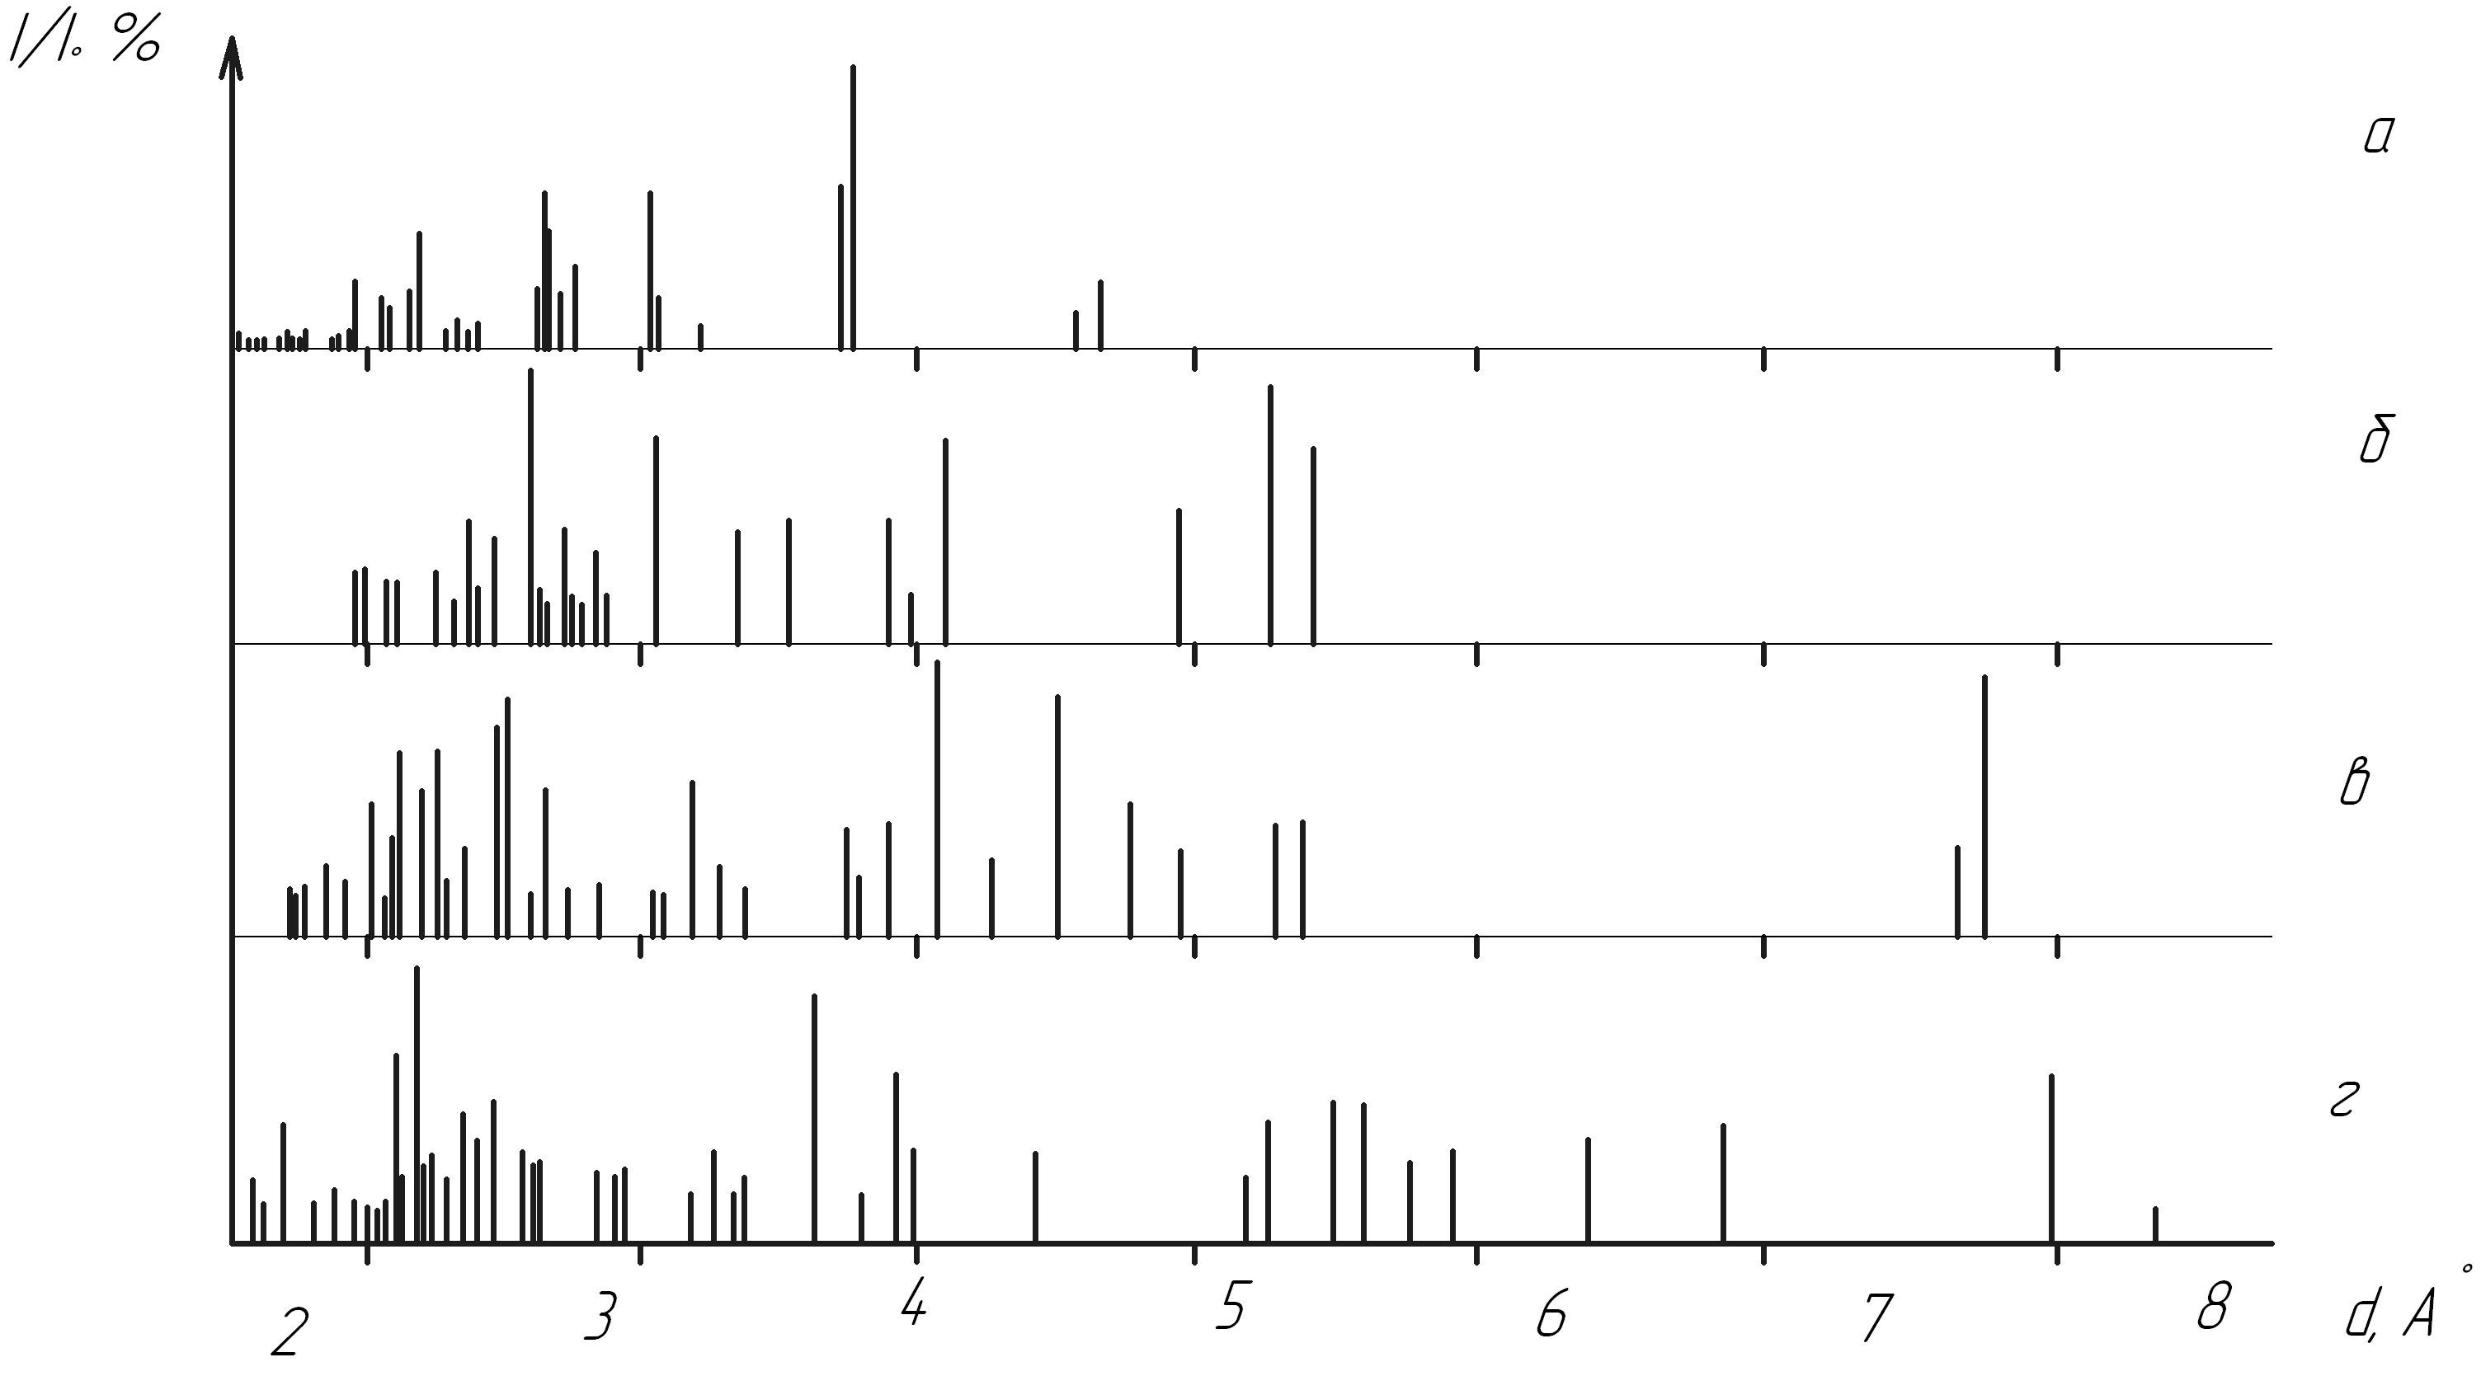
Pic. 3. A stroke X-ray chart of initial salts of nitrates a) potassium, г) neodymium and identified coordination compounds, b) K₂[Nd(NO₃)₅(H₂O)₂], в) K₃[Nd₂(NO₃)₉]·H₂O

The used tools made it possible to investigate physical and chemical transformations in the resulting compounds under the influence of heat and confirmed their indentity.
The results of the research. By physical and chemical methods in water-salt system of neodymium nitrates and potassium at 50 ^{о}C between structural components there were found the exchange interactions with the formation of 2 new anionic coordination compounds. The number, composition, concentration limits of crystallization phases coexisting in the system, the nature of their solubility were studied. The phase diagram of solubility was built. Concentration limits of saturated solutions from which the complex nitrates appear coincide with compositions of nonvariant points of solubility isotherms. All possible types of compounds were found. They all are synthesized in a single crystal form. The systematic study of some of their properties was carried out.
In the studied water-salt systems with the increase of the activation energy of heating the complexometric ability of Ln increases. Competing processes of substitution of H₂O molecules on NO₃⁻-group in presence of Ln³⁺ create conditions for formation of corresponding high symmetric complexes. The different ways of their spatial packing with other structural elements in the crystallization process leads to separation from a liquid phase of anionic coordination compounds of definite composition and structure. The processes of complex formation are affected by the nature of the central atom-complexformer, directed effect on the solutions structure of available singly charged cations (e.g., K⁺), the concentration and character of thermal motion of structural elements. A significant effect of the temperature factors, the need for some activation energy for such transformations and their staging were found. The found peculiarities of the aggregate behavior of structural elements in the studied system indicate that the leaky competing reactions are strong technological factors significantly affecting the changes of the lanthanides structural forms activity.
The authors have also studied thermography of the solid phases formed in the system of neodymium nitrates and potassium to explain some regularities that occur in the studied processes of synthesis of oxide rare earth-containing functional materials, as well as for comparison characteristics that confirms the identity of the received new coordination compounds. The given information of KNO₃ behavior is based on references data [19–22]; Nd(NO₃)₃·6H₂O (Pic. 4), K₂[Nd(NO₃)₅(H₂O)₂], K₃[Nd₂(NO₃)₉H₂O]·H₂O – on data from our own studies (Pic. 5, tables 2, 3).
Thermal decomposition of Nd(NO₃)₃·6H₂O is of a complex character (Pic. 4).
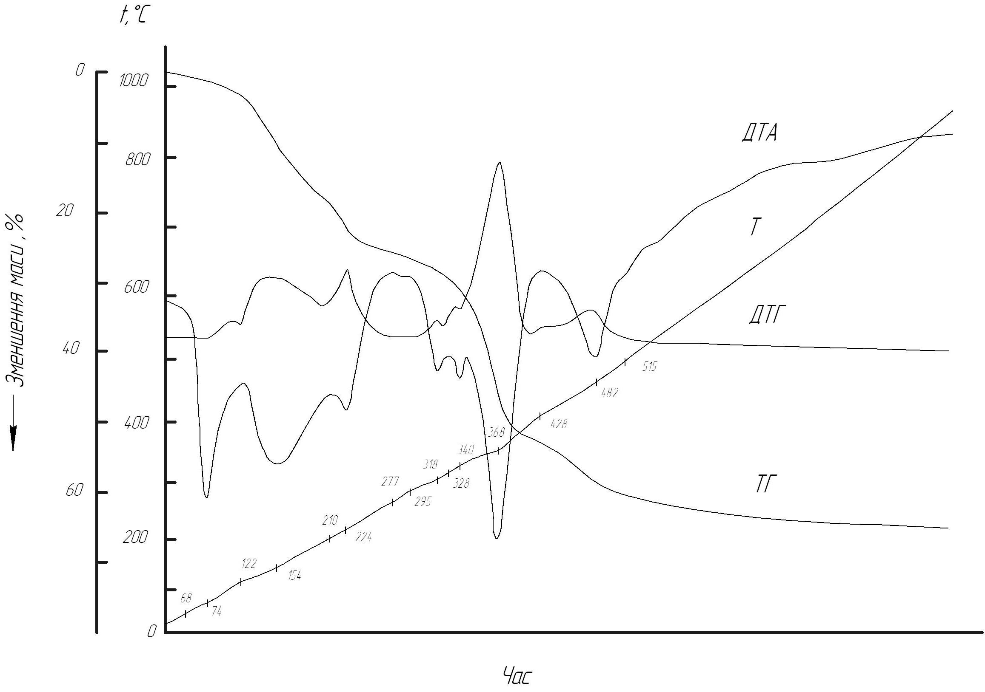
Pic. 4. Derivatograph Nd(NO₃)₃·6H₂O
The obtained results are consistent with the data given in a work [23]. At 74 ^{о}С Nd(NO₃)₃·6H₂O it melts in crystallization water (start melting point is 68 ^{о}С). In temperature range of 74–224 ^{о}С conversions happen in viscous liquid metastable phase, due to instability of its crystallohydrate forms. The peaks on the curves DTA, DTG with extremes 154, 224 ^{о}С correspond to end effects that overlap and are linked with dehydration of a sample according to the scheme:
Anhydrous neodymium nitrate exists in the temperature interval 277–295 ^{о}С. This is indicated by the dominance of relations in the melt crystallohydrate forms of neodymium nitrate in spectroscopic studies [24] and clear stoichiometry and composition of complex oxynitrates formed at later stages of decomposition.
The fact of existence of Nd(NO₃)₃ simplifies elemental analysis of studied samples and allows to do analytical determinations according to dry residue.
In [23] on the base of data from chemical, thermal analyses the scheme of further decomposition of Nd(NO₃)₃ is proposed
(330 ^{о}С),
(356, 365 ^{о}С),
(450 ^{о}С).
According to our data, Nd₂O₃ is formed above 515 ^{о}С.
Thermal transformations identified in water-salt system of potassium coordination compounds of neodymium (representative of the cerium subgroup) and terby (representative of yttrium subgroup) [25] were studied up to 1000 ^{о}С and shown in picture 5.
The temperature values of the identified effects, their character and nature are systematized and summarized in tables 2, 3. The obtained data allow the identification of phases. A number of characteristics and laws was found. Their justification from the positions of competing processes is being done.
Based on the characteristics of obtaining process of oxide REE-containing functional materials there is an interest to limits of concentration ratios of components to which in phase diagrams the crystallization fields of initial nitrates of rare-earth elements, coordination compounds and their mixtures correspond.
The results of thermal transformations studies of new solid phases found in the model system (Pic. 5, tables 2, 3) indicate the different nature of the processes of transformation of compounds of rare-earth elements of cerium and yttrium groups, low and high – temperature of compounds forms of «light lanthanides». Thermograms of elements compounds in the first subgroup are characterized by the formation of anhydrous nitrates. Among compounds with the same name and outer sphere cation the nitrates with a high content of lanthanotus are more heat resistant.
The fact of existence of polymorphism in crystals of composition K₂[Ln(NO₃)₅(H₂O)₂] (Ln – La – Nd) was found. This phenomenon can be explained by the fact that in crystals disorder occurs due to implementation availability of several distinctive orientations of ions NO₃⁻. This kind of disorder is possible due to symmetry of flat NO₃⁻ - ligand, the way of coordinating them by central atom (Ln³⁺- complexing agents), as well as the method of packing complexes into spatial structure.

Temperature of representatives transformations of the coordinating group of REE nitrates

Compounds | Representatives | Dehydration | Melting in crystallization water | Polymmorph transfer | Melting of anhydrous form | Note
K₂[Ln(NO₃)₅(H₂O)₂] | La – Nd | 95,111 | 95 | 219 | 314 | cerium subgroup, values for coord. compounds Nd
K₃[Ln₂(NO₃)₉]·H₂O | La – Sm | 126 | – | – | 347 | cerium subgroup, values for coord. compounds Nd
K[Ln(NO₃)₄(H₂O)₂] | Y, Gd – Lu | 138,172 | 138 | – | – | yttrium subgroup, values for coord. compounds Yb

- The composition of thermolysis products (air, 980 ^{о}С) of coordination nitrates REE, Y and potassium according to the XRD

Compounds | Representatives | Composition of transfer  products
K₂[Ln(NO₃)₅(H₂O)₂] | La – Nd | KLnO₂ , Ln₂O₃
K₃[Ln₂(NO₃)₉]·H₂O | La – Sm | Ln₂O₃
K[Ln(NO₃)₄(H₂O)₂] | Y, Gd – Lu | Ln₂O₃

The temperature properties of yttrium subgroup compounds are characterized by the absence of stable anhydrous forms of nitrates, low melting temperatures, dehydration from the molten state, the formation of Ln₂O₃ (980 ^{о}С).
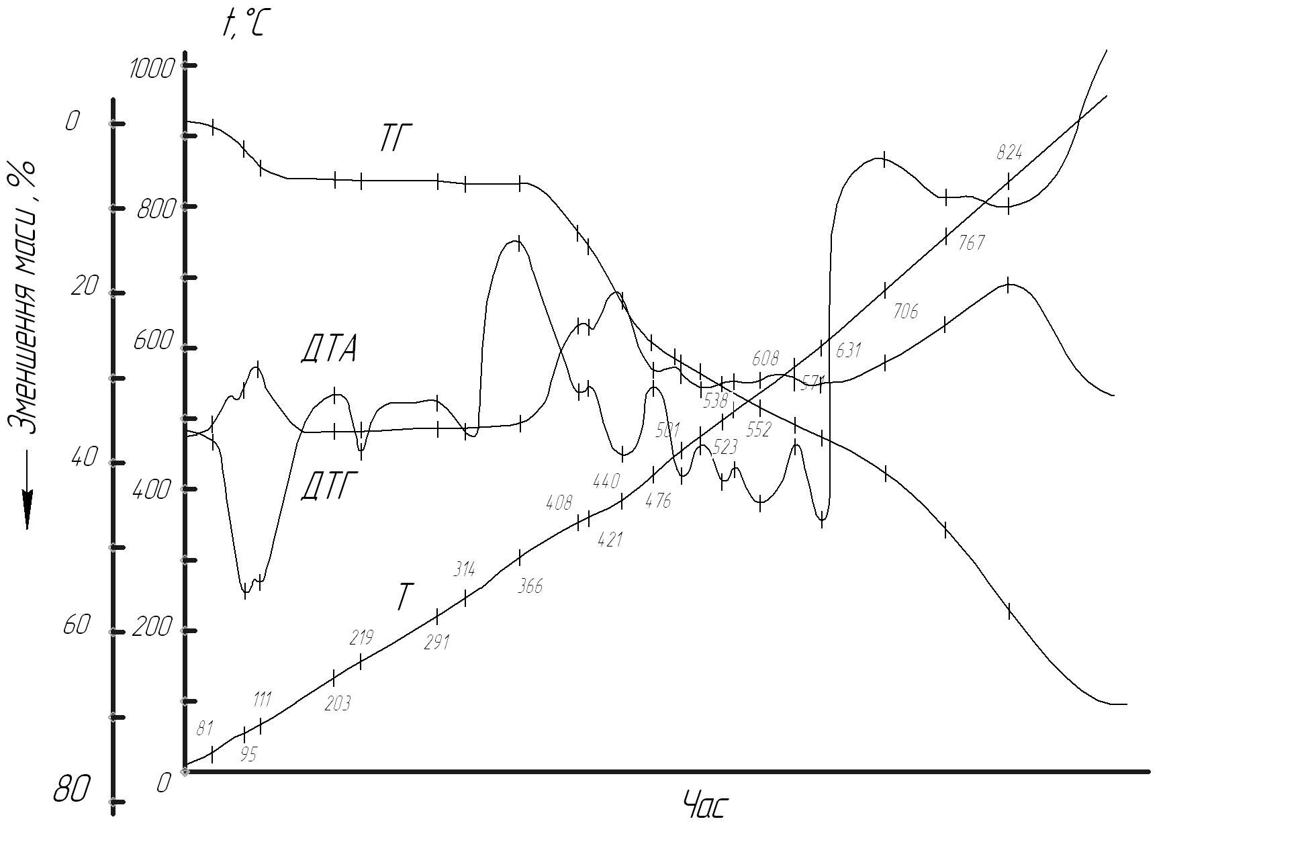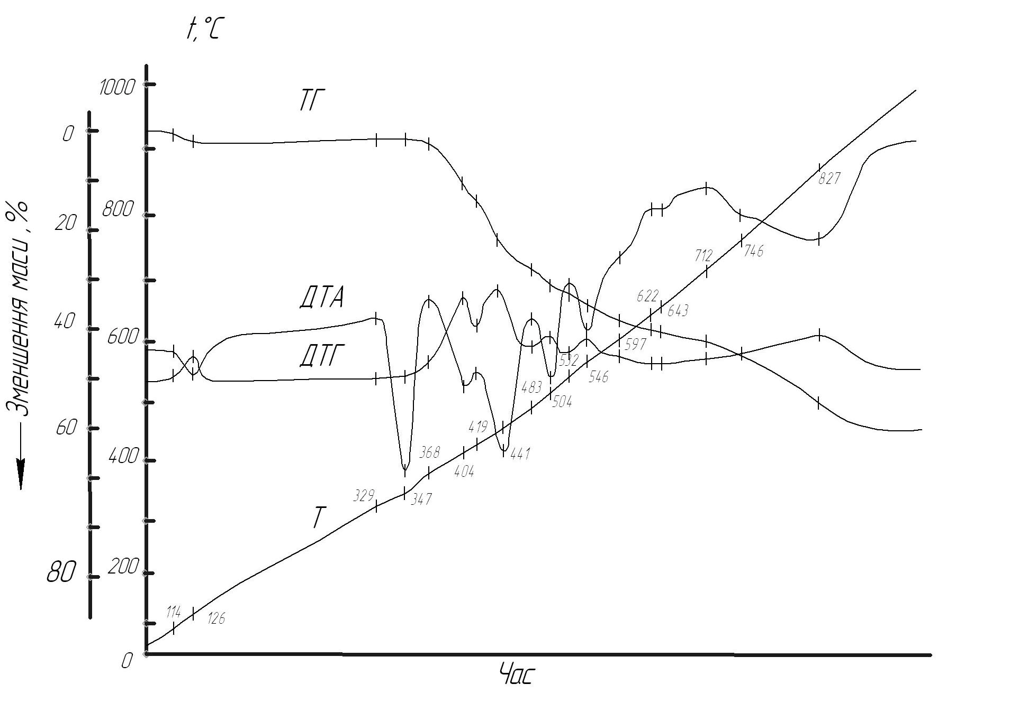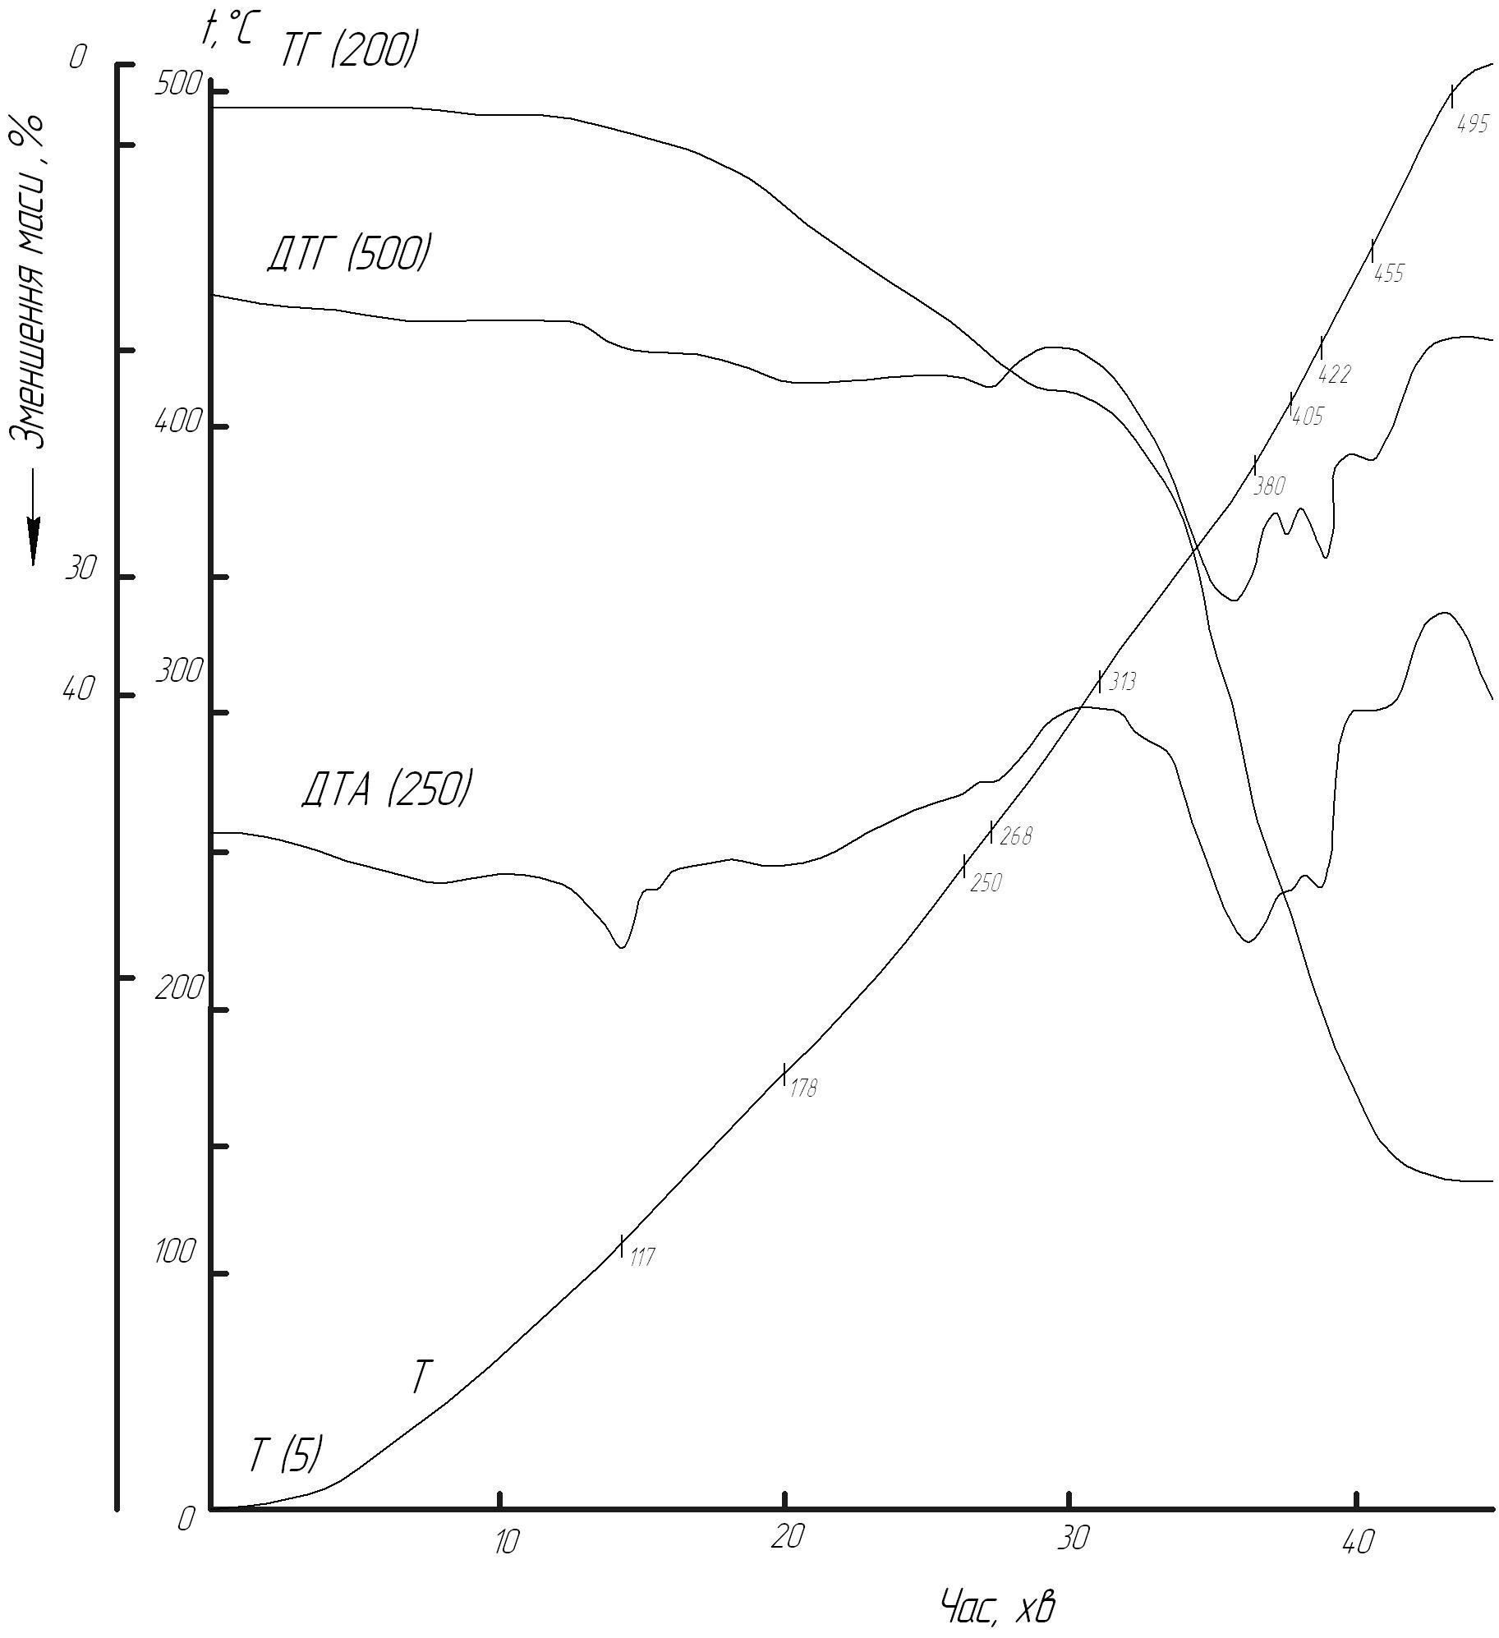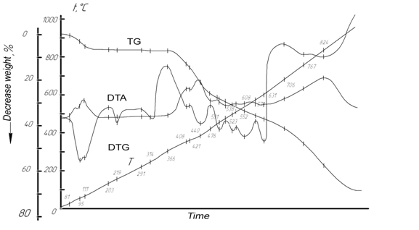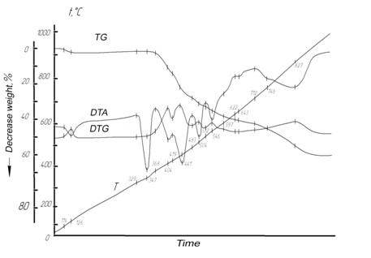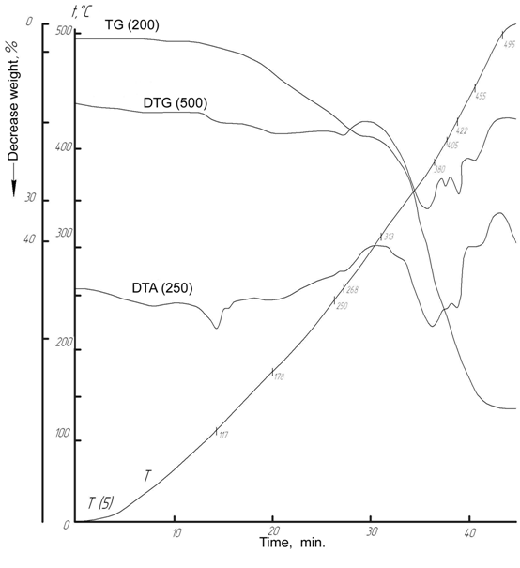
K [Yb(NO
3
)
4
(H
2
O)
2
]
K
3
[ Nd
2
(NO
3
)
9
]
K
2
[Nd(NO
3
)
5
(H
2
O)
2
]
Pic. 5. Derivatograph chart of potassium coordination nitrates of neodymium and therby
The composition of thermal conversion products (about 980 °C) compounds of cerium subgroup depends on the composition of initial nitrates, the degree of volatility of oxides of corresponding alkali metals. In products of thermolysis the compounds K₂[Ln(NO₃)₅(H₂O)₂], except oxides K₂O, contain also their dioxolanthanides KLnO₂.
Analysis of the research results with the study of model systems and system analysis of information obtained from scientific publications on the topic of this paper evidents that a positive feature of the use of these REE-containing nitrate systems compared to other soluble systems of chlorides, oxalates is in that, that competing ion exchange interaction leads to easy formation of a whole class of anionic coordination compounds Ln³⁺ with oxygen atoms (electron donors) NO₃⁻-groups (ligands) of the entire natural range of rare earth elements with all cations of alkali metals, and still stable both in solutions and melts. This allows to carry out technological transformations with a low energy cost (due to low activation energy of the processes of complexation Ln³⁺ with planar small NO₃⁻-groups). Complex compounds are fusible, little aggressive, elements of cerium subgroup are non-volatile. It allows to work at lower temperatures, the temperature range of stability of complex particles increases.
Conclusions:
- the results of the study indicate that processes of obtaining REE oxide-containing structural and functional materials for various purposes using nitrates with various elements of electronic structure by chemical mixing the initial components in joint selection of products from the liquid phase by sequential or joint deposition followed by heat treatment happen stage by stage through the formation of several intermediate phases. Their structure, content and behaviour, in each case, require systematic empirical knowledge about their joint behavior in full concentration ratios in a given temperature interval.
- the differences in the behavior of structural components in systems lanthanides of cerium and yttrium subgroups, the nature of interaction, stages, characteristics and regularities of flow were found.
- new knowledges are the basis for:
● search of ways of increasing the activity of Ln-forms;
● clarification of the nature of serial thermal transformations of nitrate REE-containing multicomponent systems of different aggregate states in the course of their thermal treatment; conditions of formation and existence, properties of intermediate phases; influencing factors; possible methods of control;
● for creation of modern, perfect low-cost technologies for the synthesis of functional various purposes materials with reproducible properties.

BIBLIOGRAPHY
1. Аносов В. Я. Основы физико-химического анализа / В. Я. Аносов, М. И. Озерова, Ю. Я. Фиалков. – М. : Наука, 1976. – 503 с.
2. Белоус А. Г. Влияние способа получения на фазовые превращения, структуру и магниторезистивные свойства манганитов La_{0,7}Sr_{0,3}MnO_{3y} / [А. Г. Белоус, Е. В. Пашкова,
О. И. Вьюнов и др.] // Укр. хим. журн. – 2005. – Т.71. – №5. – С 17–23.
3. Белоус А. Г. Сложные оксиды металлов для сверхвысокочастотных и высокопроницаемых диэлектриков. / А. Г. Белоус // Укр. хим. журн. – 2008. – Т.74. – №1. – С. 3–21.
4. Гавриленко О. М. Кристалохімічні особливості та властивості Li+,{Na+, K+}-заміщених ніобатів лантану і структурою дефектного перовскіту / О. М. Гавриленко, О. В. Пашкова,
А. Г. Білоус // Укр. хим. журн. – 2005. – Т.71. – №8. – С. 73–77.
5. Гавриленко О. М. Літій провідні матеріали на основі ніобатів і танталатів лантану: синтез, структура, властивості / О. М. Гавриленко // Укр. хим. журн. – 2004. – Т.70. – №9. – С 31–34.
6. Горощенко Я. Г. Физико-химический анализ гомогенных и гетерогенных систем / Я. Г. Го-рощенко. – К. : Наукова думка, 1978. – 490 с.
7. Дрючко А. Г. Использование особенностей температурных превращений координационных нитратов РЗЭ при изготовлении изделий электронной техники. / [А. Г. Дрючко, Д. А. Сто-роженко, Н. В. Бунякина и др.] // Науковий вісник КУЕІТУ (Нові технології). – 2004. – №1–2 (4 –5). – С. 53–57.
8. Дурилин Д. А. Синтез, структура и свойства системы твердых растворов La_{0,7}Ca_{0,3-х}Na_{х}MnO₃ / Д. А. Дурилин, О. З. Янчевский, А. И. Товстолыткин [и др.] // Укр. хим. журн. – 2004. – Т.70. – №9. – С 34–37.
9. Кобилянська С. Д. Синтез нанорозмірних систем (Li, La){Ti, Nb}O₃ методом золь-гель /
С. Д. Кобилянська, О. М. Гавриленко, Ю. П. Гомза // Укр. хим. журн. – 2010. – Т.76. – №4. –
С 84–88.
10. Кудренко Е. А., Шмытько И. М., Струкова Г. К. Структура прекурсоров сложных оксидов РЗЭ, полученных методом термолиза растворителя // Физика твердого тела. – 2008. – Т.50. – Вып.5. – С. 924–930.
11. Мазуренко Е. А. Координационные соединения металлов – прекурсоры функциональных материалов / Е. А. Мазуренко, А. И. Герасемчук, Е. К. Трунова [и др.] // Укр. хим. журн. – 2004. – Т.70. – №7. – С. 32–37.
12. Миттра Р. Критический взгляд на метаматериалы. // Радиотехника и электроника. – 2007. – Т.52. – №9. – С. 1051–1058.
13. Парсонидж Н. Беспорядок в кристаллах / Н. Парсонидж, Л. Стейвли. – М. : Мир, 1982. – Ч.1. – 434 с.
14. Пашин С. Ф., Антипов Е. В., Ковба Л. М. Влияние катионного замещения в твердых растворах YBa₂-xSr_{x}Cu₃O_{y} на температуру сверхпроводимости // Сверхпроводимость : физика, химия, техника. – 1990. – Т.3. – №10. – С. 2386–2389.
15. Солопан С. О. Синтез і властивості композиційних структур на основі сегнетоелектричних та магнітних фаз / С. О. Солопан, О. І. В’юнов, Л. Л. Коваленко [та ін.] // Укр. хим. журн. – 2006. – Т.72. – №1. – С 28–31.
16. Термические константы веществ. Таблицы принятых значений / под ред. В. П. Глушко. – М. : Наука, 1978. – Вып.10. – Ч.2. – 442 с.
17. Тітов Ю. О. Особливості механізмів утворення шаруватих скандатів SrLn_{n}Sc_{n}O_{3n+1} із систем сумісно закристалізованих нітратів / Ю. О. Тітов, М. С. Слободяник, Я. А. Краєвська [та ін.] // Укр. хим. журн. – 2010. – Т.76. – №5. – С 11–16.
18. Турцева Т. И., Глизерман В. И. Спектроскопическое изучение водных растворов нитратов редкоземельных элементов // Вестн. Моск. ун-та. Химия. – 1973. – Т.14. – №1. – С. 51–54.
19. Шмытько И. М., Кудренко Е. А., Струкова Г. К. Инициирующее действие непрерывного нагрева на фазообразование при твердофазном синтезе сложных оксидов редкоземельных элементов // Письма в ЖТЭФ. – 2007. – Т.86. – Вып.7. – С. 544–548.
20. Щуров В. Г., Алексеева О. М. Термографические исследования разложения шестиводных нитратов лантаноидов в ряду лантан – самарий. – В кн. : Термический анализ и фазовые равновесия. – Пермь : изд-во Пермск. гос. ун-та, 1982. – С. 38–45.
21. Carling Robert W. Heat capacities of NaNO₃ and KNO₃ from 350 to 800 K. – Thermochim. Acta. – 1983. –V.60. – №3 – P. 265–275.
22. Melcher C. L. // Nucl. Instr. Methods in Phus. Res. - 2005. – V.1, A 537. – P. 6–14.
23. Nissen Donald A. Thermophysical properties of the equimolar mixture NaNO₃ – KNO₃ from 300 to 600ºC. – J. Chem. and Eng. Data. – 1982. – V.27. – №3. – P. 269–273.
24. Ueda K. // 3rd Laser Ceramics Symp.- October 8-10, 2007, Paris, 2007. – P. IO-C-1.
25. Yanagida T., Roh T., et al. // Nucl. Instr. Methods in Phus. Res. – 2007. – V. 1, A 579. – P. 23–26.

