© 2015
Rozhkov A. A., Doctor of Agricultural Sciences
Chernobay S. V., postgraduate student
(scientific adviser is Doctor of Agricultural Sciences A. A. Rozhkov)
THE INFLUENCE OF SEEDING RATES AND FOLIAR FEEDINGS ON THE EFFECTIVENESS OF GROWING OF SPRING BARLEY VARIETY DOKUCHAEVSKIY 15
Reviewer – Doctor of Agricultural Sciences V. I. Filon
The article presents the results of studies conducted during 2012–2014 years on the experimental field of KhNAU named after V. V. Dokuchayev about the impact of the application of different options for seeding rates and foliar application on the variability of grain yield of spring barley varieties Dokuchaevskiy 15. It was set high economic and bioenergetic efficiency of foliar application crops. The highest productivity of grain and the best indicators of economic and bioenergetic efficiency of cultivation were obtained on options for crop seeding rate of 5,0 million seeds/ha. It was also found that the optimization of seeding rate provides the increase of effectiveness of foliar application.
Key words: seeding rate, fertilizing, spring barley, grain yield, economic and bioenergetic efficiency, cost, profitability.

Formulation of the problem. Formation of highly productive grain crops need more than other crops, a regulation complex of factors that determine high biological and economic potential crop plants. This is due to with what during the growing season is a growth and differentiation of vegetative and generative organs and processes that determine not only the amount of material produced by, but also its distribution in the plant, including the accumulation in seeds. Therefore, the formation of productivity should be considered in conjunction with those factors on which indicator depends as the overall biological productivity and its main parts – the crop of grain.
Analysis of recent research and publications which discuss the problem. Numerical studies have shown that the level of competition between plants in crops is a key factor in raising the level of implementation of the resource potential of their productivity [7, 8]. There is no consensus as to stand density at which plants can get maximum yield does not exist yet. To understand the problem, it’s necessary to understand the formation of a crop with the development of its constituent elements. These processes occur in different ways depending on the combined effect of external and internal factors.
Recent advances in breeding for yield show that the higher genetic potential of plant productivity, the greater may be the norm seeding. Obviously this is due to the structure of crops, changing the distribution of assimilates, specific gravity of individual of productivity elements that take part in the formation of the crop.
Increased productivity and improving product quality is always accompanied by extra costs money. Therefore, the benefits of their application depends not only on the increase in yield, but also on economic efficiency, which is an important indicator for assessing expediency distributing the production elements of growing technology that increases the level of productivity [6].
Summary measure of cost-effectiveness ratios are performance and costs of their receipt. Defining criterion of economic efficiency in market conditions is the profit per unit production costs [10].
In recent time along with the economic assessment of all attention of researchers are attracted by energy efficiency evaluation technologies of growing different crops, some technological elements [9]. At present this assessment is versatile and allows us to compare energy intensity of certain measures under different conditions [1, 2, 4]. This approach allows us to give a quantitative characteristic of energy efficiency.
Bioenergy system of indicators is more stable that it is extremely important in a free pricing, inflation processes changes in exchange rates. It is clear that bioenergetic approach cannot replace economic, but it gives a wide-ranging and objective assessment of the effectiveness of cultivation [5].
The intensification of agricultural production and increase yields accompanied by increased bioenergy costs, including by improving the technology of growing crops. Because of this, there is a need to develop energy-saving technologies of cultivation, in which less energy will be spent.
The aim of research was to improve the cultivation technology of spring barley in order to better disclosure the genetic potential of grain productivity of spring barley plants.
The objective of research was to determine the combined effect of seeding rate and foliar fertilizing on the level of implementation of the genetic potential grain productivity of crops of spring barley varieties Dokuchayevskiy 15, substantiation of optimum variants of studied technological elements terms of economic efficiency and bioenergy.
Methods of research. The study was conducted during 2012–2014 years on experimental field KhNAU named after V. V. Dokuchayev based on the rotation of the department plant growing usual method [3].
The plots of the first order were rates of seeding the following options: 4,0; 4,5; 5,0 and 5,5 million of seeds/ha. The plots of the second order were the options foliar fertilizing crops in the phase out of the tube: 1 – control (without fertilizing); 2 – Kristalon particular (dose of 1,5 kg/ha); 3 – Reakom-CP-grain (dose of 5 l/ha); 4 – Kristalon particular + Agro EM; 5 – Reakom-CP-grain + Agro EM. Dose of a biological product Agro EM was 10 l/ha.
Accounting area of sown area of experiment – 30 m². Number of repetitions of the experiment – four. The total number of plots in the experiment – 80. Experiment was founded by split plots in two tiers.
Soil research field – typical black-earth on the carbonate loess. In the arable soil layer contains 4,4–4,7 % of humus, mobile phosphorus (by Chirikov) – 138 mg/kg, of potassium – 103 mg/kg soil.
Place research has unstable character moisture. The rainfall during the growing season in 2012, 2013 and 2014 years amounted to 252,4; 217,1 and 263,9 mm, many years index – 241,0 mm.
The temperature regime during the growing season research especially in 2013 was characterized by a significant increase in this indicator compared to the long-term data. Installed exceeding temperature regime made significant adjustments on the course of plant growth and development, the formation of grain productivity at the same time it is possible to provide a complete, objective assessment of influence of technological elements on the formation of grain yield.
Results of research. In studies we found high influence of investigated technology elements on variability in grain productivity of crops of spring barley. On average over three years of research, the maximum grain yield was 5,0 million seeds/ha – 2,49 t/ha at seed rate (see picture).
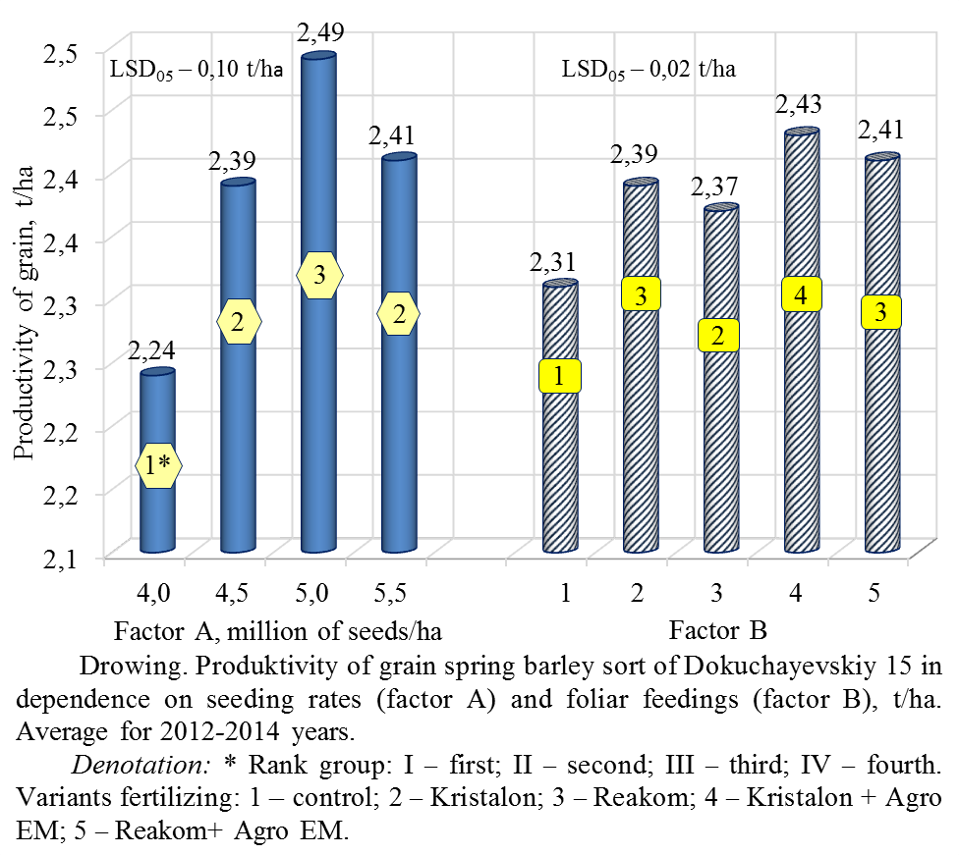
According to statistical calculations of indicators yields of grain depending on the impact of seed rate belonged to different homogeneous groups. With increasing seeding rates increase of grain yield gradually decreased. In particular, the largest increase in grain yield observed with increasing seeding rates from 4,0 to 4,5 million seeds/ha – 0,15 t/ha (6,7 %), with increasing seeding rates from 4,5 to 5,0 million seeds/ha yield increased by 0,10 t/ha (4,2 %). With increasing seeding rates from 5,0 to 5,5 million of seeds/ha marked decrease grain yield by 0,08 t/ha (or 3,3 %).
According to statistical analysis using rank test Uollyer-Duncan, four homogeneous groups of indicators grain yield has experienced depending on the influence of foliar fertilizing crops of polymeric fertilizers and biopreparation Agro EM. Maximum statistically significant increase of grain yield of spring barley varieties Dokuchayevskiy 15 compared with the control experiment was to use compatible variants of polymeric fertilizer – Kristalon and Reakom with biopreparation Agro EM – respectively 2,43 and 2,41 t/ha. Compared with options for unilateral use Kristalon and Reacom yields of grain in variants compatible with their use biopreparation Agro EM increased by 0,04 t/ha (2 %) (see picture).
Calculations of bioenergetic efficiency of growing spring barley under different seeding options and foliar fertilizing crops in the tube output phase show high efficiency of these technological elements (table 1). On average over three years of research, energy efficiency ratio (EER) growing spring barley was highest for seeding rates 5,0 million seeds/ha – 3,53 units. Significant growth of EER subject to seeding this seeding rate, was due to a higher accumulated energy yield is almost equivalent cost of non-renewable energy.
Compared to the alternatives, which used the minimum and maximum seeding rate – 4,0 and 5,5 million of seeds/ha Kee growing spring barley seed at a rate of 5,0 million of seeds/ha increased respectively by 3,8 and 7,0 %.
Calculations of bioenergetic efficiency of growing spring barley depending on the impact of foliar fertilizing show high efficiency of these factors. Kee was highest in foliar fertilizing variants with a mixture of complex fertilizers of special Kristalon with biopreparation Agro EM. Compared with the control (without fertilizing) it grew by 4,2 %. Significant changes influence foliar fertilizing crops on variability indices of bioenergetic efficiency in the application of the studied variants seeding rates in conducted experiments is not installed.
Weather conditions have made some adjustments on the influence of the studied variants seeding rates and foliar fertilizing crops for bioenergy efficiency indicators cultivation. At the same time in all years of research the formation of higher indicators efficiency of bioenergy cultivation of spring barley provided comprehensive conducting fertilizing Kristalon special and biopreparation Agro EM at a rate of seeding – 5,0 millions of seeds/ha.
The calculations of the economic efficiency of growing spring barley showed high efficiency seeding rate 5,0 million seeds/ha, which was a significant increase in profitability and profit growth compared with control option (table 2).
1. Bioenergy effectiveness of cultivation of spring barley variety Dokuchayevskiy 15 depending on the influence of seeding rate and foliar fertilizing crops in phase out of the tube (average for 2012–2014)
Seeding rate, millions of seeds/ha | Variant feeding | Crop capacity, t/hа | Costs non-renewable  energy, MJ |  | Accumulated energy harvest,  MJ/hа | EER
Seeding rate, millions of seeds/ha | Variant feeding | Crop capacity, t/hа | on 1 hа | on ton of grain | Accumulated energy harvest,  MJ/hа | EER
4,0 | I* | 2,14 | 10740 | 5019 | 35203 | 3,28
4,0 | II | 2,24 | 10832 | 4836 | 36848 | 3,40
4,0 | III | 2,22 | 10830 | 4878 | 36519 | 3,37
4,0 | IV | 2,30 | 10877 | 4729 | 37835 | 3,48
4,0 | V | 2,28 | 10875 | 4770 | 37506 | 3,45
4,5 | I | 2,31 | 11135 | 4820 | 38000 | 3,41
4,5 | II | 2,40 | 11227 | 4678 | 39480 | 3,52
4,5 | III | 2,38 | 11225 | 4716 | 39151 | 3,49
4,5 | IV | 2,45 | 11272 | 4601 | 40303 | 3,58
4,5 | V | 2,43 | 11270 | 4638 | 39974 | 3,55
5,0 | I | 2,42 | 11525 | 4762 | 39809 | 3,45
5,0 | II | 2,50 | 11617 | 4647 | 41125 | 3,54
5,0 | III | 2,48 | 11615 | 4683 | 40796 | 3,51
5,0 | IV | 2,54 | 11662 | 4591 | 41783 | 3,58
5,0 | V | 2,52 | 11660 | 4627 | 41454 | 3,56
5,5 | I | 2,37 | 11920 | 5030 | 38987 | 3,27
5,5 | II | 2,41 | 12012 | 4984 | 39645 | 3,30
5,5 | III | 2,39 | 12010 | 5025 | 39316 | 3,27
5,5 | IV | 2,44 | 12057 | 4941 | 40138 | 3,33
5,5 | V | 2,42 | 12055 | 4981 | 39809 | 3,30
Average for the rate sowing | 4,0 | 2,24 | 10831 | 4835 | 36848 | 3,40
Average for the rate sowing | 4,5 | 2,39 | 11926 | 4697 | 39316 | 3,50
Average for the rate sowing | 5,0 | 2,49 | 11616 | 4665 | 40961 | 3,53
Average for the rate sowing | 5,5 | 2,41 | 12010 | 4983 | 39645 | 3,30
Average for feeding | I | 2,31 | 11330 | 4906 | 38000 | 3,35
Average for feeding | II | 2,39 | 11422 | 4780 | 39316 | 3,44
Average for feeding | III | 2,37 | 11420 | 4818 | 38987 | 3,41
Average for feeding | IV | 2,43 | 11467 | 4719 | 39974 | 3,49
Average for feeding | V | 2,41 | 11465 | 4757 | 39645 | 3,46
Average for the experiment |  | 2,38 | 11421 | 4796 | 39184 | 3,43
Marking: * – control experiment; variants of the experiment: I – without fertilizing; II – Kristalon special; III – Reakom; IV – Kristalon + Аgrо ЕМ; V – Reakom + Agro ЕМ.
2. Economic efficiency of cultivation of spring barley varieties Dokuchayevskiy 15 depending on the influence of seeding rate and foliar fertilizing crops in the phase out of the tube
(average for 2012–2014)
Seeding rate, millions of seeds/ha | Variant feeding | Crop capacity, t/hа | Costs,  UAH/ha | The cost of grain, UAH/ha | Profit, UAH/ha | Cost price, UAH/hа | Profitability, %
4,0 | I* | 2,14 | 2932 | 4066 | 1134 | 1370 | 39
4,0 | II | 2,24 | 2996 | 4256 | 1260 | 1338 | 42
4,0 | III | 2,22 | 3003 | 4218 | 1215 | 1353 | 41
4,0 | IV | 2,30 | 3051 | 4370 | 1319 | 1327 | 43
4,0 | V | 2,28 | 3058 | 4332 | 1274 | 1341 | 42
4,5 | I | 2,31 | 3057 | 4389 | 1332 | 1323 | 44
4,5 | II | 2,40 | 3121 | 4560 | 1439 | 1300 | 46
4,5 | III | 2,38 | 3128 | 4522 | 1394 | 1314 | 45
4,5 | IV | 2,45 | 3176 | 4655 | 1479 | 1296 | 47
4,5 | V | 2,43 | 3183 | 4617 | 1434 | 1310 | 45
5,0 | I | 2,42 | 3182 | 4598 | 1416 | 1315 | 45
5,0 | II | 2,50 | 3246 | 4750 | 1504 | 1298 | 46
5,0 | III | 2,48 | 3253 | 4712 | 1459 | 1312 | 45
5,0 | IV | 2,54 | 3301 | 4826 | 1525 | 1300 | 46
5,0 | V | 2,52 | 3308 | 4788 | 1480 | 1313 | 45
5,5 | I | 2,37 | 3307 | 4503 | 1196 | 1395 | 36
5,5 | II | 2,41 | 3371 | 4579 | 1208 | 1399 | 36
5,5 | III | 2,39 | 3378 | 4541 | 1163 | 1413 | 34
5,5 | IV | 2,44 | 3426 | 4636 | 1210 | 1404 | 35
5,5 | V | 2,42 | 3433 | 4598 | 1165 | 1419 | 34
Average for the rate sowing | 4,0 | 2,24 | 3008 | 4256 | 1248 | 1343 | 42
Average for the rate sowing | 4,5 | 2,39 | 3133 | 4541 | 1408 | 1311 | 45
Average for the rate sowing | 5,0 | 2,49 | 3258 | 4731 | 1473 | 1308 | 45
Average for the rate sowing | 5,5 | 2,41 | 3383 | 4579 | 1196 | 1404 | 35
Average for feeding | I | 2,31 | 3120 | 4389 | 1269 | 1351 | 41
Average for feeding | II | 2,39 | 3184 | 4541 | 1357 | 1332 | 43
Average for feeding | III | 2,37 | 3191 | 4503 | 1312 | 1346 | 41
Average for feeding | IV | 2,43 | 3239 | 4617 | 1378 | 1333 | 43
Average for feeding | V | 2,41 | 3246 | 4579 | 1333 | 1347 | 41
Average for the experiment |  | 2,38 | 3196 | 4527 | 1331 | 1342 | 42
Marking: * – control experiment; variants of the experiment: I – without fertilizing; II – Kristalon special; III – Reakom; IV – Kristalon + Аgrо ЕМ; V – Reakom + Agro ЕМ.

Regardless of the timing of studies in the calculation of the economic efficiency of the studied variants cultivation using purchase prices for grain and resource materials that existed in 2014.
In normal seeding 5,0 million seeds/ha profit growth compared with controls was 225 UAH/ha (18,0 %). The level of profitability in this variant also had the highest – 45 %, which is 3,0 % higher than the control (table 2). Significant increase of economic efficiency at the rate of sowing carried 5,0 million seeds/ha provided significantly higher in crop value of 1 ha with a slight increase in cost of cultivation.
In terms of economic efficiency in the best seeding rate experiment was 5,0 million of seeds/ha. This option was the lowest cost – 1308 UAH/t, and the highest level of profitability – 45 %.
In modern conditions it is important to consider the economic aspects of intensification technology using chemicals. With the increasing prices of fertilizers cost per unit of additional products can be economically justified and indiscriminate use of fertilizers increases the cost of production, affects the ecological environment.
Calculations of economic efficiency have shown positive effects fertilizing crops of spring barley by polymer fertilizers. In ensuring the growth of net profit was the best option in common use of biological product Kristalon special and Agro EM. Increase profits in this version compared to the control (without fertilizing) increased to 109 UAH/ha (8,6 %).
Сonclusion. The highest yield and best indicators and economic efficiency of bioenergy cultivation of spring barley varieties Dokuchayevskiy 15 marked variations in seeding rate 5,0 million seeds/ha after fertilizing crops by mixture Kristalon special with biopreparation Agro EM, which gives reason to recommend these options for distribution into production.
On average over three years of research, optimization seeding rate and fertilizing crops of spring barley varieties Dokuchayevskiy 15 to the phase out of the tube and mix Kristalon + Agro EM ensure a profit at the level of 1525 UAH/ha, which is 391 UAH/ha (34,5 %) more than in the control variant.
BIBLIOGRAPHY
- Бозолова Е. И. Методика биоэнергетической оценки технологии производства продукции растениеводства / Е. И. Бозолова, Е. В. Глинка. – М. : Колос, 1983. – 45 с.
- Горбачова О. Ю. Біоенергетична оцінка ресурсозберігаючої технології вирощування сільськогосподарських культур в умовах степової зони УРСР / О. Ю. Горбачова, М. В. Орешкін // Вісн. с.-г. науки. – 1988. – №9. – С. 28–33.
- Доспехов Б. А. Методика полевого опыта (с основами статистической обработки результатов исследований) / Б. А. Доспехов. – М. : Агропромиздат, 1985. – 305 с.
- Методические указания для подготовки и написания дипломных проектов (работ по экономической и энергетической оценке результатов исследований) / [сост. В. П. Мартьянов]. – Х., 1996. – 30 с.
- Стрижова Ф. М. Биоэнергетическая и экономическая эффективность производства зерна сортов яровой пшеницы / Ф. М. Стрижова // Вестн. Алтайск. гос. аграр. ун-та. – Серия «Агрономия». Барнаул, 2012. – №3. – С. 5–7.
- Терехов А. И. Экономические проблемы развития производства проса / А. И. Терехов // ВАСХНИЛ ВНИИ зернобобовых и крупяных культур. – Орел, 2001. – С. 3–7.
- Томащівський З. М. Продуктивність озимого жита залежно від обробітку ґрунту і удобрення в умовах Полісся України / З. М. Томашівський, А. П. Білітюк, А. І. Макарук : [зб. наук. пр. Інституту землеробства УААН]. – К. : Нора-Прінт, 1999. – Вип. 3. – С. 3–8.
- Ториков В. Е. Нормы и сроки посева зерновых / В. Е. Ториков // Зерновые культуры. – 1993. – №1. – С. 26–28.
- Фатыхов И. Ш. Озимая пшеница в адаптивном земледелии Среднего Предуралья : монография / И. Ш. Фатыхов, Л. А. Толканова ; под ред. И. Ш. Фатыхова. – Ижевск : РИО ФГОУ ВПО «Ижевская ГСХА», 2005. – 156 с.
- Шоль В. В. Повышение экономической и биоэнергетической эффективности производства высококачественного зерна озимой пшеницы (по материалам сельскохозяйственных предприятий Краснодарского края) : дисс. на соиск. уч. степени к. экон. н. : 08.00.05 / Шоль Владимир Владимирович. – Краснодар, 2001. – 218 с. – (Кубанский гос. аграр. ун-т).

