© 2015
Stepanenkov H. V., postgraduate student
(scientific adviser – Doctor of Agricultural Science, Professor P. V. Pysarenko)
Poltava State Agrarian Academy
INFLUENCE OF DRINKING WATER QUALITY ON LEVEL OF POPULATION HEALTH IN POLTAVA REGION IN 2001–2002
Reviewer – Doctor of Agricultural Sciences, Professor M. YA. Shevnikov
The influence of drinking water quality on the level of population health in Poltava region is considered, and the results of the research are given. The obtained results are shown in the graphs and calculated correlation coefficients. Graphs are shown both for the total incidence in the area and for two the most common groups of diseases (blood circulatory system diseases, diseases of the musculoskeletal system and connective tissue). It has been proved that the quality of drinking water in the region has a significant effect on human health. Appropriate general conclusions are drawn.
Keywords: drinking water, population health.
Formulation of the problem. Water is an essential resource without which life is impossible on Earth. And a human is not the exception since our body contains 80 % water. Naturally, the production of goods pollutes water resources and the health of people who consume this water begins to deteriorate. This problem is particular acute for those countries where there is inadequate surface water.
Analysis of recent research where this issue is reported. In recent years, there is a tendency of towards increasing water use in Poltava region [3, 6]. So in 2012 an amount of used water was grown to 248,4 mln m³, from which 77,06 mln m³ was underground water [6]. At the same time the population size in the area is gradually reducing [1]. However, water quality in rivers and streams is not satisfactory (53 % of collected water samples is characterized as «very dirty» [8]), groundwater and underwater quality is deteriorating too, which is mainly used for water supply and drinking purposes [3, 8], and not only by the rural population, but also by enterprises in urban areas, although the enterprises extract deep water that is clean enough. Thus, 50 % of the population uses groundwater for drinking, the quality of which is very different depending on the location and the well depth. The main pollutants of surface water is biochemical consumption of oxygen (BCO₅) and biogenic elements, groundwater and underwater (depending on region) – total iron, fluorine, ammonia nitrogen and nitrates, total hardness of water [2, 3]. The dynamics of groundwater contamination by nitrate ions is an extremely hot topic, as the tilled land ratio is 0,75 in Poltava region, and farmers often use excess fertilizers in the pursuit of profit. The presence of nitrate ions in potable water is sufficient negative factor, since the presence of these ions in potable water causes disturbances in the gastrointestinal tract, heart and nervous system and is particularly dangerous for children till age of one year, which cause methemoglobinemia. This problem has been researched by several authors [4, 5, 7].
The purpose of this research is examining the influence of drinking water quality on the population health level in Poltava region.
The task was to calculate the correlation coefficients and construct a graph of the influence of drinking water quality on the population health level in Poltava region.
Materials and methods. The materials for this research were collected in the regional department of statistics in the region and regional sanitary-epidemiological station [1, 2]. To solve this problem, systematic, analytical and statistical methods have been used.
The results of research. The population health problem is extremely important, since the number of people in the area during the research period (from 2001 to 2012) is decreased by 152,9 thousand and has a downward tendency. But at the same time the total number of diseases decreases. The dynamics is shown in Picture 1.
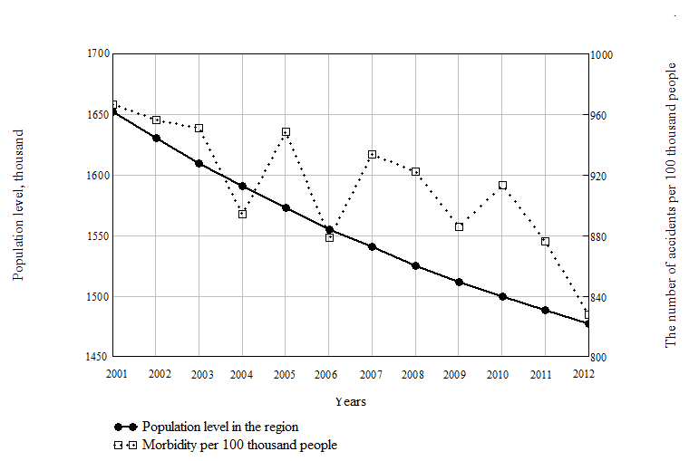
Picture 1. Dynamics of the population level of the region and primary morbidity (according to the regional management of the static) from 2001 to 2012
As we can see, the population level in the region is gradually reduced and has a highlight tendency to further reductions. However, the total number of diseases is decreasing, and that is a positive factor. Therefore, for a more accurate calculation, the relative value were used, it is the the number of accidents per 100 thousand of inhabitants.
Materials of research were data taken in the Poltava regional sanitary epidemic station [2] and in the statistics department [1]. On the basis of these data, the analysis of the influence of the state of drinking water on the health of the region's population, corresponding graphs were constructed and Pearson correlation coefficients were calculated by the known formula:
$P=\frac{\sum{\left(x−\overline{x}\right)⋅\left(y−\overline{y}\right)}}{\sqrt{\sum{{\left(x−\overline{x}\right)}^{2}}⋅\sum{{\left(y−\overline{y}\right)}^{2}}}}$, | (1)
or built-in Microsoft Office Excel = PEARSON (array 1; array 2). To simplify the evaluation of water quality, integral index are used, which is the arithmetic average between the discrepancy of samples under current law, selected in the centralized water supply (according to sanitary-chemical and bacteriological parameters) and decentralized water supply (according to sanitary-chemical and bacteriological parameters) for 12 years [2]. The results are shown below.
Picture 2 shows the dynamics of the discrepancy of water quality under current law (state sanitary rules and norms), average for the region.
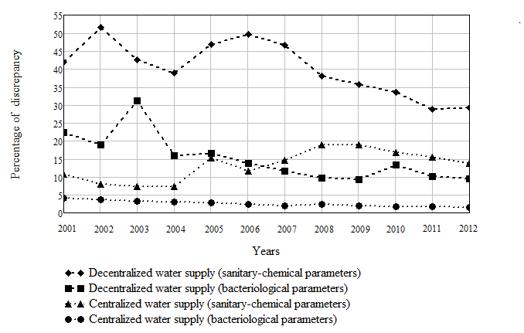
Picture 2. Dynamics of water quality in the region
As you can see there is a tendency toward improving water quality of decentralized water supply and a certain slight deterioration centralized water supply (the latter deals with wear of water supply systems).
The following graph shows the comparison of the integral indicator of water quality in the region and primary morbidity.
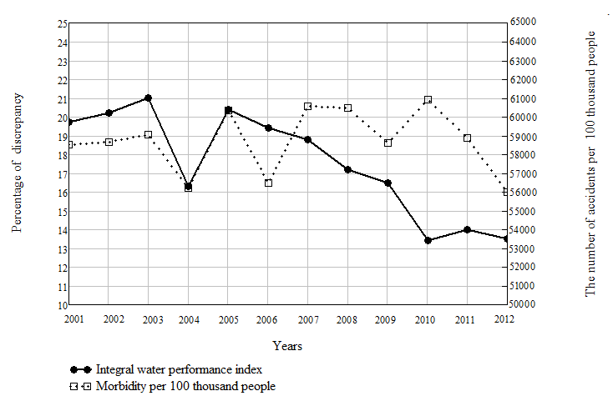
Picture 3. Comparison of the integral indicator of drinking water quality of and primary morbidity
As we can see on the graph, curves are very different, the dependence is not observed; it also confirms the low value of the correlation coefficient (r = 0,29). It is easily explained: respiratory diseases numbers 44 % from the total number of diseases (4808,5 thousand from 10952,7 thousand accidents or the whole research period), which are not related to the quality of drinking water. Therefore accidents were excluded as interfering ones; at the same time and another group was excluded – injury, poisoning and some other consequences of external causes. After that the correlation coefficient has been recalculated and the graph was plotted and presented in Picture 4.
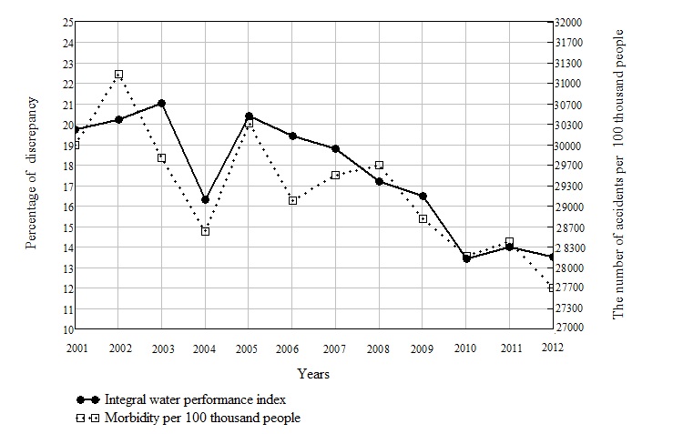
Picture 4. Comparison of the integral indicator of drinking water quality and the primary morbidity (without respiratory diseases and injuries, poisoning and other consequences
of external causes)
As we can see on this graph when respiratory diseases and injuries were not considered, the curves have become quite similar; moreover that fact is confirmed by the high value of the correlation coefficient (r = 0,86), which indicates a high correlation. This indicates that the quality of drinking water significantly affects on the health level in the region. The tendency of water quality improvement together with the reduction of the number of diseases is the positive fact.
The correlation coefficients for individual groups of diseases are also calculated. The following diseases for which these ratios obtained sufficiently high values: blood circulation diseases, diseases of the musculoskeletal system and connective tissue – r=0,76 and r=0,66, respectively are itemized. Particular attention should be paid to the disease of blood circulatory system, as it is the second-largest group of diseases – 8 % (990,7 thousand from 10952,7 thousand accident during the research period). Another group of diseases, also ranks high, third place – 482,3 thousand accidents. Resulting graphs are shown below.
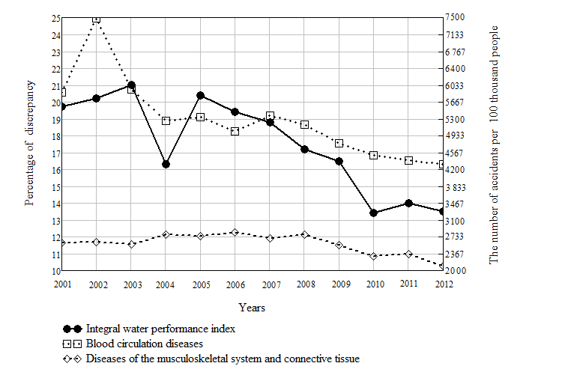
Picture 5. Comparison of integral indicator of drinking water quality and some groups of diseases.
As we can see, the curves are very similar, that confirms the rather high value of the correlation coefficient.
Conclusions:
1. The population level in Poltava region is gradually decreasing and has a downward tendency.
2. Population primary morbidity is reduced in both absolutely and relatively (per 100 thousand inhabitants).
3. The quality of drinking water in the region is also gradually improving, especially for decentralized water supply.
4. There is a significant correlation between drinking water quality and primary morbidity as it is indicated by a correlation coefficient (r = 0,86).
5. The main diseases in the region are respiratory diseases, followed by diseases of blood circulatory system, and on the third place there are diseases of the musculoskeletal system and connective tissue.
6. There is a correlation between drinking water quality and separate groups of disease: they are diseases of blood circulatory system, diseases of the musculoskeletal system and connective tissue r=0,76 and r=0,66 respectively
BIBLIOGRAPHY:
1. Дані обласного статичного управління в Полтавській області з 2001 по 2012 роки [Електронний ресурс]. – Режим доступу : http://www. poltavastat.gov.ua/
2. Дані обласної санітарно-епідеміологічної станції в Полтавській області з 2001 по 2012 роки.
3. Екологічний атлас Полтавщини : навч. видання ; [за ред Ю. С. Голіка, В. А. Барановського,
О. Е. Ілляш]. – Полтава : Полтавський літератор, 2007. –128 с.
4. Коваль В. В. Динаміка забруднення вод сільськогосподарського призначення нітратами в умовах Полтавської області / В. В. Коваль, В. О. Наталочка, С. К. Ткаченко, О. В. Міненко // Вісник Полтавської державної аграрної академії. – 2011. – №2. – С. 32–36.
5. Мосейчук А. А. Оцінка якості питної води в джерелах децентралізованого водопостачання Полтавської області / А. А. Мосейчук, І. А. Бойко // Вісник Полтавської державної аграрної академії. – 2011. – №4. – С. 12–17.
6. Національна доповідь про якість питної води та стан питного водопостачання в Україні у 2012 році [Електронний ресурс]. – Режим доступу : http://minregion.gov.ua/discussion/proekt-nacionalnoyi-dopovidi-pro-yakist-pitnoyi-vodi-ta-stan-pitnogo-vodopostachannya-v-ukrayini-u-2012-roci/.
7. Нітратне забруднення джерел питної води в Україні: дослідження ВЕГО «МАМА-86» за 2001–2008 р. – К., 2009. – 16 с. – Режим доступу : http://www.ecotoilet.com.ua/UserFiles/Images/ Content/content/instructions/Нітратне забруднення джерел питної води в Україні.pdf.
8. Регіональна програма охорони довкілля, раціонального використання природних ресурсів та забезпечення екологічної безпеки з урахуванням регіональних пріоритетів Полтавської області на 2012–2015 роки (програма «Довкілля – 2015») [Електронний ресурс]. – Режим доступу : http://www.eco-poltava.gov.ua/vikprogd.htm.

